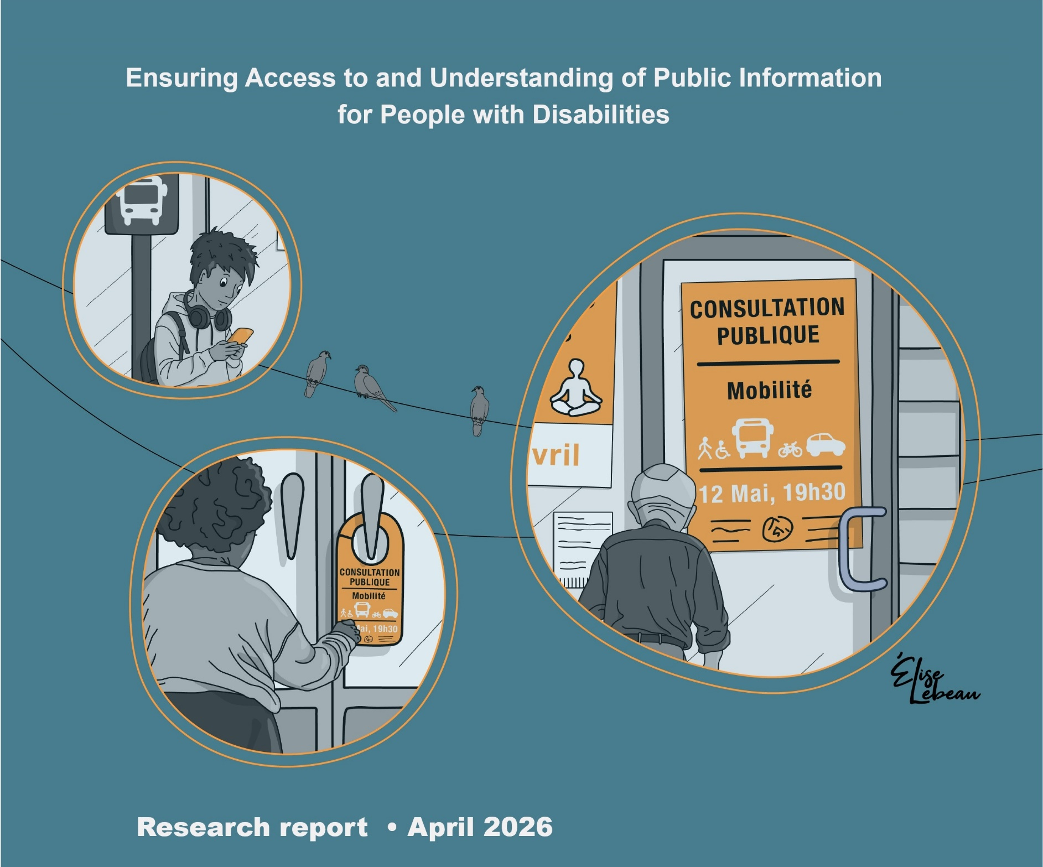

Edith Jolicoeur, Julie Ruel, Marie-Josée Goulet, Marie-Ève Gonthier, Francine Julien-Gauthier

In collaboration with: Nathalie Roussel, André C. Moreau, Anie-Claude Paquin, Annie Duplessis, Marie-Ève Lefebvre, Marie-Ève Bolduc, Jessica Lacroix, Martine Lorrain-Cayer, Léa Dufour, Gabrielle Desmeules-Thériault and Rosalie Courtois



This document is an appendix to:
Jolicoeur, E., Ruel, J., Goulet, M.-J., Gonthier, M.-E., & Julien-Gauthier, F. (2026). Ensuring access to and understanding of public information for people with disabilities: Research report. Université du Québec à Rimouski. https://doi.org/10.65130/n4rs8mc

Language Notice
Some figures and tables in this report remain in their original French. In cases where a complete translation was not feasible, the original French version has been retained to preserve the accuracy, readability, and integrity of the visual content.


This report is published under a Creative Commons Attribution 4.0 International (CC BY 4.0) license. You are free to share and adapt it, provided that you give appropriate credit to the authors.

We acknowledge the financial support of Accessibility Standards Canada/the Government of Canada.

Acknowledgements and financial support:

This research was made possible through the financial support of Accessibility Standards Canada (ASC). Support for a portion of the quantitative data analysis from the questionnaire was provided by the Institut universitaire en déficience intellectuelle et en trouble du spectre de l’autisme (IUDITSA).
This project benefited greatly from the collaboration of a valued colleague, André C. Moreau. We also wish to highlight the contribution of Marie-Ève Lefebvre, professor at Université du Québec à Rimouski (UQAR).
The analyses were also made possible by the meticulous work of these research officers: Marie-Ève Bolduc, Jessica Lacroix, Martine Lorrain-Cayer, and Léa Dufour.
We extend a very special thank you to the residents of L’Arche Canada and the staff members who work there daily. Thank you for opening your doors to us.
Finally, we would like to acknowledge the contribution of the staff of the City of Victoriaville, in particular Nathalie Roussel, Strategic Advisor, as well as Fanny Landry, Director of the Communications and Citizen Relations Department, and her team. Their dedication was a key driving force behind this research. We also thank Rosalie Courtois, Communications Officer throughout the duration of the project. Finally, this project would not have been the same without the active participation of the members of the two communities of practice.

Table of Contents

List of figures 8
Introduction 10
Background 11
Project Problem Statement 13
Project Objectives 14
Project Partners 15
Methodology 18
Participation in the People with Disabilities Group 22
Presentation of Training Sessions and Communities of Practice 26
Training Sessions 26
Webinar 26
Training on Designing Clear Communications 27
Specialized Workshop on Designing Accessible Content 28
Specialized Workshop on Designing Legal Content 29
Training on Communicating with People with Specific Needs 29
Link Between Training Sessions and Communities of Practice 29
Summary of the Community of Practice – Communication 30
Summary of the Community of Practice – Legal 33
Presentation of Data Collection Tools and Results 37
Literacy Awareness Level Questionnaire 37
Evaluation of Web Pages at the Start and End of the Project 41
Focus Groups Held at the Beginning and End of the Project with Representatives of People with Disabilities 48
Review of the First Meeting 49
Focus Groups Held at the Beginning and End of the Project with Representatives of People with Intellectual Disabilities 56
Review of the First Meeting 57
Review of the Second Meeting 60
Focus Group with Members of the Community of Practice – Communication 64
Focus Group with Members of the Community of Practice – Legal 69
Evaluation of Tools by People with Disabilities Group 83
Registration to Recreational Activities 84
Emerald Ash Borer 85
Residual Materials Collection Calendar – Online and Print Versions 87
Tree Canopy FAQ 90
Fire Safety Door Hanger 92
Emergency Kit Door Hanger 94
Four Videos on Vegetation 97
Video on Pool Safety 99
Video on the Tree Canopy 100
Minute Victo – Using Water Wisely! 102
Minute Victo – Dogs 104
Traces Urbaines Trail 106
Evaluation of the Six Pages Associated with the Panels 114
Evaluation of Web Accessibility Tools for Site Personalization 121
Descriptive Quantitative Evaluation of Accessibility Tool Usage at the City of Victoriaville 130
Summary of the Evaluation of the Tools: 131
Individual Interviews with the Participant Group of People with Disabilities 133
Examples of Other Projects Developed 135
Example 1: Urban Planning Department Letter – Sent via Email 137
Example 2: Poster on the Emerald Ash Borer 139
Example 3: Door Hanger on Water Usage 141
Exemple 4: Public Notice 144
Summary and Interpretation of Results 147
Findings for Implementing Change in Other Settings 150
Conclusion 154
References 155
Appendix 1: Writing Guidelines 157
Appendix 2: Canopy FAQ 158

List of figures

Figure 1: Gantt Chart Illustrating the Project Stages 19
Figure 2: The Action Research Cycle (Roy and Prévost, 2013, p. 136) 22
Figure 3: Initial Interface of the iPads Provided to Participants 24
Figure 4: Example of Illustrated Procedures Provided to Participants 25
Figure 5: Activity Banner Featured on the Version of the Website Available in March 2024 52
Figure 6 : Two-Page Promotional Summary Sheet 84
Figure 7 : Emerald Ash Borer Poster 86
Figure 8 : Residual Materials Collection Calendar 88
Figure 9 : The Fire Department Door Hanger 93
Figure 10: Door Hanger: Do You Have an Emergency Kit? 95
Figure 11 : Four Videos on Vegetation 98
Figure 12 : Video on Residential Pool Access Control 99
Figure 13 : Video on How to Estimate the Tree Canopy Fee 101
Figure 14 : Video on Using Water Wisely 103
Figure 15 : Video on Walking Your dog 105
Figure 16: Panels on Preexisting Structures at Eye Level and at a Right Angle 107
Figure 17 : Panel at an Accessible Height 108
Figure 18: Presence of QR Code Instructions 108
Figure 19 : Angled Panels That Are Difficult to Acces 109
Figure 20 : Panels Located Too Far from the Sidewalk 110
Figure 21: Panels Elevated Above Sidewalk Level 111
Figure 22 : Panel Placed Too High 111
Figure 23: Font Size Too Small 112
Figure 24 : Picnic Table Blocking Access 113
Figure 25. Homepage of the Traces Urbaines Interactive Tour 114
Figure 26 : Image of Stop 1 - The Texaco Garage 115
Figure 27: Video Image from Stop 4A - Jean Béliveau 116
Figure 28: Video Image from Stop 17 – The Syndicat Store 117
Figure 29: Image of Stop 27 – The L’enVolée Artwork 118
Figure 30: Image of Stop 30 – The Roundabout 119
Figure 31: Pictogram Options Provided by the Vendor 121
Figure 32: Full Set of Features Offered by accessiBe, the City of Victoriaville’s Accessibility Tool 126
Figure 33: Accessibility Tool Used by Eczema Society of Canada 127
Figure 34 : UserWay Accessibility Tool 128
Figure 35: Accessibility Tool Offered by the RAAQ 129
Figure 36: Original and Final Versions of an Urban Planning Department Letter 137
Figure 37: The Final Version Integrates a Clear Photo of an Infested Tree Alongside Simplified Text 139
Figure 38: Front and Back Views of the Original Version of the Door Hanger 141
Figure 39: Front and Back Views of the Final Version of the Door 142
Figure 40: Original Version of the Public Notice 144
Figure 41: Final Version of the Public Notice 145


Introduction
This report pertains to the research project entitled Ensuring Access to and Understanding of Public Information for People with Disabilities, conducted from July 31, 2023, to March 31, 2026. The project’s overall objective was to engage staff and community members involved with people with disabilities to fundamentally transform the communications issued by the City of Victoriaville, ensuring they are more accessible, understandable, and usable. This report outlines the various activities carried out over the course of the research project and concludes with a summary of the results. These findings bring to light key considerations for fostering communications that are clear for the entire population, including people living with disabilities.


Background
According to the latest data from the report on adult skills assessment (OECD, 2024), nearly half of all adults exhibits low proficiency in reading texts that contain specific, unfamiliar vocabulary, as well as in interpreting or evaluating information.
Furthermore, certain risk factors appear to make some adults even more vulnerable. These factors notably include educational attainment, migration status, age, and living with a disability.
In a society where access to and mastery of information are essential, literacy is a critical issue of civic engagement. It represents the ability to understand and use information to gain autonomy and make informed choices (OECD, 2013).
Public communications can be difficult to understand, particularly because they are primarily transmitted in textual formats (Grenon et al., 2021). However, these formats often require high reading fluency and a vast vocabulary, which can complicate comprehension for a segment of the population, especially when the content is long, dense, or filled with technical terms.
Moreover, the green or digital shift initiated in recent years (Science-Presse, 2023) to reduce carbon footprints calls for the removal of paper formats. This does not account for the needs of that portion of the population that lacks the digital tools or skills to navigate the Internet effectively. Indeed, a survey (ATN, 2024) highlights that nearly 1 in 10 Quebec adults does not have an Internet connection and has not had the opportunity to use one in the past three months. Data collected during this survey also shows that this ratio increases with the age of the population. Consequently, public communications in their current form raise issues of inclusion, particularly for certain groups, including seniors and people with disabilities.

All levels of government have a responsibility to design communications that are clear, understandable, and accessible to their entire population. To achieve this, the use of plain language has been proven to be a viable path toward the inclusion of all members of society.
To design information in plain language, content creators must engage in a strategic approach to communicating and presenting information in a way that enables the target audience to easily find what they are looking for, understand what they find, and use it to act, make decisions, or meet their needs (ASC, 2025). This approach does not involve oversimplifying or removing important information. Rather, it focuses on making essential information more accessible and easier to read (Government of Canada, 2025). In addition to these principles, content must be validated with the target audience (ASC, 2025).
Based on these findings, and in response to the call from Accessibility Standards Canada (ASC) to further research the identification and removal of accessibility barriers, our research team proposed to train and support the staff of a Canadian city. This initiative aims to better understand the transition process toward clearer and more accessible communications, in order to inform the development of the next generation of model standards.

Project Problem Statement
This project was conducted in partnership with the City of Victoriaville, which has long been committed to reducing accessibility barriers for its population. This commitment is reflected in its universal accessibility policy and in an action plan it has deployed annually since 1999. More recently, in its 2020–2027 social policy strategic plan, Target 5.1 set the objective of improving the understandability of municipal communications to better account for varying abilities in reading, comprehending, and using written information. In parallel, however, the 2022–2027 municipal strategic plan outlined a digital transition for the administration. If not guided by inclusive communication practices, this transition could create new barriers or reinforce existing ones, particularly for individuals who face challenges with comprehension, digital literacy, or information access.
In this context, a central challenge emerges: “How can we ensure that municipal communications, which are increasingly digital and often text-heavy, are truly accessible and understandable for the entire population, especially for people with disabilities and those more vulnerable to literacy barriers?” Having already held several staff awareness workshops, the City was specifically looking to transform its practices in a sustainable way. To achieve this, the City sought to equip relevant staff, create and test more accessible documents, adopt a method for identifying concrete barriers in messaging, and verify whether these changes effectively reduce the obstacles encountered. This approach also involved the target audience, specifically people with disabilities, to evaluate whether communication projects were indeed more accessible and to ensure that no new barriers were inadvertently created.
Consequently, the methodology associated with this research involved rigorously documenting and evaluating the transition process toward clearer and more accessible municipal communications. The goal was to support the development of a next generation of model standards, building on the work of Ruel et al. (2016, 2018, 2019), which would then be applicable to other levels of government.

Project Objectives
The initial objectives of this research project were as follows:
- Identify barriers to accessing and understanding information, including digital information, within a community, specifically that of Victoriaville.

- Raise awareness and train and support City staff members, who are the designers of this information, in adopting promising practices to eliminate these barriers.
- Evaluate the results of the promising practices piloted.
- Provide recommendations for facilitating access to and understanding of information that are applicable to other levels of government.

Project Partners
The following section introduces the City of Victoriaville, where the research project took place, along with the other partners who contributed to this initiative.
Victoriaville is a medium-sized Canadian city. With nearly 50,000 residents, it faces challenges similar to those of the provincial and federal governments. Using a city as a field of study is particularly relevant because it generates a large volume of communications intended for the entire population, across various situations often linked to essential services. This context allows for the concrete observation of how barriers emerge, how teams identify them, and which practices make information easier to understand and use. The lessons learned from a municipal setting are also transferable because many public organizations face similar realities, such as diverse audiences, service obligations, and the digital transition. Finally, a city provides a framework conducive to experimentation and continuous improvement, notably through feedback from the target audience and interdepartmental collaboration. Consequently, the findings from this pilot project are highly transferable.

To better understand the barriers encountered in accessing and understanding municipal information, the initiative involved representatives from several local community organizations. This brought together diverse perspectives rooted in the lived experiences of individuals facing different realities, helping to document concrete needs for clearer and more accessible communications. The following organizations were involved:
- Association des proches aidants Arthabaska-Érable
- Association pour l’intégration sociale
- Association des personnes malentendantes des Bois-Francs
- L’Entrain support group
- Handicap Action Autonomie Bois-Francs
- L’Envol stimulation centre
- Autisme Centre-du-Québec
- Parrainage civique des Bois-Francs
- Association régionale de loisir pour personnes handicapées du Centre-du-Québec (ARLPHCQ)
- Association de la surdité du Centre-du-Québec (ASCQ)
- Association des traumatisés cranio-cérébraux Mauricie–Centre-du-Québec (Association TCC MCQ)

Thanks to their contributions, the research was able to rely on essential field expertise to guide actions and foster improvements that are truly beneficial to the population.
To ensure that the inclusive communication projects met the needs of people with disabilities, we also called upon a group of 12 individuals living with disabilities. These participants provided a critical perspective on specific inclusive communication projects and formulated concrete suggestions to make messages easier to understand and use. These participants were recruited by local community organizations in Victoriaville as well as by L’Arche Canada. L’Arche Canada is a national non-profit organization and a member of the international L’Arche movement. It brings together communities where people with intellectual disabilities share their daily lives and develop reciprocal relationships with a focus on inclusion.
Finally, Espace MUNI also contributed to the project. Espace MUNI is a non-profit organization that supports municipalities and regional county municipalities (RCMs) by offering guidance, tools, and inspiration to foster healthy, inclusive, and sustainable living environments.

Espace MUNI sat on an advisory committee that met several times throughout the project. It also facilitated the transfer of knowledge by providing access to its website to host the tools produced, including a guide for transforming municipal communication practices, practical memos, and this report.

Methodology
This section first describes the participatory action research (PAR) approach, as outlined by Roy and Prévost (2013). Subsequently, specific aspects regarding the participation of people with disabilities in the research will be detailed.
Participatory Action Research
This project is based on a PAR model. Roy and Prévost (2013) note that this research approach is rooted in the principle that scientific knowledge is generated through action. Theory supports action, and from action, theory emerges.
According to these authors, action research is characterized by three key elements:
- It is conducted with people rather than on them.
- The initial intent is to foster change.
- It adopts a cyclical rather than a linear process.
Before initiating the research, researchers and community players share their concerns and collaboratively develop various strategies to improve the situation. In the present study, this stage took place during the drafting of the grant application.

Numerous meetings were held with the City’s universal accessibility coordinator to fully understand the current state of affairs and ensure the project was grounded in scientific knowledge, while also meeting local expectations. This planning phase also involved multiple consultations with managers from various municipal departments and elected members of the city council to secure their formal approval. A Gantt chart (Figure 1) illustrated the actions that were planned for the research period.
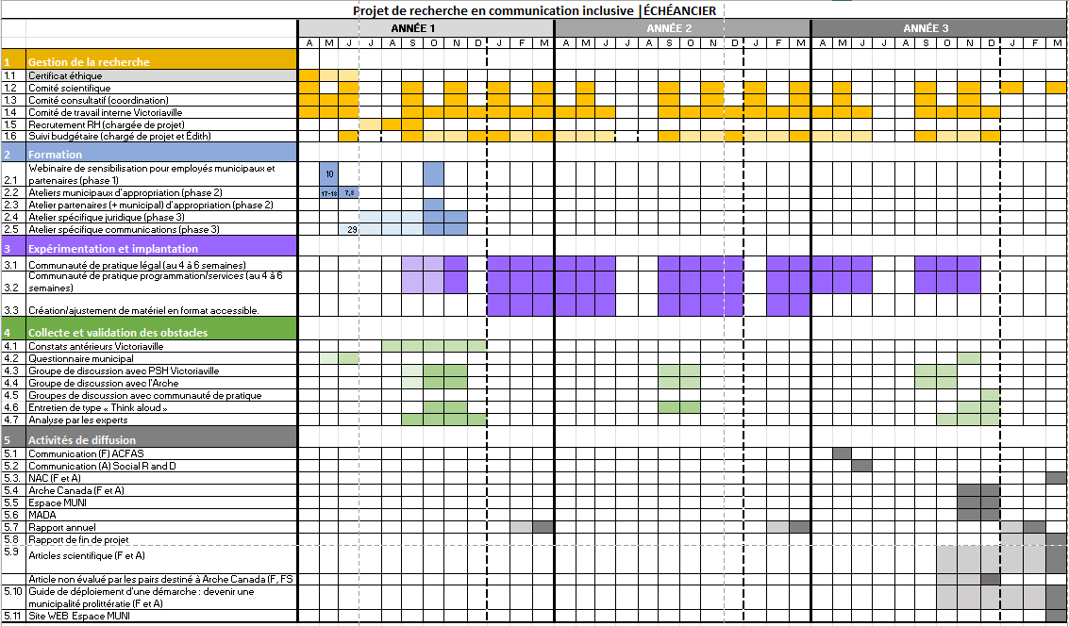

Figure 1: Gantt Chart Illustrating the Project Stages

Initially, the project plan included a series of training sessions: an awareness webinar, a one-day workshop on designing accessible information, and a specialized one-day workshop for staff in communications or those handling legal information. Following these sessions, the plan involved two years of support for City staff through the establishment of two communities of practice: one for communications personnel and another for departments responsible for legal information (e.g., legal services, urban planning, fire services). A group of people with disabilities was associated with these two communities of practice to provide critical feedback on the tools developed, and specifically to prevent the creation of new barriers.
Over the two-and-a-half-year course of the project, adjustments were made to the initial plan. In the early months, it became necessary to hold additional training sessions, as it was not possible to gather all work teams at the same time. Similarly, extra community of practice meetings were added, sometimes with only available members or smaller groups, because certain projects could not wait until the next scheduled meeting to move forward.
At a specific point in the project, staff members were tasked with revising text for the new website, launched in the fall of 2025. Faced with the challenge of revising and making all this content easier to read and understand, the staff utilized generative artificial intelligence (AI) by providing it with clear writing instructions. Initial texts were submitted to the chatbot ChatGPT. These preliminary versions were then refined by staff to ensure the information was accurate and presented in the desired order. The list of clear writing instructions can be found in Appendix 1 of this report.
In a similar vein, midway through the project, administrative assistants identified the need to feel more involved in the process. It was thus decided to add quick training segments to their monthly meetings. Additionally, a training session focused on welcoming people with specific needs was proposed. Due to its positive reception, this session was delivered four times, to various City staff. Finally, during the last year of the project, noting a significant turnover in municipal staff, it was decided to re-offer the series of webinars and workshops on plain language communications.
In Roy and Prévost’s (2013) description, the action research cycle concludes observing the adopted changes, assessing the involved parties’ capacity to act, and making a generalization of knowledge. In order to be able to achieve all this, data collection involved various tools. A pre- and post-research questionnaire was sent to staff members who participated in the training. The City’s website was evaluated at the beginning and end of the project. Detailed meeting summaries were produced for the communities of practice. Furthermore, focus groups and individual interviews were conducted with participants. Successive versions of communication projects were compared and serve as artefacts presented in this report. Thus, the analysis of these various tools will contribute to the reflection and evaluation of this project, specifically to synthesize the findings and issue recommendations.
Figure 2 illustrates the action research cycle described above.

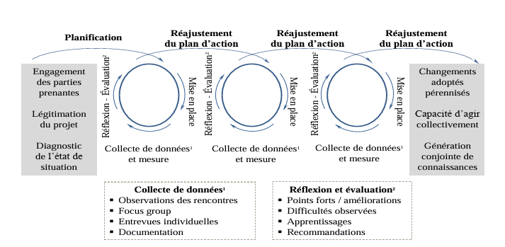
Figure 2: The Action Research Cycle (Roy and Prévost, 2013, p. 136)

Participation in the People with Disabilities Group
In recent years, significant efforts have been made to foster the inclusion of people with disabilities (United Nations [UN], 2006). In this research, disability is defined as any impairment or functional limitation, whether permanent, temporary, or episodic, and whether visible or not. When this reality interacts with a barrier, it can hinder a person’s full and equal participation in society (Accessible Canada Act, S.C. 2019, c. 10).
Accordingly, for this research project, individuals living with disabilities were invited to form a group tasked with providing critical feedback on various projects underway at the City of Victoriaville.
To assemble this group, managers from several organizations supporting people with disabilities were contacted. These managers served as the initial point of contact for the participants.
Throughout the study, 12 individuals participated in this group. While most remained involved for the entire duration of the project, some participated for a shorter period. The participants represented a diverse range of lived experiences with disability: visual or hearing impairments, intellectual disabilities, autism spectrum disorder, mobility challenges, cognitive impairments, traumatic brain injuries, aphasia, and mental health conditions. The three individuals who withdrew before the project’s conclusion primarily cited health-related reasons.
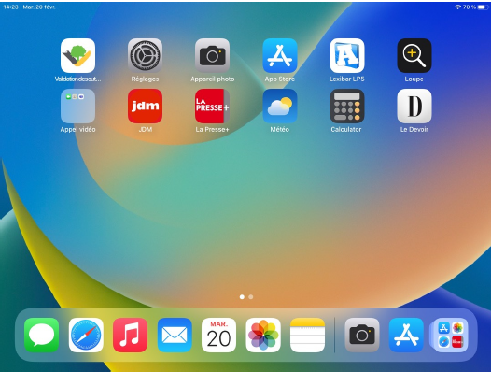
Since most group participants did not have a driver’s licence and lived in isolated areas of the region, they were provided with an iPad. These tablets were preconfigured so that a specific icon appeared as soon as the device was turned on, providing direct access to a page containing the documents for the projects being evaluated. To facilitate remote technical support, the layout of the applications on the home screen was standardized for everyone. Additionally, several other applications were pinned to the main display: Settings, Camera, the App Store, Magnifier, Weather, Calculator, and various news apps. A folder titled “Video Calls” contained the FaceTime app, which was used to easily contact participants. Participants were also encouraged to download games or other apps of their choice to promote frequent use and help them become more proficient with the device. Figure 3 shows the interface configured for each of the tablets provided to the participants.
Figure 3: Initial Interface of the iPads Provided to Participants
The tablets were delivered in person to the participants at their homes. During these visits, hands-on practice sessions were conducted on making FaceTime calls.
A paper document of approximately 15 pages, containing several illustrated procedures (powering the device on and off, adjusting the volume, charging the tablet, checking battery status, connecting to the Internet, etc.), was provided to each participant. This document was also available in both PDF and Word formats directly in the tablet’s file system. Figure 4 provides an example of one of the procedures included in this document.
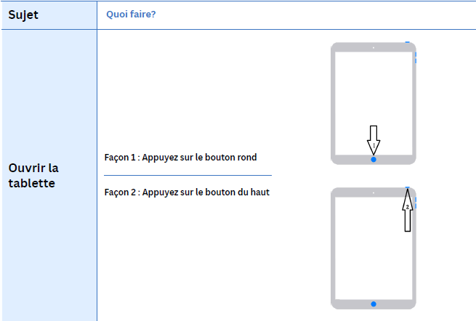
Figure 4: Example of Illustrated Procedures Provided to Participants
Finally, a series of videos was also produced to explain these various functions. These videos were also made available directly on the tablets.
The following sections of this report will detail the various training sessions attended by City of Victoriaville staff and their partners, including representatives from the community. Subsequently, the different data collection tools will be described, along with their key findings.



Presentation of Training Sessions and Communities of Practice
The project was structured around training sessions, communities of practice, the evaluation of tools alongside people with disabilities, and various measurements taken before and after the pilot phase. The following subsections detail these various components.

Training Sessions
A central pillar of this research project was the training of staff members, first to raise awareness regarding the importance of designing clear information for the general public, and subsequently to teach them how to effectively deliver this information. The following subsections provide a detailed look at these different training offerings.

Webinar
To raise awareness among all City of Victoriaville staff, a 90-minute webinar titled Literacy, Inclusion, and Communication for Clear and Accessible Information was presented multiple times over the two-and-a-half-year project duration. At the start of the project in the fall of 2023, the webinar was delivered five times. Furthermore, due to staff turnover, the same webinar was offered again in 2025 on three additional occasions.
This webinar was intended for all staff members in contact with the Victoriaville population. In total, 277 people attended the webinar throughout the project. Whenever possible, external partners were also invited, such as volunteers or staff from organizations serving people with disabilities. A total of 64 external partners attended.

The webinar covered various themes, including literacy levels in Canada and Quebec, and more specifically in the Centre-du-Québec region, where the research was conducted. It also addressed the challenges associated with low literacy levels and the legal framework surrounding information accessibility for all. Finally, the webinar concluded by exploring ways to become a “pro-literacy” organization, one that actively promotes more inclusive communications.

Training on Designing Clear Communications
Following the initial phase, a full-day training session was offered to staff members specifically involved in information design. Once again, this training was delivered multiple times, as it was not possible to pull all members of a single department away for an entire day. This session was held four times during the first months of the project and once in the fall of 2025, prior to the project’s conclusion. These training days reached a total of 102 people, including 97 City of Victoriaville employees and 5 external partners.
During these sessions, groups of approximately 20 people familiarized themselves with the recommendations proposed in the guide Communiquer pour tous, Guide pour une information accessible (Ruel et al., 2018). The training day alternated between theoretical content and practical exercises. Participants were invited to break into small groups to discuss scenarios and examples reflecting the reality of municipal communications in Quebec. At each of these meetings, external partners (e.g., the director of a support organization for people with disabilities) were also invited to participate.

Specialized Workshop on Designing Accessible Content
This specialized workshop was intended for staff members responsible for drafting communications, with the goal of making them more accessible. Similar to the full-day session on clear communication design, this workshop blended theory and practice.
However, several individuals scheduled to attend the fall 2023 session had to withdraw; consequently, only eight people were able to attend. Furthermore, since some content overlapped with the previous training and other portions proved less relevant, the decision was made not to repeat this specific workshop

Specialized Workshop on Designing Legal Content

A full-day workshop was also organized for staff members working in departments with a legal component, such as the Office of the City Clerk, Urban Planning, Property Assessment, and Fire Safety. This session was facilitated by a lawyer who specializes in plain language legal communication. Eleven people attended this training in the fall of 2023.

Training on Communicating with People with Specific Needs
Finally, a dedicated training session was delivered four times in the fall of 2025. It was initiated following a request from administrative assistants who wished to improve their communication skills when interacting with individuals with specific needs. Staff from other departments also expressed interest in the session. We delivered this one-hour training on four occasions to a total of 69 participants.

Link Between Training Sessions and Communities of Practice
In the fall of 2023, following the delivery of the webinar, the training on clear communication design, and the two specialized workshops on accessible content (including legal information), two communities of practice (CoP) were established. The objective of these CoPs was to support members in designing more accessible communications. To achieve this, each participant chose a project for which they were responsible and worked on making it clearer. Participants would then present their progress during CoP meetings to further refine their work. During these sessions, the facilitator and fellow participants reviewed the materials and suggested adjustments to ensure the content was easier to read and understand. The CoP focused on legal communications was co-facilitated by a lawyer specialized in drafting plain language legal information.

Summary of the Community of Practice – Communication

Descriptive Overview of Meetings
Between January 31, 2024, and December 11, 2025, the CoP primarily comprising communications department staff (CoP-C) held 17 official two-hour meetings. In addition to these, one extraordinary meeting took place on January 20, 2025, and three further sessions were held in the summer of 2025 to focus on specific projects during periods when no CoP meetings were originally scheduled.
Initially, 11 staff members attended the first meeting to launch the CoP process. This number decreased to 10 at the following meeting. These 10 participants represented the Communications and Citizen Relations Department (6), the Recreation, Culture, and Community Development Department (2), the Sustainable Development Office (1), and the Information Technology Department (1).

Early in the process, one individual changed positions within the organization and another left the organization altogether. The latter was replaced in the CoP-C by another employee later in the process. Consequently, a core group of nine people was invited to all CoP-C sessions. Other staff members were invited to specific meetings when the topics concerned them or during internships at the City. Participation remained relatively stable, with an average of seven people per meeting (minimum four, maximum nine). These seven individuals formed a consistent core, attending 13 out of 18 meetings. The majority of meetings were held in a hybrid format, while seven took place in person. Meetings occurred every four to six weeks, with longer breaks during the summer. A total of 43 projects were presented to the CoP. When these were submitted in advance, the CoP facilitator reviewed them before the meeting. On average, discussions focused on three projects per session.
Recurring Themes and Challenges
Analysis of the discussions held during the CoPs highlights recurring themes that structured the collective work from one meeting to the next. The first theme concerns the clarity of communications: clarifying the primary message and the actions expected from the public, organizing information (headings, subheadings, and step-by-step sequences), and making calls to action easy to identify.

A second recurring theme involves vocabulary and the understanding of concepts. In several projects, the teams were led to identify words requiring explanation, examples, or rewording (technical concepts, administrative terms, and implicit expressions). Discussions often focused on the level of abstraction and the risk of varying interpretations. This vigilance helped in choosing more concrete and familiar words, explaining technical terms, and prioritizing phrasing that reduces ambiguity.
A third theme concerns the accessibility of formats and media. Feedback emphasized the importance of removing barriers in some document types (e.g., PDFs that are difficult to read with assistive technologies), removing text embedded in images, and simplifying navigation. The use of links or QR codes prompted reminders to clearly indicate their destination and provide an accessible alternative (direct link, short URL, or other means of access). More broadly, members discussed the practical conditions that allow content to be easily consulted, regardless of the context or the tool being used.
A final theme addressed work organization challenges. Writing to be understood requires time, multiple iterations, and coordination among several parties. Certain difficulties were recurrent: validation delays, constraints related to institutional obligations, and the need for shared drafting rules.

Summary of the Community of Practice – Legal

Descriptive Overview of Meetings
The CoP comprising individuals responsible for drafting legal communications (CoP-L) held 18 meetings between January 31, 2024, and December 10, 2025. Sessions took place every four to six weeks, with a summer break. The format of this second CoP was similar to the first: Meetings lasted three hours, during which participants presented the progress of their projects. Colleagues and facilitators raised issues concerning comprehension, organization, and accessibility, followed by discussions to identify solutions.
Initially, the CoP-L consisted of a core group of 11 people who agreed to participate and present communications containing legal information. Participants represented Legal Services (3), the Assessment Department (2), Fire Safety (3), and Land Management (3). In addition to these 11 members, two other individuals (one from the Sustainable Development Office and one communications officer supporting the research project) were present to ensure project continuity. These two individuals also attended the CoP-C meetings. By September 2024, three people had ceased their participation for various reasons: medical leave, career changes, and excessive workload. Consequently, from September 2024 onward, the core group of participants for this CoP stood at eight people.

Attendance averaged six members per meeting, with a minimum of four and a maximum of eight. A stable core of approximately six people attended about a dozen meetings. These members were joined by the facilitator and an expert in accessible law.
In total, 26 projects were evaluated by the facilitator or the accessible law expert throughout the duration of the CoP-L. On average, four projects were refined during each session.
Recurring Themes and Challenges
As with the CoP-C, a recurring theme involves clarifying the key message: what to remember, what to do, in what order, and what key guidelines to follow. Discussions often revisited structure (headings, subheadings, steps), information hierarchy, and action-oriented phrasing (e.g., clearly stating expectations, deadlines, and contact options). The group also sought to reduce the reading burden through shorter sentences, simpler vocabulary, and meaningful examples.
Another theme touches on the balance between legal requirements and comprehension. Several discussions focused on what must absolutely be kept to remain compliant while removing what might create confusion. This challenge was particularly evident in projects involving complex processes, such as public notices and referendum processes, where the group worked to make the steps understandable without overwhelming the public with technical details.

The meetings also showed constant attention to formatting and media. The CoP-L explored and improved various formats (fact sheets, door hangers, web content, and videos) in pursuit of more accessible presentations.
Finally, several discussions addressed issues of organization and sustainability: the need to align practices across teams, support long-term buy-in, and avoid a return to old habits. There was also a focus on standardization (creating templates, ensuring consistency between similar documents) and the internal circulation of learnings (e.g., raising awareness, sharing examples).
Broadly speaking, the analysis highlights a dynamic of continuous improvement for both CoPs. Projects reappeared from one meeting to the next, reflecting a revision cycle (e.g., adjusting vocabulary, reviewing information hierarchy, validating key messages). Members suggested content transformations aimed at improvement, and some projects were put on hold when constraints persisted. The CoP meetings served not only to refine message content but also to consolidate procedures, making the work more stable from one session to the next.


Presentation of Data Collection Tools and Results
Throughout this research, various data collection tools were used, including the following:
- A questionnaire to assess the level of literacy awareness within the City of Victoriaville’s departments;
- Website page evaluations conducted at the beginning and end of the project;
- Focus groups held at the beginning and end of the project with representatives of people with disabilities;
- Focus groups held at the beginning and end of the project with representatives of people with intellectual disabilities;
- Focus groups held at the end of the project with participants from the two CoPs;
- A focus group composed of the CoP members’ managers.
We will first present the preliminary results obtained from these various data collection tools, and then the evaluation of projects by the group of persons with disabilities. This will be followed by their feedback on the research process itself. We will conclude with a review of the use of a web accessibility tool.

Literacy Awareness Level Questionnaire

The literacy awareness level questionnaire for the City of Victoriaville’s departments was inspired from a toolkit originally developed for healthcare organizations seeking to evaluate their literacy awareness (AHRQ Health Literacy Universal Precautions Toolkit, 3rd edition:Tool #2, Agency for Healthcare Research and Quality, 2023). It was adapted to a general municipal context and then specifically tailored for the City of Victoriaville. The questionnaire consisted of 54 questions using a four-point Likert scale (Doing well, Needs improvement, Not doing it, Not sure, or Not applicable). It was used to gather respondents’ perceptions of how the City or a specific department was aware of and addressing certain literacy challenges.

The first section consisted of two general questions regarding the City’s current approach. The following section contained 14 questions about improving oral communication. The third section included 23 questions addressing improvements to written communication. The fourth section comprised 15 questions focusing on citizen empowerment and the improvement of support networks.
The questionnaire concluded with two short-answer questions: “Which communication situations were not addressed in this questionnaire but should have been?” and “Do you have any additional comments?”
The estimated completion time for this questionnaire was 15 to 20 minutes.
In total, 53 people completed the questionnaire during the pretest phase, and 48 people responded posttest.
For the statistical analysis, respondents were grouped into four categories based on the department in which they worked (see Table 1):
- Sustainable Development and Land Management
- Public Works, Fire Safety, Legal, Engineering and Environment, and Infrastructure
- Human Capital, Communications, Finance, Management / Mayor’s Office, and Information Technology
- Recreation, Culture, and Community Life
Group | Pretest | Posttest | Total
1 | 11 ou 20,8% | 13 ou 27,1% | 24 ou 23,8%
2 | 11 ou 20,8% | 10 ou 20,8% | 21 ou 20,8%
3 | 16 ou 30,2% | 14 ou 29,2% | 30 ou 29,7%
4 | 15 ou 28,3% | 11 ou 22,9% | 26 ou 25,7%
Total | 53 ou 52,5% | 48 ou 47,5% | 101 ou 100%
Table 1: Description of Pretest and Posttest Respondents
The analyses in this report were conducted using R version 4.5.2. We performed Fisher’s tests to determine if responses changed between the pretest and posttest. Mantel-Haenszel tests were used to verify if the pre–post tables varied by department. Unfortunately, paired data models were not possible for the pretest and posttest comparison, as participants were not uniquely identified. The report’s conclusions are summarized at the beginning of each section.
For the first section of the questionnaire (two general questions on the current approach), although a slight improvement was observed, it was not statistically significant.

For the second section of the questionnaire (14 questions regarding perceived improvements in oral communication), a statistically significant perceived improvement was noted for two items: the identification of literacy issues (p < 0.001) and the use of clear and simple oral communication techniques (p < 0.001). When responses were compared by department, a statistically significant difference between departments was noted regarding the identification of literacy issues. This identification was more pronounced in the departments covering public works, fire safety, legal, engineering, and IT, as well as those encompassing recreation, culture, and community life. These departments corresponded to those from which members had actively participated in the CoP initiative.
The third section of the questionnaire consisted of 23 questions addressing perceived improvements in written communication. Statistical analysis revealed a statistically significant perceived improvement for 10 of the 23 questions. Respondents specifically found that written communications were clearer, more concise, and used simpler language. When compared by sector, these improvements appeared to be most recognized within the group encompassing Human Capital, Communications, Finance, Management / Mayor’s Office, and Information Technology. Conversely, individuals in the Recreation, Culture, and Community Life Department noted the fewest changes.

The final section of the questionnaire included 15 questions regarding citizen empowerment and the improvement of support networks. A statistically significant change was perceived in three questions related to the clarity of roles and responsibilities, as well as the support and follow-up provided to the public. When observing the results by department, it was the members of the Recreation, Culture, and Community Life Department who noticed the most significant changes in this area.
In conclusion, the project demonstrated significant perceived improvements in three of the four questionnaire sections: oral communication, written communication, and community empowerment. The most pronounced improvement was seen in written information, which aligns with the heavy emphasis placed on this element throughout the project.

Evaluation of Web Pages at the Start and End of the Project
The evaluation of the City of Victoriaville’s website was conducted in March 2024 and again in the winter of 2026. The objective of this report was to assess the website’s accessibility.
The accessibility audit of the City’s website was performed first manually, using a checklist, and then automatically, using free online tools. These specific web pages were audited:

- Home page (HP)
- Universal accessibility (UA)
- Specialized transit (ST)
- Sports and recreation (SR)
- Collection of residual materials (RM)
- Dog licences (LC)
For the manual verification of the website’s accessibility, a checklist was adapted from Communiquer pour tous : guide pour une information accessible (Ruel et al., 2018). The audit grid consisted of 121 success criteria divided into 11 categories. However, some criteria were not evaluated, as they did not apply to the specific pages being reviewed (e.g., the “Digital files” and “Questionnaires” categories). Consequently, 104 of the original 121 criteria were evaluated, distributed across 8 categories:
- Navigation
- Web page design and drafting
- Images
- Multimedia content
- Persons with disabilities
- Persons with intellectual disabilities
- Persons with a visual impairment
- People with a hearing impairment
In 2024, for each criterion, a score between 0 and 10 was assigned based on the degree of compliance of the web page with the criterion in question (10 = perfect compliance), which was then converted into a percentage.

At the beginning of the project, the best-rated aspects related to the use of images (86.6%) and to web page design and drafting (85.2%). The lowest-rated aspects involved the criteria on considering persons with disabilities (0%), persons with intellectual disabilities (10.6%), visual impairments (31.5%), and hearing impairments (0%). Regarding criteria for navigation, the success rate was 38.5%, while the rate for multimedia content was 37.5%.
At the end of the project, the evaluation of navigation identified several elements facilitating website orientation. The logo and navigation bar remained in the same position from one page to another. A breadcrumb trail also helped users understand their location within the site. Simple aids supported movement, such as a “Back to Top” arrow and, in certain areas, a “Back” arrow. Finally, a search function was accessible throughout the site, and content displayed correctly on mobile and tablet devices without horizontal scrolling.
That said, when scrolling down a page, the menu bar and breadcrumb trail did not always remain visible, often forcing the user to scroll back up. The “Back” function was not offered consistently, making the user journey less uniform. Hyperlinks were not presented in a standardized way (varying by colour, underlining, framing, or arrows), and some labels remained too general (e.g., “Details,” “View”). The search function could have also been improved with features such as autocomplete suggestions and better tolerance for word variations.
In summary, comparing the manual evaluations from 2026 and 2024 highlights several improvements, including the following:
- Added navigation aids, including arrows.
- Standardized underlining, where only hyperlinks were underlined
- Engaging tone, using “we/you” phrasing and imperative verbs to better connect with users
- Improved readability on several pages, featuring shorter, affirmative sentences following the subject–verb–object order, with one primary subject per page.
However, the new website also showed a decline in compliance for certain criteria, including these:
- Search functionality, which no longer featured autocomplete, was less tolerant of typos and appeared less effective than in 2024
- Heading hierarchy, which was not consistently maintained.
Finally, certain criteria remained unmet across both evaluations:
- Lack of persistent navigation, as the navigation bar and breadcrumb trail disappeared when users scrolled down

- Inconsistent hyperlink styling, with links presented in multiple formats

- Vague link titles, which were not always explicit or descriptive
- Limited personalization, making it difficult for users to customize their browsing experience
- Lack of video content, or videos that were difficult to locate.
In this context, navigation represented an element requiring further refinement. Although the site already offered several useful landmarks, the user experience was not yet sufficiently consistent or predictable. Proposed improvements aimed for stabilized visual cues, uniform link styling, clearer labels, and more robust search engine support, following a logic of accessibility for the entire population.
The automated verification of the City of Victoriaville’s website accessibility was conducted in two stages. First, the website’s compliance with the Web Content Accessibility Guidelines (WCAG) 2.2 was verified using AudioEye software (https://www.audioeye.com/). The WCAG 2.2, issued by the World Wide Web Consortium (W3C), aims to provide “a shared standard for web content accessibility that meets the needs of individuals, organizations, and governments internationally” (W3C, 2023). The AudioEye software performed a verification of 21 out of 56 success criteria.
At the start of the project, the results of the WCAG 2.2 compliance check performed by AudioEye indicated that out of the 21 criteria verified, 259 errors were detected. These primarily concerned structure and meaning, which must be understandable even without visual formatting (193 errors); this deficiency negatively impacted individuals with visual impairments. Errors (n = 21) also affected links that did not clearly indicate their destination or purpose, which was particularly detrimental to individuals with motor impairments. Finally, certain errors (n = 15) specifically impacted individuals with cognitive impairments and involved instructions that lacked clarity. Other errors detected by AudioEye pertained to colours and contrast (14 errors), labels (10 errors), headings (4 errors), and navigation (2 errors).

At the end of the project, a marked decrease in accessibility issues was observed. When the new version of the City of Victoriaville’s website was submitted to AudioEye, the software detected 39 problems. These issues were grouped into five primary categories:
- Non-text content presented to the user did not always provide a text alternative, which negatively impacted users with visual or cognitive impairments.
- Hyperlinks were not always explicit or were shown inconsistently, potentially affecting individuals with visual or cognitive impairments.
- Contrast levels were occasionally insufficient, which was detrimental to persons with visual impairments.
- Images of text did not always contain a text alternative readable by speech synthesis tools, which posed barriers for those with visual impairments.
- The logical sequence of headings was not always maintained, which potentially hindered individuals with cognitive, motor, or visual difficulties.

Secondly, given that only one WCAG 2.2 criterion specifically addresses text content, the readability of the text on the six evaluated pages was analyzed using automated online tools: Scolarius (www.scolarius.com) and Translated Labs (www.translatedlabs.com).
At the start of the research, most pages evaluated by Scolarius indicated that the content required a “college” or “university” reading level to be understood. Only the page regarding the collection of residual materials required a “high school” reading level. Evaluation via Translated Labs indicated that all pages were “difficult” to access, with the exception of the dog licence page, which presented an “average” access level. Within the RCM of Arthabaska, where Victoriaville is located, it was estimated that in 2021, 56.8% of the population aged 16 to 65 possessed a literacy level below 3 (Langlois, 2023). This level fell below the threshold desired for effective functioning in today’s information society (OECD, 2013). Consequently, for texts to be accessible to the entire population, a “high school” level on Scolarius and an “easy” to “average” level on Translated Labs were required.
At the conclusion of the research, the same six pages were evaluated; however, most had been split into multiple pages to reduce content density. Evaluation using the Scolarius tool indicated that nearly one third of the evaluated pages (35.3%, or 6 out of 17 pages) required a “primary school” reading level, while two pages (11.8%) demanded a “high school” reading level. Five of the 6 pages (29.4%) regarding universal accessibility required a “college” reading level, and the four pages concerning sports and recreation (23.5%) demanded a “university” reading level. As regards the evaluation using the Translated Labs tool, the pages obtained either an “average” reading result (47.1%, or 8 out of 17 pages) or a “difficult” result (52.9%, or 9 out of 17 pages). Consequently, it was noted that the efforts deployed to design clearer information appeared to yield observable results.

Focus Groups Held at the Beginning and End of the Project with Representatives of People with Disabilities

During the first year of the project (February 24, 2024) and at the conclusion of the project (November 25, 2025), we met with individuals representing organizations that worked with persons with disabilities.
Several organizations were contacted:
- Association des proches aidants Arthabaska-Érable,
- Association pour l’intégration sociale,
- Association des personnes malentendantes des Bois-Francs,
- L’Entrain support group
- Handicap Action Autonomie Bois-Francs
- L’Envol stimulation centre

- Parrainage civique des Bois-Francs
- Association régionale de loisir pour personnes handicapées du Centre-du-Québec
- Association de la surdité du Centre-du-Québec
- Association des traumatisés cranio-cérébraux Mauricie–Centre-du-Québec

Review of the First Meeting
During the first meeting, five individuals were present, representing the following organizations: Handicap Action Autonomie Bois-Francs, L’Entrain support group, Parrainage civique des Bois-Francs, Association des personnes malentendantes des Bois-Francs and the L’Envol stimulation centre.
The following key points emerged during this meeting:
1) The indispensable role of organizations in relaying information
- Members of various organizations do not spontaneously seek municipal information online.
- Organizations act as mediators: they identify, translate, simplify, and disseminate information in various formats, including print, audio (such as telephone calls or reminders) and verbal support.
- Many individuals require an intermediary, such as family members or support persons, to help them understand and take action.
2) Digital exclusion of a significant population segment.
- A tension exists between “paperless” goals and actual accessibility; participants emphasized that access to information should take priority.
- Many individuals are not comfortable with using the Internet due to age, lack of necessary equipment, or learning difficulties.
- Even for those who use technology, keeping skills up to date remains a demanding task.

3) Essential nature of print and other accessible formats.

- A “single-channel” approach does not suit everyone’s needs.
- Print remains the most effective channel for several groups.
- Participants stressed the need to maintain multiple communication methods (digital, print, public signage, and local media).
- Individuals with visual impairments require audio versions.
- The addition of visual elements, such as pictograms and images, supports comprehension.

4) Effectiveness of local information channels.
- Community television is useful for some, though it is not ideal for those with visual impairments due to a lack of integrated audio description.
- Electronic notice boards and bulletin boards are effective when messages are kept short and frequent.

- Public spaces, such as hospitals, credit unions, and waiting areas, were identified as relevant locations for disseminating municipal information.
5) Benefits and challenges of using maps
- Maps representing locations are appreciated as visual cues; however, they often contain too much text and small font sizes, which discourage some users.
- A clear legend and relevant pictograms (e.g., indicating hearing-accessible locations) were deemed necessary.
- For certain realities, such as mental health, simple and standardized pictograms are not always available to meet diverse needs
6) Additional observations from the first meeting
- The sound of hold music was reported as potentially distressing for some individuals who are hard of hearing.
  - Suggestion: Participants proposed adding an “on/off” option for hold music (or a choice of style), similar to other services.
- For those who used the Internet, the activity banner on the City’s website (combining pictograms, brief info, time, and location) was judged to be clear and useful (see Figure 5).
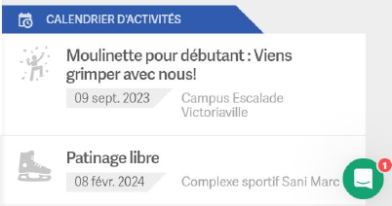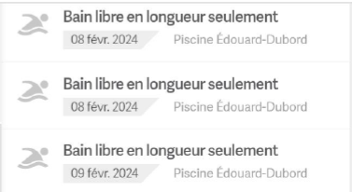
Figure 5: Activity Banner Featured on the Version of the Website Available in March 2024.
Figure 5: Activity Banner Featured on the Version of the Website Available in March 2024

During this first meeting, various communication tools used by the City were discussed. The identified elements were briefly outlined.
Taxibus
- The Taxibus is used by many people with disabilities.
- The primary challenge concerned the requirement to provide specific stop numbers (departure and arrival) during the reservation process.
- This requirement increased the administrative burden on support organizations, which had to maintain lists of these stops, answer member inquiries, and provide information and reassurance.

- The instructional video regarding Taxibus was judged to be too dense; too much information was presented too rapidly. Participants suggested creating shorter, slower, theme-based video clips instead.
Discontinuation of the printed residual materials collection calendar
- The residual materials collection calendar represented a very important reference tool for residents.
- The withdrawal of the printed version triggered a high volume of phone calls and created a sense of insecurity among many residents and persons with disabilities.
- Support organizations perceived that the City had transferred this burden to them; consequently, some organizations were printing paper versions of digital documents and conducting follow-ups with their members.
Review of the Second Meeting
During the second meeting, four individuals were present, representing the following organizations: one from Parrainage civique des Bois-Francs, two representatives from Autisme Centre-du-Québec, and one representative from Association des personnes malentendantes des Bois-Francs. Additionally, one representative from Handicap Action Autonomie was unable to attend in person but requested to provide written responses to the discussion guide.
Below are the key findings from the second meeting held in November 2025:
1) The necessity of multiformat communication

- It was emphasized that the City should not rely solely on the web for messaging; a portion of the population had little to no Internet access or used it only for limited purposes, such as Facebook.
- When the Internet was used, the City’s Facebook page, website, and email communications were identified as the preferred channels.
- Print materials remain widely used by members of organizations serving persons with disabilities.
- Participants noted the importance of including visual aids or audio versions.
- The availability of information via telephone and human support is valued and viewed positively.
2) The key role of community organizations in relaying information.
- Community organizations frequently receive municipal information and redistribute it. While “two-way” exchanges (City ↔ community organizations) are desired, it was observed that communication currently remains largely one-way (from the City to the organizations). Direct, reciprocal links need to be strengthenedsens.
- Organizations would need municipal information earlier, as they often plan their activity calendars several months or even a year in advance. However, the City sometimes releases information only a few weeks before an event, which makes coordination difficult, particularly for organizations providing print versions to their members.

- Organizations expressed a desire for a more formal relationship with the City and for clearer information regarding available support, their rights, and the City’s expectations of them.
3) Message accessibility and readability
- Generally,website interfaces were perceived as too cluttered, featuring too many tabs and too-small hyperlinks, which complicates access to information.
- Municipal information is sometimes difficult to locate. On the website, titles lack clarity and the breadcrumb trail is complex. The site structure places users at risk of “losing” a page and being unable to find it again.
- The mobile app for residual materials collection reminders was judged simple and useful. Awareness initiatives were welcomed; however, it was noted that many persons with disabilities do not own smartphones.
4) Transportation as a major barrier
- Transportation was viewed as a recurring issue that dictates access to services and activities. Individuals living in rural areas are more isolated.
- The ability to reserve transportation by telephone was seen as a positive feature.
- For people with reduced mobility, existing solutions are available (e.g., specialized vehicle rentals), but the process was judged to be complex.

Focus Groups Held at the Beginning and End of the Project with Representatives of People with Intellectual Disabilities

In the first year of the project (November 2023) and at the conclusion of the project (November 2025 and January 2026), we met with a group composed of three individuals with intellectual disabilities. These three participants had been recruited by L’Arche Canada, an organization providing support and services to persons with disabilities. Their selection was primarily based on their interest in communicating about various topics. Generally, the members of this group enjoyed being involved, sharing their opinions, and expressing their points of view.
The three participants worked several days a week in sheltered workshops, which provide adapted internship or employment environments. Their interests and preferred activities were creative (knitting, crafts, textile arts, glasswork, drawing), social or cultural (choir, cinema, dance, parties). They also engaged in physical activities such as walking and bowling.
Both meetings followed a similar structure: The focus group first addressed themes previously defined in a discussion guide, followed by the performance of tasks using a think-aloud method. For example, during one task, participants were asked to find the scheduled times for family swim sessions at the municipal swimming pool.

Review of the First Meeting
All three participants were present at the first meeting. The primary points that emerged are as follows :
1) Diverse information sources for City activities
The participants explained that they sought information regarding activities from varied and often combined sources, including the following:
- A human network: This primarily consisted of L’Arche support staff, assistants, friends, family, and word-of-mouth.
- Print documents: Participants obtained information from programming booklets provided by organizations they frequented, as well as flyers, newspapers, or summary sheets of available activities.
- Digital channels: Although they indicated they did not specifically visit the official city website, they were able to find information on the City of Victoriaville’s site upon request. Their strategies included visiting activity-specific websites directly, using Google to find phone numbers, and searching for online schedules. Information found online was typically jotted down on paper for easier handling and retention.
Participants also shared practical tips, such as keeping business cards from favourite locations for contact details and using information found on-site, such as opening hours posted on doors.
Finally, they noted that at their residence, information, such as activity schedules and transportation times, is posted on a board, which was identified as an excellent method.
2) Use of specialized transit
To participate in activities, participants reported primarily using specialized transit. This represents a planned method of transportation, as trips have to be reserved hours or days in advance.

It also requires that users cancel their trip if an unforeseen conflict arises. Participants discussed the concept of a “voyage blanc” [no-show], which occurs when a person who had reserved transportation fails to appear. In such situations, a penalty is typically applied. Participants explained the costs associated with the service and the various payment methods, such as tickets and monthly passes.
Certain practical challenges emerged: For instance, users need to inform the carrier if they use a wheelchair or a walker, to ensure the vehicle’s capacity matches their specific needs.
3) Barriers to social participation
The participants addressed several obstacles that reduce their ability to participate socially:

- Requirement for accompaniment: accompaniment: Participants noted an obligation to be accompanied when planning and executing certain trips or activities. As reported by the participants, this dependency affects making appointments, trip planning (such as booking transportation), and cancelling transportation. Similarly, one participant mentioned that health issues in recent year have made it a requirement that she be accompaniment during travel. For her, this requirement renders her less autonomous and limits her ability to plan activities, as she has to wait for a staff member at her residence to become available. Participants added that the current shortage of support personnel exacerbates this situation.
- Digital access and website complexity: Participants stated that they find it easier to navigate on a tablet than a smartphone, as the larger screen aids dexterity. Furthermore, tablets are easier to use than computers because operating a mouse is often more difficult.
  - The primary on-screen accessibility problems identified were as follows:
    - Text that is too small or excessively lengthy
    - Location maps that are frequently difficult to read
    - Hyperlinks that are not always easily recognizable
    - Large images and banners at the top of websites that obstruct the view of the desired information
    - Pages that are visually overloaded, particularly with advertisements or distracting elements

    - Websites that do not offer customization options, such as keyboard navigation, visual profiles for people with a visual impairment, or the highlighting of headings and hyperlinks
4) Needs expressed
Throughout the meeting, participants identified several potential areas for improvement:
- Putting essential information first: ensuring the “what,” “when,” “where,” “how to register/reserve” and “cost” are prominently displayed
- Mobile and tablet optimization: ensuring user-friendly versions specifically for mobile devices and tablets
- Customization options: offering features to enlarge text, adjust contrast, and ensure clickable links are easy to identify
- Streamlined visual design: reducing the size of decorative images to create less cluttered pages
- Alternative support: providing a phone number for direct assistance
- Maintaining non-digital channels: preserving print and telephone options for information del.

Review of the Second Meeting
The second meeting was conducted in two stages, as one of the participants encountered an unforeseen conflict on the originally scheduled date. This second meeting served to review specific projects completed by City of Victoriaville staff and to further explore reflections regarding access to public information. The following points outline the primary findings that were added to those already identified during the first meeting.

- Importance of word choice.
Certain terms are difficult to understand. Participants provided the example of the word “canopée” [canopy], which did not refer to anything familiar to them. One participant mentioned that upon hearing the word, she visualized a small canoe. Other participants suggested that references to more familiar concepts, such as “the environment,” should be prioritized. It was also noted that definitions for such terms should be provided immediately following their use.
- Information in video format facilitates understanding.
In addition to logos and images that aided comprehension, participants mentioned that messages conveyed through short videos produced by the City of Victoriaville were easy to understand. These videos featured short clips, which helped maintain attention. The use of music and sound effects was also found to help capture interest.
- Numerical details obscure the message
Participants noted that some videos were still difficult to follow, especially when they included statistics for various scenarios. They cited an example of a video concerning regulations for pool fencing. Multiple distances and regulatory measurements were mentioned, which resulted in very little information being retained.

- Online information searches are often time-consuming and difficult.
Although participants were able to perform keyword searches, they admitted to having difficulty finding information using this strategy.
For assistance, some participants use voice search by dictating their requests. However, voice search can fail if speech is unclear or if keywords are imprecise. This leads to multiple attempts and an overwhelming number of results, making it difficult to select the correct one.
While participants sometimes search directly on platforms like YouTube or the App Store, they acknowledged that they do not always know where to find the information.
To overcome these difficulties, participants rely on mediators: They tell a trusted person what they are looking for, and these individuals assist them with their Internet searches.

- Usability issues with the new Victoriaville website

During testing of the website’s new iteration, several points of friction were identified:
- The landing page banner was very large. Participants struggled to realize they needed to scroll down to access the primary information.
- Several discrepancies were noted within the Activities section:
  - Start and end times were not consistently provided.
  - The distinction between activities requiring registration and those with open access was unclear.
  - Pricing transparency was inconsistent; some activities were marked “free” while others lacked any price indication, even when likely free of charge.
  - Descriptions were often vague, leaving participants uncertain about the actual nature of the activities.
  - Navigation proved difficult on mobile devices. Within the “Quick view” function, the Close button overlapped with the scrolling area. When a window accidentally closed, re-finding the previous information became a time-consuming and difficult process.
  - Activities appeared to be sorted alphabetically rather than chronologically. This complicated the search for popular recurring activities (such as swimming or skating) which appeared at the end of the list. Furthermore, it was extremely difficult for users to filter activities by specific times of the week, such as evenings or weekends.
  - Certain schedules and payment methods remained difficult for participants to interpret.

Focus Group with Members of the Community of Practice – Communication
In December 2025, all participants in the communication CoP meetings were invited to a focus group to share their experiences. The primary findings are outlined below, beginning with positive outcomes followed by identified challenges.
Positive outcomes
- Centring communications on the population
Participants noted that, prior to the project, many communications were designed “between departments” rather than for the intended audience. Over the months, a shift in perspective was observed. The goal shifted from ensuring colleagues understood the message to ensuring the target population understood it. When drafting communications, staff began to ask, “What does the person need to know? What is the essential information?”
- Shift in writing habits
Participation in the CoPs created “reflexes” during the drafting process. Training sessions and monthly meetings led staff to realize that a significant portion of the population lacked the literacy levels required to understand previous communications.

Consequently, employees now intentionally use simpler phrasing and vocabulary, verifying that texts are clear and comprehensible before public release.
- Benefits of interdepartmental peer support
The group’s diversity, comprising members from various departments, and the presence of an external advisor helped identify unclear information. During these meetings, participants would openly state whether or not they understood the content being presented. This allowed for the early detection of ambiguities. This real-time feedback served as a tool for clarification; in other words, peer reviews revealed “invisible” problems that often went unnoticed when working in isolation.
  - Dedicated time within a fast-paced municipal environment
A primary obstacle was the rapid pace of municipal operations and a general lack of time. Participants acknowledged that, without this dedicated time to refine their tools, their on-the-job pace would have made it difficult to prioritize communication projects.
  - Pride in tangible results
Participants expressed pride in the concrete changes observed in municipal communications. They remarked that messages were better understood and that clarifying questions like “What does this mean?” came up less frequently. Furthermore, they noted increased engagement from the public; users began interacting more effectively on social media, even answering or correcting one another, which demonstrated a better grasp of the information provided.

However, these effects remain anecdotal and are not yet formally measured. Participants suggested implementing simple indicators—such as tracking the volume of comments received, the number of clarification requests, or specific website feedback—to better demonstrate the value of their work and maintain momentum.
In the same spirit, the idea of submitting a project for an award was proposed to validate these efforts and strengthen motivation. Examples included the Mérite municipal – Municipalité et développement durable award from the Ministère des Affaires municipales et de l’Habitation, or the Ovation municipale award presented by the Union des municipalités du Québec (UMQ).
Challenges
- Maintaining consistency amid staff turnover and external collaboration
Participants indicated that the rapid pace of municipal operations posed challenges when communication projects involved colleagues who had not received the initial project training. They noted that when pressure to publish increased, plain language goals tended to be sidelined unless they had been integrated from the very beginning of the process.

To address this, participants emphasized the need for a standardized onboarding process to train new staff. Furthermore, to ensure these new practices became uniform across the board, they suggested extending training to community partners and external contractors, such as graphic design teams. This approach would prevent having to start from scratch due to staff turnover or when collaborating externally.
Finally, to better disseminate these new approaches, participants identified several useful resources, such as fact sheets, memos, and quick-reference guides. However, they acknowledged that while these initiatives were helpful, they were not frequently utilized in day-to-day operations.
- Structuring feedback for initial project drafts
Participants noted that feedback from colleagues and the facilitator, while helpful, could also be discouraging. An excessive volume of comments created a sense of being “judged” and led to feelings of demotivation. Over time, some staff reported hesitating to present projects due to a fear of criticism.

Time management within the CoPs was also identified as a concern. Participants recalled instances where lengthy discussions centred on a single word choice, leaving other projects with very brief reviews, which resulted in frustration for some members.
- Re-evaluating workload distribution to better support certain staff member
The production of specific formats, such as video, relied on a very small number of staff members. Participants noted that quality and continuity were too dependent on a single individual to see video projects through to completion. As video becomes an increasingly utilized format, a review of task distribution was recommended to better support the team.
- Ensuring management buy-in
Participants emphasized that the initiative must be championed by department heads and elected officials. Management needs to ensure the approach is fully understood internally to prevent resistance. Without proactive awareness raising, some staff mistakenly believed that plain language represented a dumbing down of information.
- Syncing fast-paced municipal timelines with feedback from people with disabilities

Respondents valued receiving feedback from people with disabilities but found the process often conflicted with rapid municipal timelines. Feedback frequently arrived too late to be integrated into project schedules.
Furthermore, research-related constraints, such as formal ethical requirements, were perceived as limitations.
Finally, mirroring the fear of internal criticism, some participants admitted to avoiding feedback from people with disabilities to circumvent the need for further revisions or improvements to their work.

Focus Group with Members of the Community of Practice – Legal
In December 2025, all participants in the legal CoP meetings were invited to a focus group to share their experiences. The primary findings are outlined below, beginning with positive outcomes facilitated by the project, followed by challenges identified along the way.
Positive Outcomes
      - Jargon awareness and a shift in perspective
Several participants described a concrete learning process that evolved their writing style. A pivotal moment occurred when they realized that certain documents deemed “clear” internally were not understood, even by colleagues. This discrepancy served as a catalyst, reinforcing the idea that clarity is measured by actual comprehension rather than intent. Consequently, the team began to prioritize the public’s perspective, adjusting phrasing to ensure messages were more useful and easier to follow.

The long-term transition in professional practices helped overcome initial discomfort. Peer feedback and guidance, specifically from experts in accessible law, provided the necessary reassurance to support this change. Focus group discussions demonstrated a practical integration of plain language practices. The group reported sustained efforts to explain complex concepts, select common vocabulary, and draft content from the recipient’s point of view.
This approach reflected a shift in perspective: the objective was no longer merely to transmit information, but to ensure it was both understood and actionable. It also led to a more critical evaluation of other communications, such as election-related materials. Participants became more adept at identifying things that could hinder accessibility, such as jargon, formatting limitations, readability issues, and visual choices (e.g., colour contrast).
Participants also noted the development of two distinct writing registers based on the target audience: one for the general public and another for experts. This dual-track approach allowed them to maintain technical precision while ensuring information remained accessible.

    - Strengthening professional confidence and positive impacts
The transition toward clearer communication was experienced as a destabilizing change that initially caused anxiety. Several participants expressed a fear of losing credibility or increasing their professional vulnerability by moving away from archaic, protective formulas traditionally used in legal writing. Over time, this fear diminished, as experience, peer exchanges, and ongoing support bolstered their confidence. The group also described a sense of gradually moving away from overly rigid scripts to develop a more flexible writing style centred on the message’s utility for the public.
Finally, some participants anticipated positive organizational outcomes: clearer correspondence could reduce the volume of phone calls and complaints, thereby simplifying procedures for both the public and municipal teams.
    - Useful tools and standardization
The process was further facilitated by the implementation of concrete tools, which served as benchmarks for applying plain language more consistently. Participants specifically mentioned the creation of templates and boilerplate language, such as standardized phrasing designed to harmonize messaging used by a large number of staff members.

Similarly, the use of revision aids, including Scolarius for evaluating text readability, and checklists of best practices supported improvements in readability and accessibility.
Guides and fact sheets were perceived as particularly useful during the early stages of the process, as they provided clear guidelines and reduced uncertainty when transforming communications.
Challenges
1) Tensions between professional identity, legal certainty, and external recognition
The transition toward clearer communication was experienced as a destabilizing change. Modifying established writing habits, particularly traditional legal vocabulary and style, was described as “confrontational,” as these practices are deeply tied to professional identity and perceived competence. In this context, plain language was sometimes wrongly associated with oversimplification, fuelling fears of “dumbing things down” and causing professional ego-related discomfort.
In addition to identity concerns, there was a notable degree of legal uncertainty. Some participants expressed concern that new phrasings had not yet “passed the test” in a municipal court or before a judge. As long as this validation remained unconfirmed, anxiety persisted, since traditional legal writing is often viewed as a primary means of protection and compliance.

Finally, peer perception acted as another source of tension. Many participants mentioned a fear of being judged if a letter intended for the general public were to be reviewed by a legal expert, such as an external lawyer. This concern reinforced the need to strike a balance between accessibility, precision, and credibility, to ensure that communications are both understandable to the public and defensible in a legal framework.
2) Ensuring cohesive and sustainable organizational implementation
A primary challenge concerned the partial implementation of new practices. Because the change had not been officially deployed across the entire organization, adoption remained uneven across teams. Staff members who had not participated in the CoPs demonstrated a lower understanding of the project’s objectives and editorial choices. This increased the burden on participants to “educate colleagues” and justify the rationale behind communication adjustments.
This situation was linked to a second issue regarding coordination between the two CoPs. Some participants felt there was a lack of integration between the two groups, which, at times, limited information sharing and the consistency of learning outcomes. Furthermore, it was suggested that facilitators and advisors would benefit from a deeper understanding of each department’s specific mandates and constraints to better adapt tools, examples, and workflows to field realities.

Lastly, the sustainability of the initiative appeared strictly tied to political and organizational support. Instances of negative reactions from untrained elected officials showed that, without a clear understanding of the goals, more explicit communications could be perceived as a new source of complaints. Participants concluded that if the momentum did not come “from the top,” the initiative risked losing steam or becoming dependent on specific individuals rather than being embedded in long-term organizational practices.
Consequently, a clear need emerged: to clarify expectations for organizational buy-in and to structure the governance of this change. This includes establishing accountability mechanisms, common benchmarks, and a clear briefing for elected officials regarding the intended benefits, anticipated risks, and the strategic importance of information accessibility as an organizational goal.
3) Time and workload constraints

The time required to produce clearer communications emerged as a significant challenge. Several participants indicated that writing for comprehension demanded more effort than simply following established formulas. This was attributed to the need for careful reframing, structuring information, and selecting simpler vocabulary while maintaining technical precision and departmental requirements. Within this context, exhaustive discussions during the CoP meetings, sometimes focusing on a single term, were perceived as overly demanding, occasionally leading to a loss of perspective regarding the project’s utility.
This workload was frequently added to existing daily responsibilities, which resulted in fatigue and a sense that the initiative was “dragging on.” The need to produce multiple drafts, respond to follow-up or revision requests, and work evenings or weekends due to a lack of time during regular hours was cited as a source of pressure. These factors highlight the importance of scheduling dedicated time, adjusting the project’s pace, and clarifying expectations to sustain buy-in and prevent burnout.
4) Measuring the tangible impact of changes

At this stage, the concrete effects of the initiative have not yet been fully documented. While the group anticipates positive outcomes, such as a decrease in phone calls or complaints, these impacts have not yet been systematically measured.

Focus Group with Managers
In the final months of the project, it was decided to conduct a focus group specifically for managers across various departments. This decision stemmed from the observation that management played a critical role in the success of transitioning professional practices. Consequently, in December 2025, seven managers from different departments within the City of Victoriaville shared their perspectives on the initiative carried out over the previous two years.
The primary findings are outlined below, beginning with positive outcomes facilitated by the project, followed by challenges identified along the way.
Positive Outcomes
1) Mobilization leading to practice transformation
The initiative was supported by a cycle of training sessions and guidance through communities of practice (CoPs), which allowed professional methods to evolve. Although some staff members were initially hesitant, primarily because the training sessions appeared long, many reported being satisfied once they became engaged in the process. Once active in the project, several employees noted that they gained concrete benefits and felt better equipped to produce clearer and more accessible communications.

The initiative also strengthened ties between different sectors. Managers became more familiar with internal resource persons and the expertise available, which facilitated collaboration and the sharing of best practices. Finally, a consensus emerged regarding the importance of validating readability with the target audience. This ensures that, in real-world scenarios, messages are understood as intended and can be adjusted as needed.
2) A shared vision for more accessible communications
The initiative was built on a clear vision: evolving the City’s communications toward a more inclusive approach, driven by several public-facing projects. It responded to a strong commitment to making municipal information easier to understand, particularly for individuals with lower literacy levels. This orientation provided a common purpose for the actions taken and helped teams concretely aim for simpler, more useful, and more accessible messaging.
Over time, the project engaged multiple parties around the shared goal of making communications more inclusive. For several departments, the project also served as a catalyst to better align communications across different sectors, fostering greater consistency in messaging and professional practices. This expanded scope bolstered the City’s capacity to adopt common practices and permanently establish a culture of clarity.

    - Embedding a culture of clarity within the organization
After two-and-a-half years, a new reflex has taken root within the teams: systematically questioning whether the communication produced is truly clear. This habit changed the way messages were conceived from the outset and brought a more consistent focus on the public’s actual comprehension. The process also strengthened the ability to candidly identify limitations, for example, by recognizing that a portion of the population would not understand if the message remained too complex.
Discussions also revealed a shared understanding that a multi-year journey is necessary to permanently anchor these practices. This steady progression over time encouraged ownership, minimized backtracking, and helped solidify common benchmarks. Within this context, several participants reported a sense of increased autonomy and a feeling of having contributed to a project with significant organizational impact, extending well beyond isolated changes.

    - Concrete adjustments to expand impact

Several avenues for improvement emerged to strengthen the initiative and better reflect the diversity of residents’ needs. A key proposal was to expand user validation groups to include, for example, newcomers, seniors, and individuals who are less tech-savvy. This broader inclusion would allow for comprehension testing across varied contexts and would help identify barriers earlier, enabling messaging adjustments prior to distribution.
Adjustments were also proposed to make the process more practical for daily operations. A lighter training model, better adapted to the workflow, was envisioned: an initial four-hour session followed by a one-hour refresher every four to five years. This format is similar to first-aid certification, which requires periodic knowledge updates. Finally, there was significant interest in targeted working groups focused on communications that had not yet been revised. This approach would allow for progress based on priority areas and ensure visible gains across every department.
Challenges
    - Balancing ambition, availability, and workload
The initiative highlighted a major capacity challenge. The workload was particularly high for those involved in the CoPs, which eventually strained the collective momentum. When project contributions are added to regular daily responsibilities, risks increase: energy levels and participation drop, and the CoP can begin to unravel, even if commitment to the cause remains high.
Some initiatives were also underestimated in terms of time and effort. For example, the production of video clips for adaptive equipment illustrated this clearly. While the intent was strong, the sheer scale of the work only became apparent as the project progressed. Without formal planning benchmarks (estimation, sequencing, and resource allocation), pressure accumulates, potentially compromising both quality and continuity.
Finally, the fast pace of operations made it difficult to integrate feedback. Comments often arrived late, after teams had already moved on to other files, reducing the ability to make rapid adjustments. Furthermore, certain foundational content, such as the municipal budget, remained complex, not due to a lack of will, but because transforming such documents requires significant time, iterative reviews, and resources that are not always available in the short term,

    - Securing political buy-in and anticipating reactions
The initiative faced questioning at the political level, particularly regarding certain public notices. These situations demonstrate that a more inclusive communication project does not rely solely on technical or editorial choices; it also progresses at the pace of political buy-in. To move forward, clear support from elected officials is necessary to provide stable guidelines and reduce hesitation when distributing more direct or accessible messaging.

This governance challenge also implies a need for specific upward communication planning. It is useful to provide regular progress reports, explain editorial choices, and validate the project’s direction at key milestones. Without these strategic touchpoints, there is a higher risk of decisions being stalled due to a lack of shared understanding of the objectives and their impacts.
Lastly, improved comprehension naturally leads to a more engaged public that reacts more frequently. While this increased engagement is not a problem in itself, it must be anticipated. This requires preparing supportive messaging, frequently asked questions (FAQs), and a feedback management strategy to sustain dialogue and maintain public trust.
3) Balancing legal rigour and communication clarity
The alignment between legal and communication teams emerged as a point of tension. From a legal perspective, there was an occasional impression that simplification “denatures” content by altering phrasing perceived as necessary to protect the City or meet regulatory requirements. This perception can stall momentum, particularly when texts involve sensitive issues or high-level political communications.
Consequently, it was decided to establish two separate CoPs: one for communication staff and another for employees responsible for drafting legal information. In this context, a significant “letting go” was required from the legal side: accepting that certain details could be expressed differently and that public comprehension should be considered a quality criterion on par with compliance.
Finally, intervening in legal or political texts can impact professional credibility, which can make buy-in more difficult for some participants, particularly lawyers, whose communication styles are highly standardized. This underscores the importance of a clear framework, a respectful approach, and structured dialogue to build lasting trust between experts.
4) Structuring the initiative for sustainability

The long-term sustainability of the initiative is challenged by staff turnover. This makes it difficult to ensure that all teams are trained and up to date, especially when operational priorities shift rapidly. Furthermore, training alone is insufficient; the integration of learning requires practical application, concrete feedback, and ongoing support to transform daily habits.
While CoPs play a key role in fostering ownership, it is unrealistic to include every new employee. This highlights the need for a more structured and sustainable model: the support of a dedicated expert to guide teams, a coordination lead to provide follow-up, and a genuine commitment from division heads to support the application of these practices in every department. Without such a structure, progress risks remaining concentrated within a few teams rather than being adopted city-wide.

Evaluation of Tools by People with Disabilities Group

Throughout the project, a group of people with disabilities was tasked with evaluating inclusive communication projects to ensure that new communications did not introduce new barriers. In total, 15 tools were evaluated.
The first section describes the factors that facilitated or hindered access, along with avenues for improvement for 13 of the evaluated tools.

Registration to Recreational Activities
The visual materials presented for recreational activity registration consisted of a banner and a two-page promotional summary sheet showing the primary activities offered, along with links for information and registration (see Figure 6).
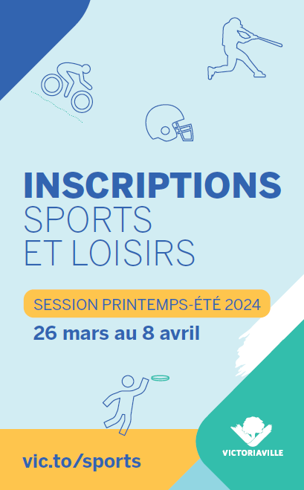
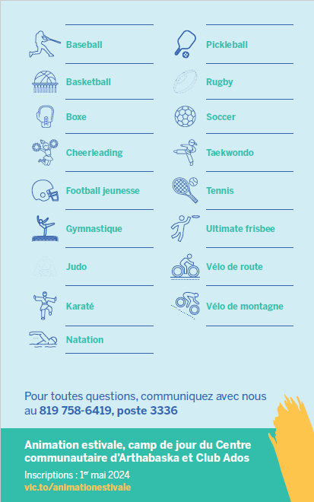
Figure 6 : Two-Page Promotional Summary Sheet
What hepls
The presentation was perceived as clear, with a layout that effectively supported reading. The font size was deemed comfortable, and the text was compatible with a speech synthesis tool.
What Hinders

The registration path was not always obvious; while participants could see the information, they could not easily identify the next steps. When using a speech synthesis tool, the long list became cumbersome to go through. Additionally, certain colour combinations (such as pale yellow on a green background) reduced readability.
Avenues for Improvement
To improve the leisure activity registration process, respondents indicated that it would be important to more prominently feature the primary call to action (e.g., the hyperlink to be used or a clear list of steps to follow). Similarly, lists could be streamlined and better structured. Finally, it was suggested that icons be made more functional (e.g., by making them clickable or associating them with specific information).

Emerald Ash Borer
This communication, presented in poster format, informs the public about the emerald ash borer, an invasive insect that kills ash trees (see Figure 7). It explains why the City must fell certain infested trees, to prevent the spread and mitigate risks. It provides reassurance by stating that removed trees will be replaced, and it directs residents to an information page.
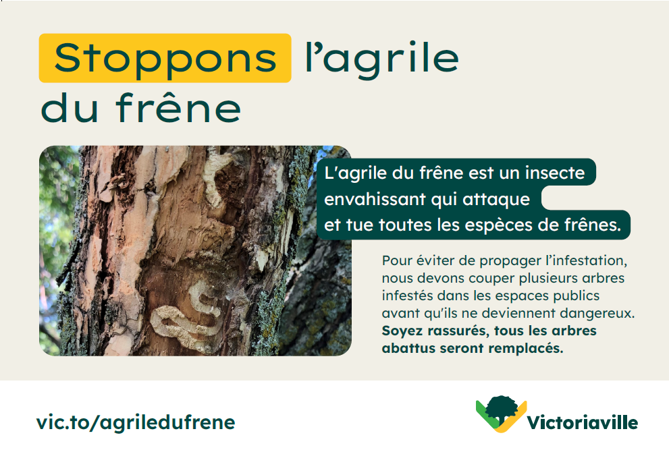
Figure 7 : Emerald Ash Borer Poster
What Helps
The content was judged to be streamlined and well-organized. Participants highlighted the effective title, strong contrasts, and a font size that made for easy reading. Overall, the design was considered visually appealing.
What Hinders
Some participants noted that they would have preferred slightly more information. Additionally, the insect in the image was not sufficiently visible. Finally, the web link was not necessarily understood as such, which could prevent users from accessing supplemental information.
.
Avenues for Improvement

The primary area for improvement would be to make the web link explicitly identifiable, for example by adding the label “Online.” Furthermore, it was suggested that the word “Stoppons” [Stop] be replaced with a more common term like “Arrêtons” to improve clarity.

Residual Materials Collection Calendar – Online and Print Versions
The evaluation focused on the residual materials collection calendar for Sector 1. This resource, available in both print and online formats, presented the month-by-month collection schedule and highlighted the primary instruction: placing bins at the curb the evening before collection (see Figure 8).
The calendar emphasized collection days using colour codes and pictograms (green bin, brown bin, black bin, bulky item collection, leaf bags, and Christmas trees), supported by a legend at the bottom of the page. The design was intended to allow users to quickly identify the correct dates and collection types while directing them to supplemental information sources.

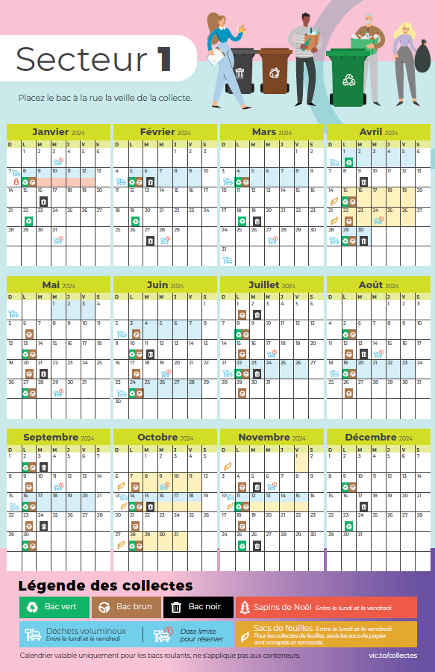
Figure 8 : Residual Materials Collection Calendar
What Helps – Online Version
The format was viewed as practical and straightforward. Colours and contrasts were generally appreciated, and the calendar enabled users to understand the information quickly.
What Helps – Print Version

The document was perceived as well-organized; headings, colour-coded bins, symbols, and legends facilitated navigation. The font size and overall presentation were judged as pleasant and easy to follow. Overall, the vocabulary was found to be simple and understandable.
What Hinders – Online Version
For screen reading, the information was perceived as too dense. Specifically, users of VoiceOver (a speech synthesis tool) noted that the information surplus made the tool difficult to use. Additionally, the legend, dates, and certain zones were sometimes too small and lacked sufficient contrast (e.g., white text on a yellow background), which slowed down reading. Finally, the instruction to “Put bins out the night before” was not sufficiently prominent.
What Hinders – Print Version
Readability decreased when contrast was insufficient, particularly in cells containing special notes. Generally, it was suggested that the overall size of the calendar be increased. This would allow for larger font sizes and more space for handwritten notes. Certain symbols could also be confusing, such as the icons used for “bulky items” and for the collection day itself. Finally, determining which specific collection sector a resident belongs to remained difficult.

Avenues for Improvement – Online Version

The primary recommended change was to reduce the document’s information density and implement shorter headings. Priority elements, such as the instruction to place bins at the curb the night before and the legend should be made more prominent. Additionally, colour contrasts should be heightened.
Avenues for Improvement – Print Version
Contrast should be enhanced in all critical cells. It would also be beneficial to enlarge key zones and provide a larger-format version of the calendar to allow for personal annotations. Finally, the visual logic needs clarification through a consistent and highly visible sign, to clearly distinguish between the symbol shown on collection day and the action required the evening before.

Tree Canopy FAQ
The tree canopy FAQ is a multipage document consisting of 17 questions, with responses ranging from a few lines to half a page in length. Due to the structure of this document, and to avoid unnecessarily inflating the size of this report, the full text is provided in Appendix 2.
What Helps

Some participants found the document to be cluttered, making the primary message difficult to identify. It was noted that information was repeated across several questions, while other pertinent details, such as the required spacing between trees, were missing. Furthermore, participants suggested that imperial units (feet) should be included alongside metric measurements (metres). Certain sentences were too long, and specific terms difficult to understand (e.g., “redevance” [fee], “cotisation” [contribution], and “canopée” [canopy]). Additionally, the document did not function as well with speech synthesis tools like VoiceOver.
What Hinders
Some participants found the document to be cluttered, making the primary message difficult to identify. It was noted that information was repeated across several questions, while other pertinent details, such as the required spacing between trees, were missing. Furthermore, participants suggested that imperial units (feet) should be included alongside metric measurements (metres). Certain sentences were too long, and specific terms difficult to understand (e.g., “redevance” [fee], “cotisation” [contribution], and “canopée” [canopy]). Additionally, the document did not function as well with speech synthesis tools like VoiceOver.
Avenues for Improvement
Respondents noted that it would be helpful to define specific terms at the outset and include a concrete example to facilitate understanding. Similarly, the content should be streamlined and broken down into themes, with a highly visible summary at the beginning that outlines key takeaways or required actions. Finally, where possible, it would be better to offer an alternative format, such as a continuous text organized by theme, and to add consistent visual cues to support reading.

Fire Safety Door Hanger
The door hanger regarding smoke alarms is a double-sided document designed to raise public awareness about the proper use of smoke alarms (see Figure 9). A QR code links to a dedicated page on the City of Victoriaville’s website, where residents can watch an educational video and complete a self-inspection checklist. This communication is intended to be placed on the doors of city residents.
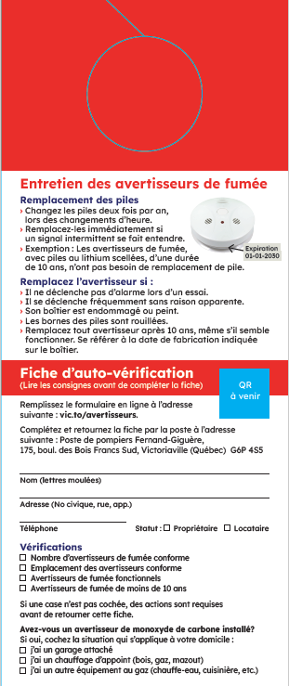
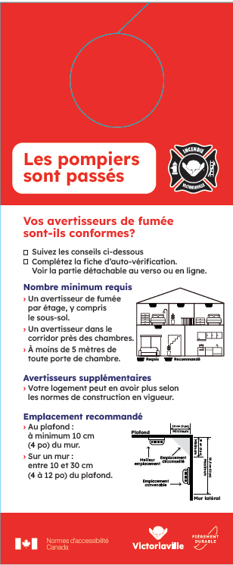
Figure 9 : The Fire Department Door Hanger
What Helps
The format was highly appreciated: The document was uncluttered, the contrast was strong, the font size was appropriate, and the headings provided clear guidance. The primary message was easy to locate, and the images effectively supported comprehension.
What Hinders

Certain elements, particularly numbers, were more difficult to navigate using speech synthesis tools like VoiceOver. The QR code lacked clarity, as its destination was not specified. Some participants noted they would tend to discard the door hanger, as it closely resembled a commercial advertisement.
Avenues for Improvement
Since PDF documents can be difficult to read with speech synthesis tools like VoiceOver, if a digital version is hosted on the City’s website, it should be provided in accessible HTML or as a tagged PDF. Additionally, a shortened URL should be added alongside the QR code, with a clear instruction such as “Watch the video.” Finally, the door hanger’s appearance should be honed to avoid it being confused with an advertisement and to ensure it is clearly identified as an official message from the City.

Emergency Kit Door Hanger
The door hanger regarding emergency kits is a double-sided document designed to encourage residents to be prepared to remain at home for 72 hours in the event of a disaster (see Figure 10). A QR code links to a dedicated page on the City of Victoriaville’s website, where residents can sign up for official city alerts. This communication is intended to be placed on the doors of city residents.
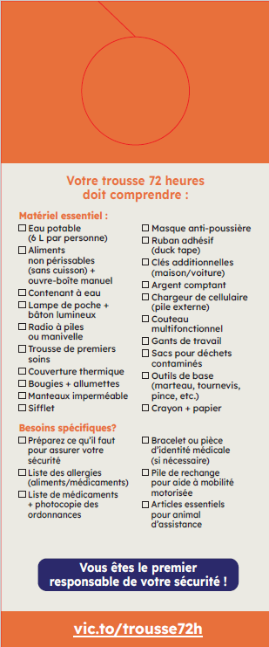
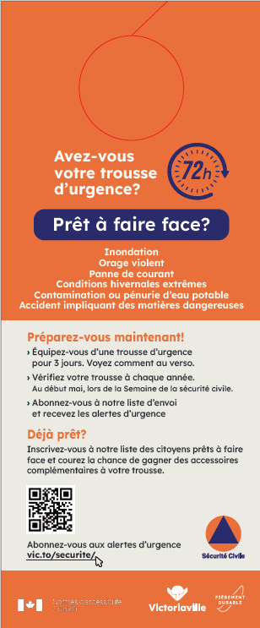

Figure 10: Door Hanger: Do You Have an Emergency Kit?

What Helps
The format was frequently judged as attractive and readable, noting the effective use of colour, subheadings, and a clear organizational structure. The checklist was appreciated when well-presented with consistent visual cues. Additionally, the inclusion of a contest was considered a good attention grabber.
What Hinders

Colour contrast was not always sufficient. For instance, the “72-hour” timeframe, despite being essential information, did not stand out effectively due to colour choices. The list of items to procure could appear overwhelming, and some participants questioned whether all items had to be stored in the same location. Certain vocabulary terms seemed vague (e.g., “matières dangereuses” [hazardous materials] or “sac pour déchets contaminés” [contaminated waste bag]”). Furthermore, some individuals expressed uncertainty regarding how emergency alerts would be delivered (e.g., via email or text) and how to confirm whether they were registered.
Finally, the QR code caused confusion; some participants assumed it linked to the contest rather than the emergency alert sign-up page. Others emphasized that not everyone is able to use a QR code, specifically individuals with fine motor challenges or those without smartphones.
Avenues for Improvement
Colour contrast for priority elements should be heightened, and the checklist should be broken down into shorter sections, such as “Essentials,” “Add-ons,” and “For your situation.” It would also be important to provide guidance on how to organize the kit, for example, using a bin, where to store it, and a suggested routine for periodic inspections.
An alternative to the QR code should be offered, such as a short URL, a phone number, or a direct web address.

Four Videos on Vegetation
These four videos were produced to promote understanding of upcoming environmental protection measures (see Figure 11). Each video is approximately 30 seconds long and addresses a specific topic: the benefits of trees, heat islands, Victoriaville’s vegetation cover targets, and the 3-30-300 rule. This rule advocates for having 3 trees visible from one’s window, 30% canopy cover in the neighbourhood, and access to a green space within 300 metres. The videos include sign language interpretation, and scripts are available upon request. The videos are available on the City of Victoriaville website.
What Helps
The short 30-second format and the pacing were well-received; participants noted that the videos were easy to re-watch and reduced the cognitive effort required for reading. The imagery and overall organization were deemed clear.

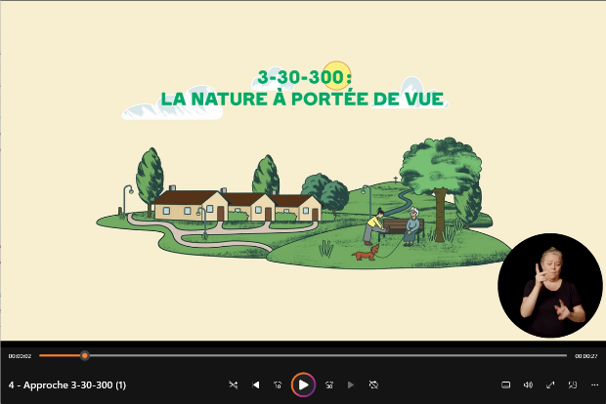
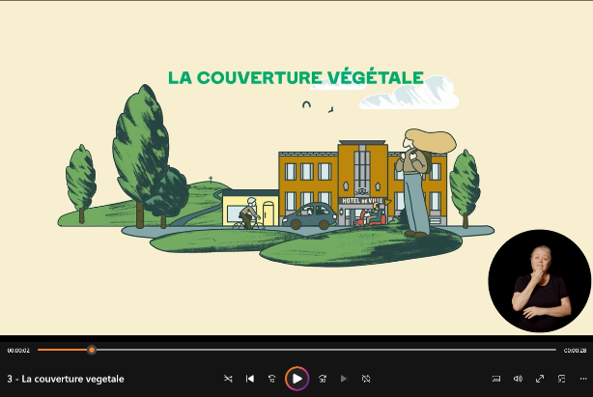
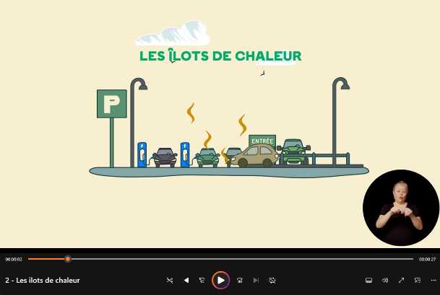
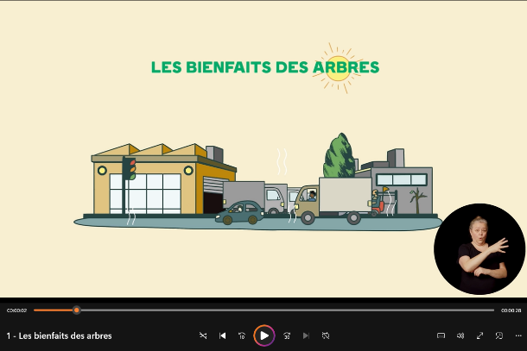
Figure 11 : Four Videos on Vegetation
What Hinders
Certain accessibility features conflicted with one another: the sign language interpretation window (Picture-in-Picture) could be obscured by the video interface; and subtitles, which were not always enabled by default, could overlap with critical visual information. Additionally, some participants found the background music intrusive.
Avenues for Improvement
Screen elements should be positioned to prevent any overlap between the sign language interpreter, subtitles, and key information. When possible, subtitles should be enabled by default; otherwise, a simple instruction should clearly indicate how to activate them. Finally, background music should be used sparingly.

Video on Pool Safety
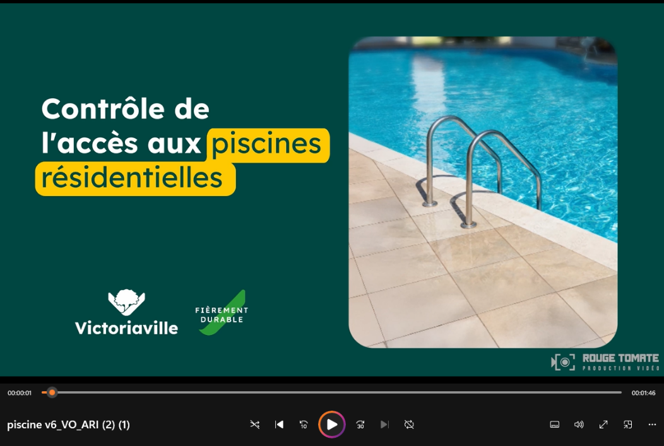
The video concerning pool safety is 1 minute and 45 seconds long (see Figure 12). It addresses the application of regulations following the implementation of mandatory pool fencing requirements. The script is available upon request, and the video can be accessed on the City of Victoriaville’s website.
Figure 12 : Video on Residential Pool Access Control

What Helps
The video was judged to be clear with a good delivery pace. Within the script, the use of bold text and a clear structure facilitated navigation, making the document highly readable overall. Speech synthesis tools like VoiceOver worked well when processing the script.
What Hinders

Certain images were difficult to interpret. Furthermore, the use of exclusively metric measurements (metres and centimetres) complicated comprehension for some participants. Within the script, illustrations did not consistently include text descriptions.
Avenues for Improvement
It would be beneficial to add a short description under each illustration in the script and to prioritize the use of simpler, more intuitive imagery. Measurements should be displayed in both metres and feet.

Video on the Tree Canopy
The video on the tree canopy explains how to estimate the canopy fee when a property owner cuts down a tree on their land (see Figure 13). The video is approximately 2 minutes
long, and the script is available upon request. The video can be accessed on the City of Victoriaville’s website
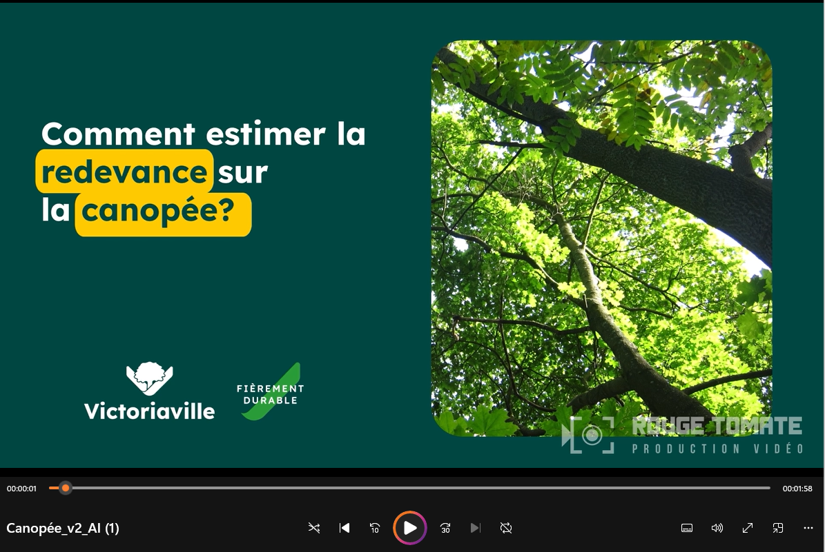
Figure 13 : Video on How to Estimate the Tree Canopy Fee
What Helps
The video format, pacing, and tone effectively sustained viewer attention. Visual cues and subtitles, when properly positioned, facilitated comprehension without requiring significant reading effort.
What Hinders
The concept of “canopy” can remain unclear if the definition is not provided immediately or if it relies on complex phrasing. The inclusion of formulas or
calculations made the video less accessible, particularly when the visuals did not support the mathematical steps. Furthermore, subtitles occasionally obscured important on-screen elements.
Avenues for Improvement
The concept of “canopy” can remain unclear if the definition is not provided immediately or if it relies on complex phrasing. The inclusion of formulas or calculations made the video less accessible, particularly when the visuals did not support the mathematical steps. Furthermore, subtitles occasionally obscured important on-screen elements.

Minute Victo – Using Water Wisely!
The video clip Using Water Wisely! is a short, vertical-format video designed for social media (see Figure 14). It is 1 minute and 10 seconds (1:10) in length. Using a humorous style, it reminds residents of the primary regulations on potable water use: watering schedules based on even and odd addresses, filling pools at night, using automatic shut-off nozzles, and the prohibition of hosing down asphalt driveways. The video includes a full verbatim transcript.
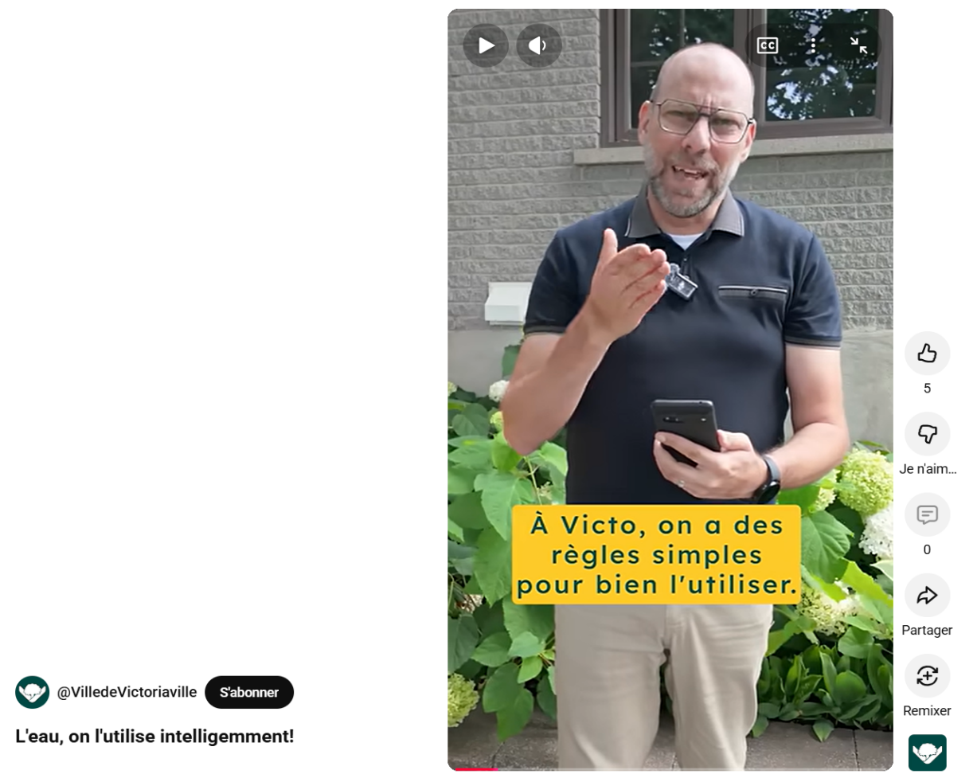
Figure 14 : Video on Using Water Wisely
What Helps
The lighthearted tone and delivery pace supported comprehension. Subtitles, when legible, provided a valuable secondary entry point for understanding the information.
What Hinders
The concept of “even” and “odd” addresses can be difficult to grasp if not accompanied by a concrete example, or if a person must rely solely on memory to apply the logic. Auto-generated subtitles occasionally obscured on-screen information.
Avenues for Improvement
It would be useful to illustrate the “even” and “odd” concept with a very simple visual example, such as a calendar. It would also be pertinent to include “Do” and “Don’t” visual cues that remain understandable even without sound. Finally, a dedicated safe zone should be reserved for subtitles to ensure they do not mask critical on-screen information.

Minute Victo – Dogs
The video clip Walking Your Dog in Victo is a short, vertical-format video designed for social media (see Figure 15). It is 55 seconds in length. Using a humorous style, it reminds residents of the primary regulations regarding dogs: the use of a leash or harness, maximum leash length, permitted walking areas, and the requirement to pick up pet waste. The video includes a full verbatim transcript.
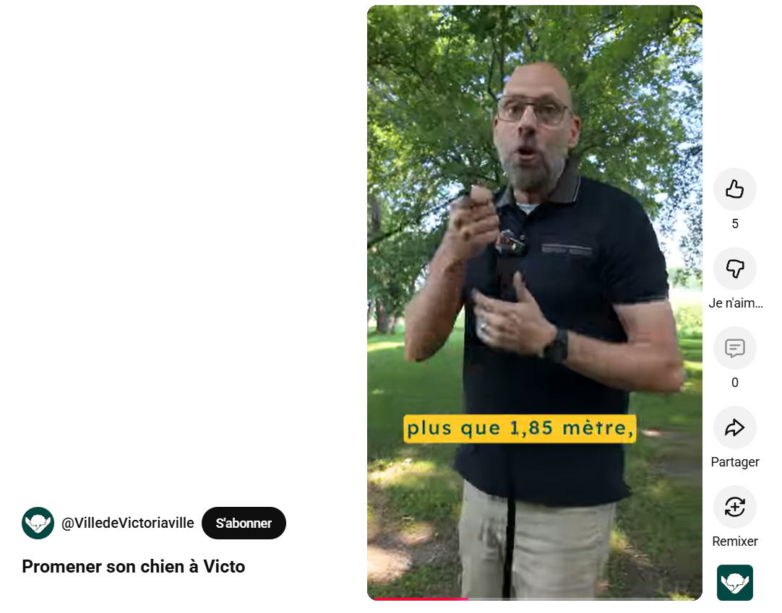
Figure 15 : Video on Walking Your dog
What Helps
The short format and imagery made the information quick to understand. Subtitles were helpful in instances where the audio was difficult to hear or follow.
What Hinders
The examples only showed a single type of situation, and some individuals felt excluded from the content due to lack of representation (e.g., persons with reduced mobility). As with the other videos, subtitle placement could obscure certain images.
Avenues for Improvement

It would be useful to vary the scenes to represent diverse situations, such as including as a person using a wheelchair. It would also be pertinent to add simple visual cues—such as pictograms, gestures, or clear indicators—to highlight what is acceptable and what is not. Finally, participants emphasized the importance of testing subtitle display to avoid any overlap with critical on-screen elements.

Traces Urbaines Trail
Traces Urbaines is an interactive heritage trail that allows visitors to discover the cultural history of Victoriaville, such as the railway station; the furniture, textile, and metallurgical industries; and prominent local figures. The circuit consists of 37 stops located throughout downtown Victoriaville. The evaluation of this tool was conducted in two phases: First, the communications officer associated with the research initiative performed an on-site accessibility assessment; subsequently, the people with disabilities group evaluated the readability of six specific interpretive panels.
Findings from the On-Site Accessibility Assessment by the Communications Officer
As a general rule, the accessibility of downtown Victoriaville for manual wheelchairs, power wheelchairs, and motorized mobility aids (MMAs) was facilitated by low sidewalks with sloped curbs. The sidewalk width allowed users to back up for an overview of the panels or to position themselves directly in front of them without obstructing the path.

Among the positive findings, it was noted that certain panels (Figure 16) were installed on preexisting city structures at the eye level of a person in a wheelchair and at a right angle, which facilitated reading.
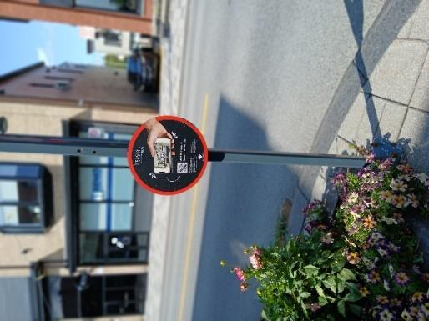
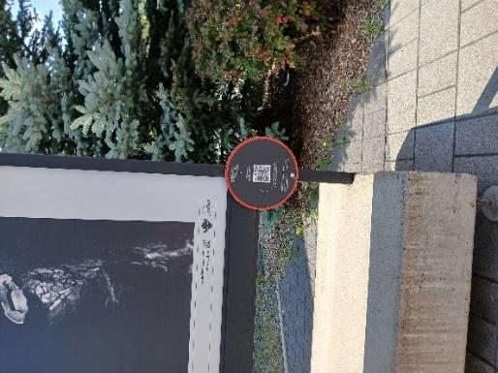
Figure 16: Panels on Preexisting Structures at Eye Level and at a Right Angle
The “Femmes d’avant-garde d’ici” [local pioneering women] panels along Passage Boudreau (Figure 17) were at an accessible height, and there was sufficient space in front of all panels to back up and take in the entire display
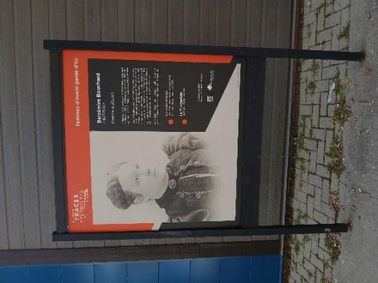

Figure 17 : Panel at an Accessible Height
Most panels contained instructions for using the QR code (see Figure 18), and use of the QR code was found to be highly intuitive. While some panels lacked these instructions due to space constraints, they could have been easily integrated into the “Femmes d’avant-garde d’ici” series.
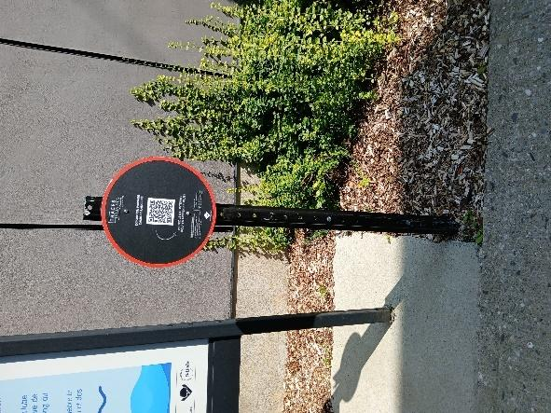
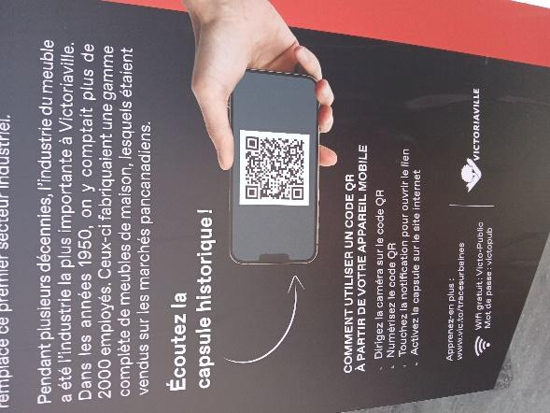

Figure 18: Presence of QR Code Instructions

The photographs below illustrate several accessibility challenges related to the Traces Urbaines trail.

Panel Angles
A significant number of the Traces Urbaines panels were angled, as shown in Figure 19. While these panels were roughly at eye level for a person in a manual wheelchair, the upward tilt prevented users from comfortably viewing the content or scanning the QR code. To do so, the individual had to lean forward to the very edge of their seat. A person using a power wheelchair might be able to view it if their seat height was sufficient.
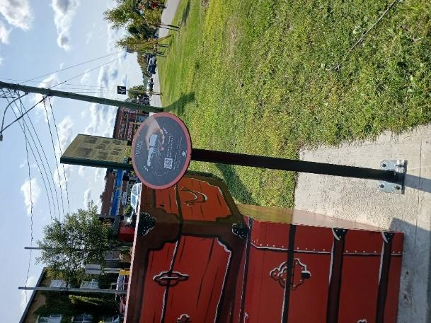

Figure 19 : Angled Panels That Are Difficult to Acces

Distance Between Panels and the Sidewalk

Several panels were positioned too far from the sidewalk, separated by a grass strip or a curb that blocked access for manual or power wheelchair users. In the following two examples (Figure 20), it was impossible for individuals using these mobility aids to scan the panel’s QR code.
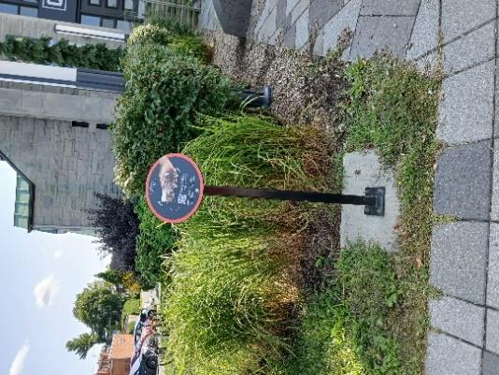
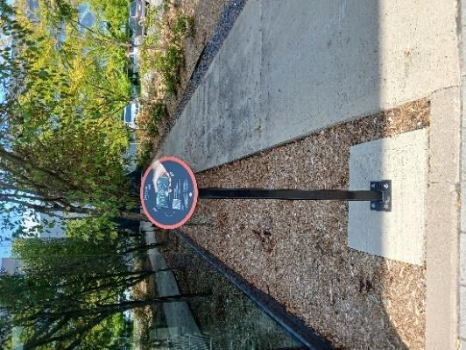

Figure 20 : Panels Located Too Far from the Sidewalk
Other panels were slightly elevated relative to the sidewalk. In the two cases shown below (Figure 21), the change in grade prevented users from approaching the panel, making the angled display even less readable for those in manual or power wheelchairs.

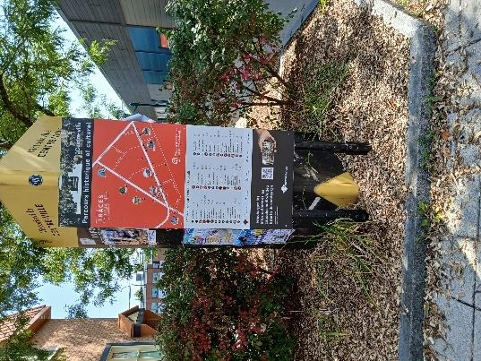
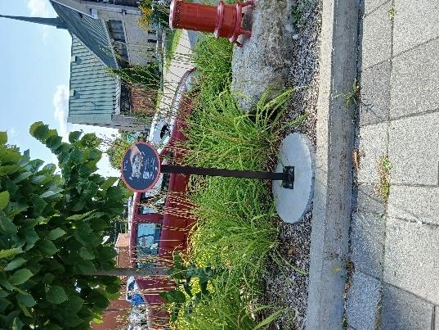
Figure 21: Panels Elevated Above Sidewalk Level

Panel Height
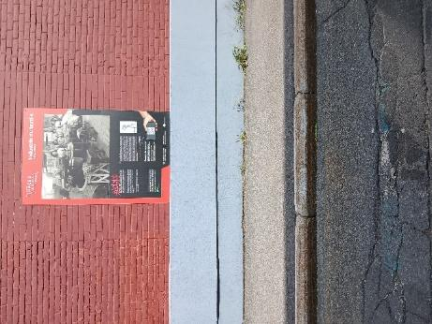
In the case of the following panel (Figure 22), one had to back up to get an overview due to its height; however, the sidewalk was not wide enough to allow for this. Consequently, a person in a manual or power wheelchair could not read the panel title or view the entire image.
Figure 22 : Panel Placed Too High

For the panel shown in Figure 23, the height made it difficult to read the text at the top. While backing up provided a full view of the panel, the user was then too far away to read the text beneath the title due to the small, fine font.

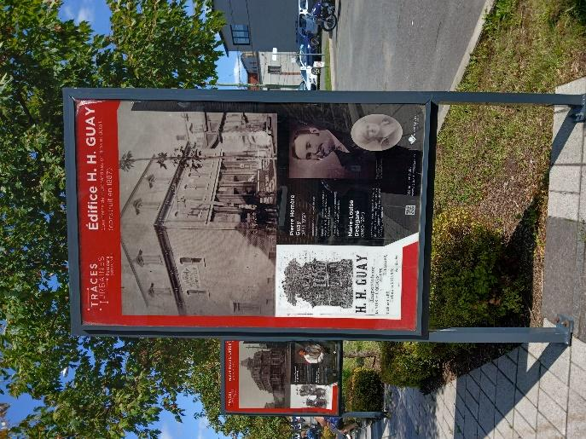
Figure 23: Font Size Too Small
Other Barriers to Accessibility
In the case of this specific panel (Figure 24), a picnic table restricted the space required to turn and face the display or to back up for a full view. On the other side of the table, a bench obstructed all movement for manual or power wheelchairs.
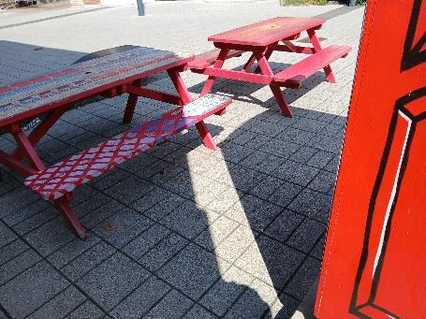
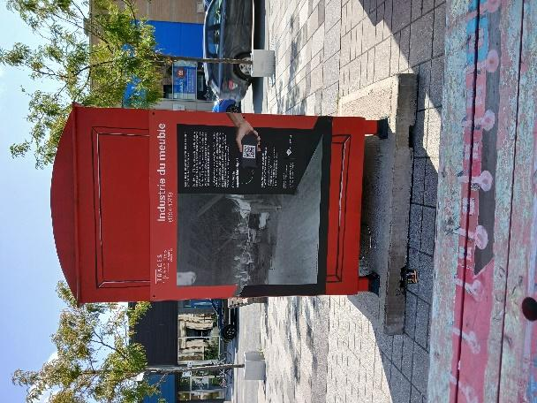

Figure 24 : Picnic Table Blocking Access
No other obstacles were observed for the remaining panels. It should be noted that the circuit was not tested using a power wheelchair; therefore, additional obstacles may exist.
Lack of Wi-Fi Access
The signal strength of the City’s public Wi-Fi network was very weak in certain areas, particularly on Rue de la Gare and along the bike path bordering Rue de Bigarré. For panels where the QR code links to a video, the use of cellular data is recommended. While it was possible to access all videos via the City’s Wi-Fi network, it sometimes required up to three attempts, and there was some wait time for the videos to load.

Evaluation of the Six Pages Associated with the Panels
Given the numerous physical accessibility barriers identified for persons with reduced mobility, six web pages associated with specific stops were selected, to reflect the variety of the trail, and were evaluated by the people with disabilities group.
The Trail Homepage
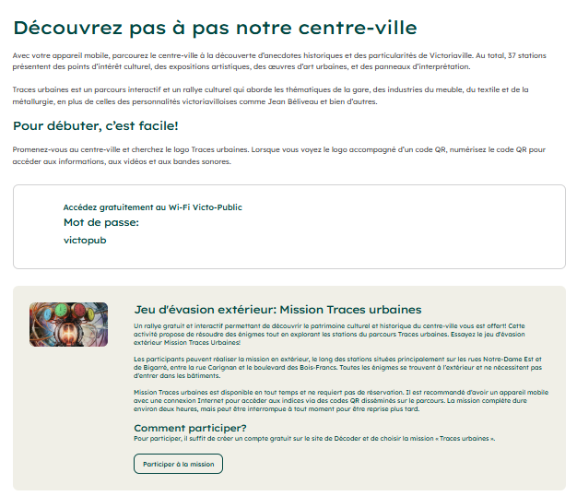
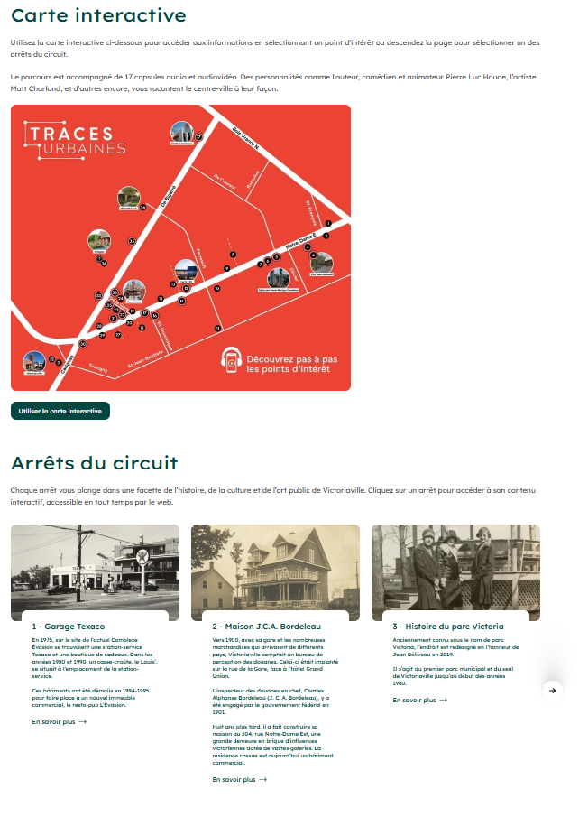
The homepage (Figure 25) consists of a brief introductory text presenting the activity, an explanation of the escape game concept and an interactive map showing the locations of the various stations. The page concludes with a carousel featuring all 37 stops.

Figure 25. Homepage of the Traces Urbaines Interactive Tour

Stop 1 – Texaco Garage
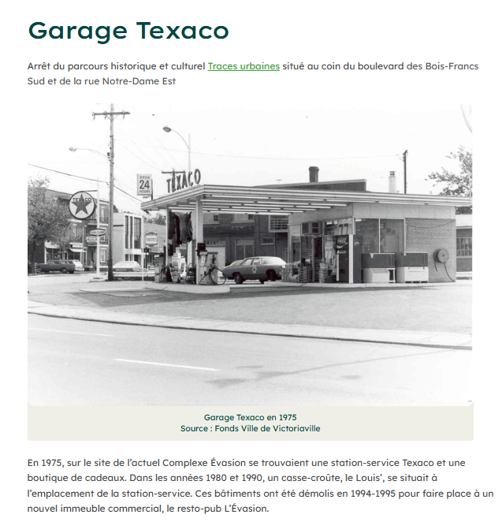
This first stop (Figure 26) falls under the “commercial” category. It features five photographs and 170 words of text.
Figure 26 : Image of Stop 1 - The Texaco Garage

Stop 4A – Parc Jean-Béliveau
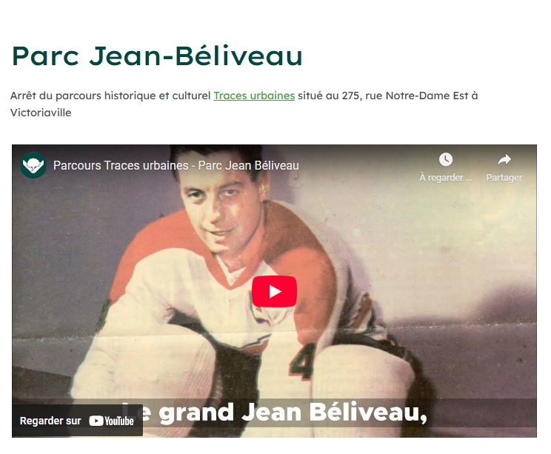
This panel, categorized under famous figures, presents information on the well-known hockey player Jean Béliveau. The associated web page features a video (Figure 27) lasting 1 minute and 38 seconds and four archival photographs. The text consists of 396 words and includes three hyperlinks providing access to additional archival photos, a link to the Canadian Encyclopedia entry on Jean Béliveau, and a broken link meant to lead to some general hockey archives.
Figure 27: Video Image from Stop 4A - Jean Béliveau

Stop 17 – The Syndicat Store
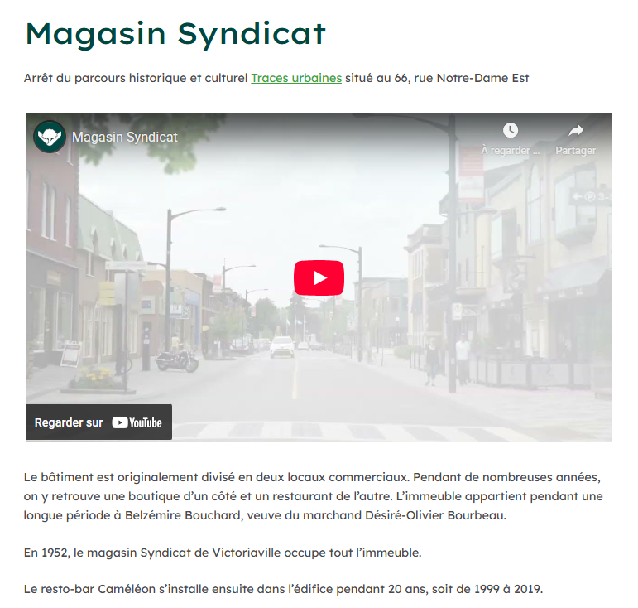
This 17th stop, which also focuses on a significant local business, features a 24-second video (Figure 28), five archival photographs, and 195 words of text.
Figure 28: Video Image from Stop 17 – The Syndicat Store
Stop 27 – The L’enVolée Artwork (Passage Desjardins)
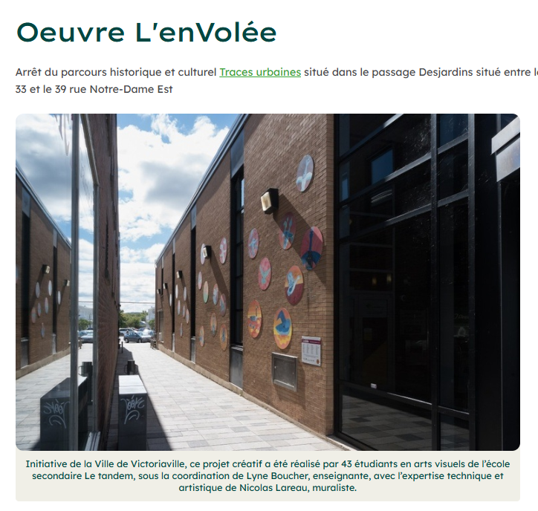
The 27th stop focuses on an artistic work created by the duo Lyne Boucher and Nicolas Lareau (see Figure 29). This page contains six photographs accompanied by 83 words of text. It also features two hyperlinks: the first provides access to Lareau’s portfolio, and the second links to a newspaper article concerning the artists.
Figure 29: Image of Stop 27 – The L’enVolée Artwork
Stop 30 – The Roundabout
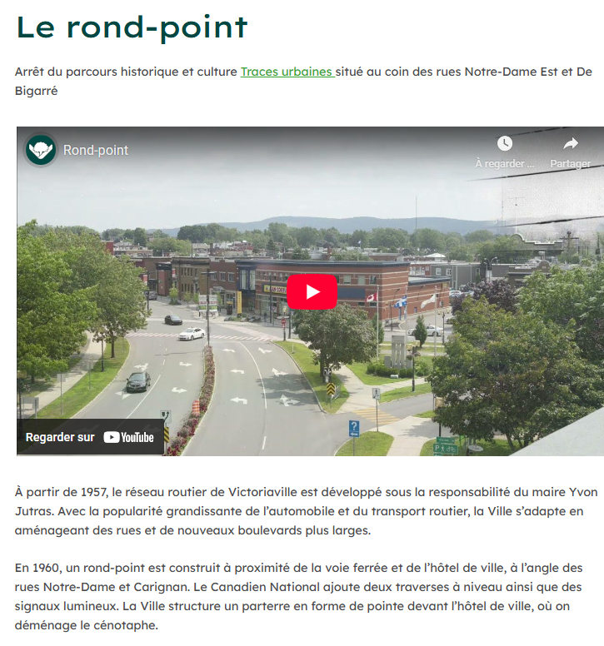
The 30th stop falls under the landmarks category and is dedicated to Victoriaville’s roundabout. This page includes a 23-second video (Figure 30), six archival photographs, and 186 words of text interspersed throughout.
Figure 30: Image of Stop 30 – The Roundabout

Global Evaluation of the Six Assessed Pages

The following evaluation aspects cover an overall assessment of the content in the six associated web pages.
What Helps
The inclusion of a video immediately upon arriving on the page was highly beneficial. In general, the texts were judged to be sufficiently short and easy to follow. Both the alternating image/text layout and the homepage carousel were well-received.
What Hinders
Captions embedded directly into images were not detected by speech synthesis tools such as VoiceOver. The interactive map did not assist all users, as some individuals preferred a step-by-step itinerary. Finally, the high volume of links was found to complicate and clutter the navigation experience.
Avenues for Improvement
Captions and image descriptions should be provided as text rather than being embedded directly within the image files. It would also be beneficial to limit the number of links at each stop, retaining only the most relevant ones. Finally, it is important to offer a simpler “step-by-step” mode that is fully compatible with screen readers.

Evaluation of Web Accessibility Tools for Site Personalization
The evaluation of web accessibility tools was conducted in several stages: selecting a pictogram and its placement; analyzing pictogram choices and positioning on other websites; analyzing the features offered by the City of Victoriaville’s tool; comparing the features of four different accessibility tools; and finally, performing a quantitative evaluation of the web accessibility tool’s usage at the City of Victoriaville.
Selection of the Pictogram and its Placement
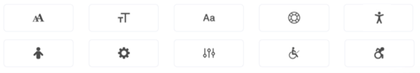
First, the people with disabilities group provided feedback on which pictogram to use from the following options (see Figure 31), as well as where it should be positioned on the page (top or bottom, left or right).
Figure 31: Pictogram Options Provided by the Vendor

Several participants found the logos to be poorly representative of accessibility. For many of the logos (the gear, the letters, and the circle), participants stated that without an explanation, they would not have guessed they represented accessibility. The use of a wheelchair symbol was often judged as too restrictive or not representative of the full spectrum of disabilities. Among the pictograms, a stylized silhouette of a person with open arms was perceived as more meaningful by some participants. Others
preferred the “active” wheelchair logo (showing a person in motion), noting it more effectively evoked the idea of accessibility, even while admitting the meaning remained vague without a clear label.

Regarding the tool’s placement, one participant noted that it had initially been placed at the bottom of the page before being moved after a few weeks to the top-left, near the start of the page. This position was judged to be superior because it is identified more quickly when speech synthesis is activated. Indeed, a screen reader scans the page from the beginning, generally following a top-to-bottom reading order (often starting at the top-left). Placing the tool at the top of the page therefore allows users to reach it faster without having to get through all the content. Other participants confirmed that the top-left placement was a good choice, as it facilitates access immediately upon arriving on the site.
Choice and Placement of Pictograms by Other Organizations and Cities
In the second phase, to guide the decision on which pictogram to use, we verified the icons used in 72 pages cited by the vendor accessiBe (the tool currently used by the City of Victoriaville). These primarily consisted of major international corporations (e.g., Cadillac, Roxy, Ladurée, O’Neill). To complement this analysis, we reviewed the websites of all Quebec cities with a population of over 25,000, adding 11 examples to the list. Finally, over the following weeks, any site encountered that utilized an accessibility tool was added, contributing another 18 sites. In total, we evaluated the pictogram choice and placement of 99 websites.

The results showed that 18.18% of the sites (n = 18) featured a logo at the top of the page. Another 68.69% (n = 68) displayed it at the bottom of the page, and 13.13% (n = 13) placed it in the middle of the page. Additionally, approximately one sixth of the sites (n = 14; 14.14%) integrated the logo into a toolbar located at either the top or bottom of the page.
Pictograms were primarily placed on the right (n = 62; 62.63%), though approximately one third of the sites positioned them on the left (n = 36; 36.36%). Recall that a left-side placement was said to be more practical for individuals with visual impairments who use screen readers, as scanning generally follows the page’s reading order from top to bottom. Finally, one site placed its logo in the centre of the page.
Concerning the choice of pictogram, the stylized silhouette of a person with open arms was by far the most widely used (n = 75; 75.76%). Among other pictograms, the use of letters in increasing sizes was also frequent (n = 9; 9.09%). The wheelchair symbol (n = 5; 5.05%) and a half-black, half-white circle (n = 5; 5.05%) were also used occasionally. Other choices remained marginally used
Analysis of the Features Offered by the Web Accessibility Tool Used by the City of Victoriaville

When members of the people with disabilities group discussed the features offered by the accessibility tool used by the City of Victoriaville, they noted that identifying and understanding the tool was not intuitive for everyone. One participant with a visual impairment indicated that the tool was easy to activate and that certain profiles (specifically the blind user profile) could be useful, particularly for individuals with low vision. However, she highlighted that some of features tested, such as magnification, did not provide her with any significant benefits, suggesting that the effectiveness of these tools varies with individual needs.
Finally, several participants identified the most useful features, notably highlighting links (to make them easier to locate) and increasing the font size. One participant observed that while the prompt to open the user guide was in French, the subsequent description was in English. This inconsistency made the tool less practical and could discourage some users from using it
Comparison of Features of Four Accessibility Tools
Having observed that the tool selected by the City of Victoriaville (accessiBe) was not intuitive to use, we selected four web accessibility tools and asked the participants from the people with disabilities group to compare their usability. All four tools were accessed via a pictogram featuring the stylized silhouette of a person with open arms.
Participants were asked to compare the tool used by the City of Victoriaville, which includes a wide range of functionalities (see Figure 32).

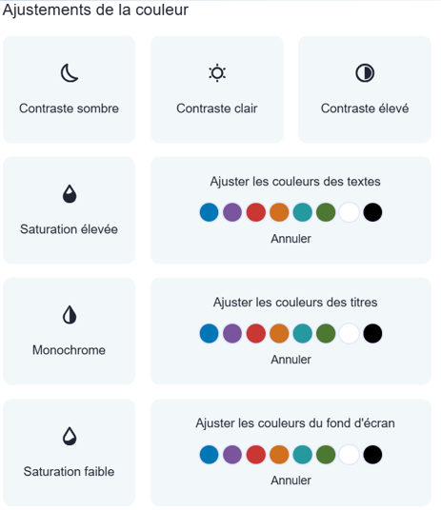
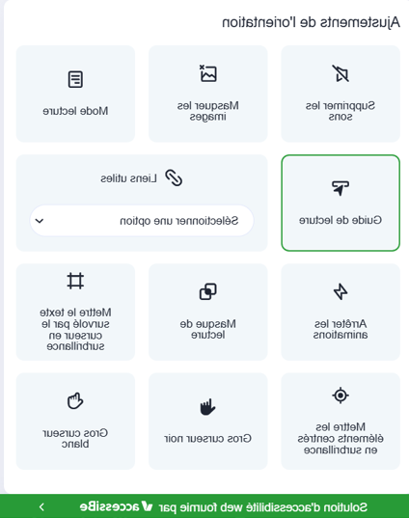
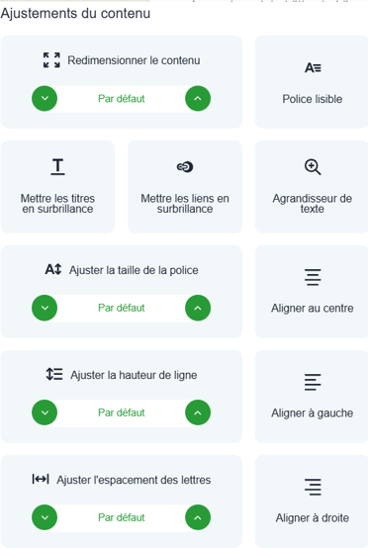
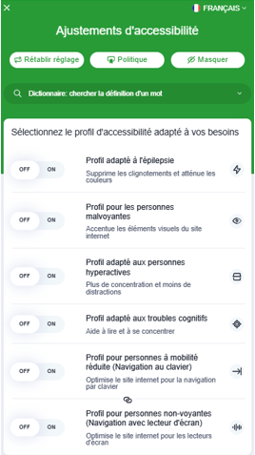

Figure 32: Full Set of Features Offered by accessiBe, the City of Victoriaville’s Accessibility Tool

The tool used by the Eczema Society of Canada consists of a toolbar with a limited number of features (Figure 33).

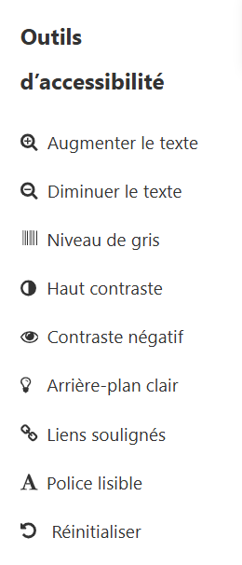

Figure 33: Accessibility Tool Used by Eczema Society of Canada

The UserWay tool, for its part, includes approximately a dozen features (see Figure 34).

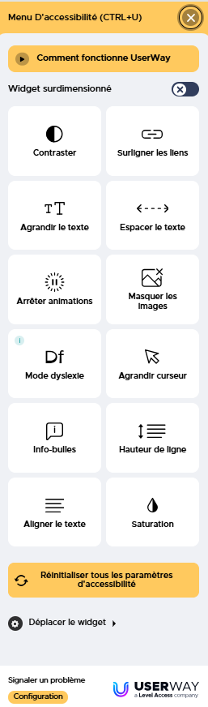

Figure 34 : UserWay Accessibility Tool

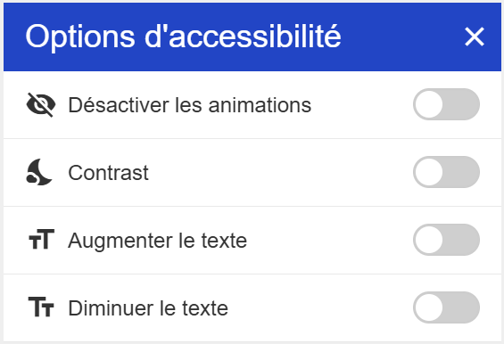
The tool on the website of Quebec’s group for the visually impaired, the Regroupement des aveugles et amblyopes du Québec (RAAQ), shown in Figure 35, allows users to disable animations and adjust the contrast and text size
Figure 35: Accessibility Tool Offered by the RAAQ

The feedback collected covered general observations applicable to all four tools.
What Helps
In general, when the accessibility button was visible, positioned at the top of the page, and accompanied by a label such as “Accessibility,” it was much easier to locate. Features such as dark mode and text enlargement were well-received when they were simple to activate.

What Hinders

On tablets, certain menus occupied too much screen space and obscured the page content. An excessive number of options could lead to confusion. Furthermore, text enlargement occasionally caused display issues, specifically the overlapping of letters.
Avenues for Improvement
Priority should be given to a button that is highly visible and accompanied by a clear label, offering a concise and stable interface. It is also essential to test text enlargement across various digital platforms (computers, tablets, and smartphones) to prevent text overlap. Finally, it would be preferable to offer fewer options, focusing instead on those that are the most functional and reliable.

Descriptive Quantitative Evaluation of Accessibility Tool Usage at the City of Victoriaville
A web accessibility tool was integrated into the City of Victoriaville’s website from April 2024 to September 2025. This integration allowed for the generation of 17 reports provided by the vendor, accessiBe. In these reports, “remediations” are recorded each time the accessibility tool is used on the City’s website. These remediation requests are grouped into categories such as navigation, contrasts, links, and more.
Quantitatively, the first four reports (April to July 2024) indicated zero remediations. Following discussions with the vendor, it appeared that this was due to a technical issue. Starting in August 2024, the number of remediations was calculated, showing 2,936 remediations (1,748 occurrences across 15 categories). The following report, from September 19, 2024, showed an increase to 5,545 remediations (3,395 occurrences across 15 categories).

As of October 2024, the format of the provided reports was modified to display occurrences without specifying the total number of remediations. In other words, while it is known that a user accessed the tool, it is no longer clear whether they modified one, two, or several navigation parameters. Consequently, for the period from October 2024 to September 2025, each report contained between 621 and 3,757 correction entries, with a median value of 2,574 remediations per month.
The categories with the highest number of remediation requests pertained to navigation and hyperlinks (clarifying the labelling of menus and links), the identification of headings to better structure information, and keyboard navigation.

Summary of the Evaluation of the Tools:
Several recurring themes emerged from the participant feedback:
  - Visual presentation was identified as a frequent challenge. Reading can be made difficult by issues such as poor contrast; small font sizes; and specific colour combinations, notably pale yellow or white text on a yellow background.

  - Compatibility with speech synthesis tools like VoiceOver encountered difficulties when information density was too high or lists were excessively long. Furthermore, certain PDFs proved difficult to navigate, and text embedded directly into images remained inaccessible to these tools.
  - The primary message and the hierarchy of information should be more prominent. Even when content was deemed clear, some participants struggled to identify calls to action (e.g., how to register) or to distinguish essential information from secondary details (e.g., in content regarding the canopy).
  - Participants noted a need for clear definitions and concrete examples for technical or abstract terms, such as “redevance” (fee), “cotisation” (contribution), “volumineux” (bulky items), and “matières dangereuses” (hazardous materials). Clarification was also required for making the distinction between odd and even. Regarding measurements, it is preferable to provide both metric (metres and centimetres) and imperial (feet and inches) units.
  - While QR codes and hyperlinks were often useful, they must always be accompanied by an explanation, i.e., to indicate their destination and provide short URLs. Additionally, an alternative to QR codes should be offered for users with mobility constraints or incompatible devices.
  - Short-form videos were appreciated, though close attention must be paid to accessibility and user control. Specifically, the placement of closed captioning sometimes overlapped with sign language interpretation

Individual Interviews with the Participant Group of People with Disabilities

At the conclusion of the process, each participant was contacted to share their feedback regarding their experience.
The feedback collected from the group was overwhelmingly positive. Overall, participants reported that they enjoyed their experience within the validation group. Several noted that the assigned tasks were straightforward and accessible, and that the level of difficulty was appropriate. The pace of meetings and evaluations was judged as reasonable, allowing each individual the necessary time to look at the materials, understand the content, and formulate their comments.
Participants highlighted several specific features that aided accessibility. Accessing documents on the tablet was described as easy, and the general workflow (entering a code, locating the project tab, and consulting the content) was well understood. Some participants also appreciated being informed in advance and being able to schedule appointments through reminders and the proposed organizational structure. One individual even indicated that they found using the tablet simpler than using a phone, reinforcing the value of offering tools adapted to specific habits and needs.
Beyond the technical aspects, several comments showed that the process was experienced as respectful and empowering. Participants thanked the team for taking the time to conduct this study and for taking their contributions seriously. The human connection appeared to play a significant role: The guidance provided was described as supportive and characterized by a patient and attentive attitude when questions were asked or when information needed to be repeated. This welcoming environment contributed to a climate of trust, which encouraged participation.

Finally, the group suggested several avenues for improvement. Some participants expressed a desire for the experience to last longer or for there to be more content to evaluate. Others proposed working in small groups, either remotely or in person, to encourage discussion. A concern was also raised regarding the diversity of lived experiences; one participant wondered if their perspective could accurately represent all individuals living with disabilities different from their own.
These comments confirm the importance of maintaining a diversity of profiles and continuing this type of validation with target populations to strengthen content accessibility and the relevance of the proposed solutions.

Examples of Other Projects Developed

A significant number of inclusive communication initiatives were launched throughout the research project. Within the CoP focused on communications, 43 projects were worked on, while the legal CoP addressed 26 projects. Furthermore, in the fall of 2025, administrative assistants expressed an interest in reviewing public-facing communications, resulting in an additional 16 projects. In total, 85 projects received direct feedback from the CoP facilitators.
In addition to these, approximately 30 supplemental projects were developed. While these did not go through the formal feedback process, they were nevertheless inspired by the project’s inclusive communication principles.
The 115 identified projects spanned a variety of formats. A large portion (n = 44) consisted of video content. Another significant group (n = 27) focused on standardizing letters and emails sent to the public, as well as forms and public notices. Several projects (n = 10) involved door hangers or fact sheets. The remaining 34 projects covered a broad range of materials, including web pages, internal memos, surveys, and PowerPoint presentations.
Given the sheer volume of projects developed, it is not possible to detail each one in this report. Instead, we have selected four examples to illustrate how these communications evolved through iterative adjustments: a letter from an inspector, a poster, a door hanger, and a public notice. For each, we provide the original version alongside the improved version, highlighting the key features that enhanced clarity. These four examples are also featured in the guide on improving communication practices, Communiquez mieux avec votre population : Démarche pour améliorer vos pratiques de communication.

Example 1: Urban Planning Department Letter – Sent via Email
Standard Letter Version 1  Dear Madam/Sir:  This email follows up on the verification of the standard permit application for [description of work] for the property located at [property address]. We inform you that the request as filed is incomplete and does not allow us to verify the project’s compliance with current regulations.  Pursuant to Article [# of article to be inserted] of the by-law respecting permits and certificates, No. 1264-2019, the following documents must be provided with your permit application:  - [document 1]  - [document 2]  Additionally, further documents or information may be requested following the analysis of these documents.  As soon as you provide us with the necessary plans and documents, we will continue the review of your building permit application.  Thank you for your cooperation. Best regards, | Standard Letter: Final Version  Subject: City of Victoriaville: ACTION REQUIRED – Incomplete Permit Application  Hello,  Thank you for submitting your permit application for your [type of work] project.  We need additional information or documents to start analyzing your application.  We will process your permit application once we have received the following:  - [document 1]  - [document 2]  You must provide these by [DATE] by replying to this email.  For assistance or further information, please contact our team:  - By email at permis@victoriaville.ca; or  - By phone at 819 758-XXXX, est. XXXX  Best regards,  Inspector’signature
Figure 36: Original and Final Versions of an Urban Planning Department Letter

Key Improvements in the Final Version
  - Explicit subject line added: “Incomplete Permit Application,” and specified that action is required.
  - Used “Hello” instead of “Dear Madam/Sir.” This should be used when the gender of the person you are communicating with is unknown.
  - Used “we” and “you” instead of a neutral, bureaucratic tone to address the individual directly.
  - Included the specific inspector’s signature for a more personal touch.
  - Used familiar words and maintained consistent terminology. For example, “application” is used throughout instead of alternating between “application” and “request.”
  - Omitted by-law and article numbers, as they are not essential to the individual’s immediate task.
  - Listed actionable information:
  - Provided a specific deadline and clear instructions on how to submit missing documents;
  - Included precise contact information for help or follow-up questions with the Urban Planning Department.
  - Generous use of white space.
  - Used unjustified, left-aligned text.
  - Used active rather than passive sentence structures.
  - Bolded text to highlight critical information.
  - Chose a sans-serif typeface, which is generally easier to read in short texts.
In both versions, bulleted lists were used to clearly present the required documents, allowing the recipient to quickly identify these documents.

Example 2: Poster on the Emerald Ash Borer
Poster Text: Version 1 (Pre-Image Integration)  Offensive Against the Emerald Ash Borer  The emerald ash borer is an invasive insect that attacks and kills all species of ash trees.  To prevent the spread of the infestation, we must fell several ash trees.  To compensate for the cutting, several trees have been planted, and planting will continue.  To learn more, visit: vic.to/agriledufrene. | Final Poster Text and Imagery:  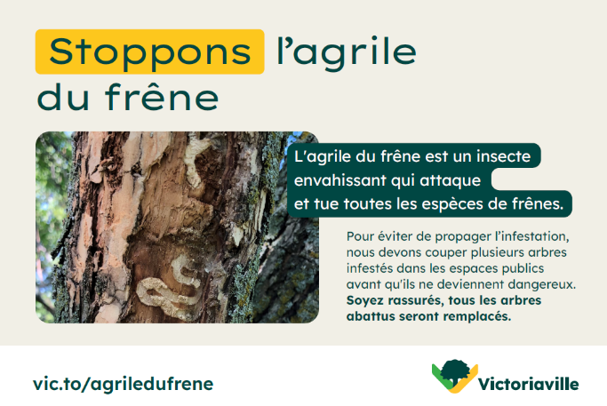
Figure 37: The Final Version Integrates a Clear Photo of an Infested Tree Alongside Simplified Text

Key Improvements in the Final Version
  - Simplified messaging:
Changed “Offensive Against the Emerald Ash Borer” to “Stop the Emerald Ash Borer,” which is more direct and engaging.
In the second sentence, replaced “In order to” (Afin de) with the simpler “To” (Pour), which is more direct and easier to process.
Used “Stop the insect from spreading” rather than “prevent the spread.” Using a verb is more direct.
Used “cut down” instead of the technical forestry term “fell.” “Cut down” is much more common in everyday language.
  - Placed the text acting as a caption close to the image it describes.
  - Linked the image directly to the caption text, visually demonstrating the damage caused by the emerald ash borer.
  - Added a supportive message addressed directly to the public: “Rest assured, all trees that are cut down will be replaced.”

Example 3: Door Hanger on Water Usage
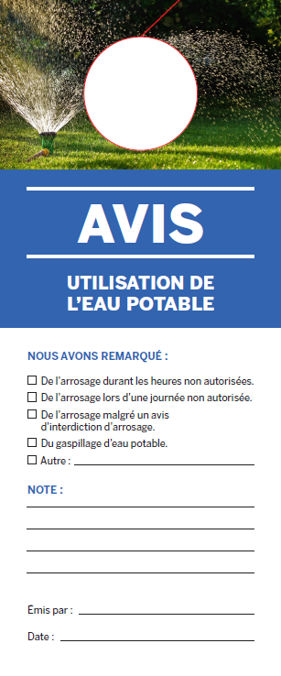 | 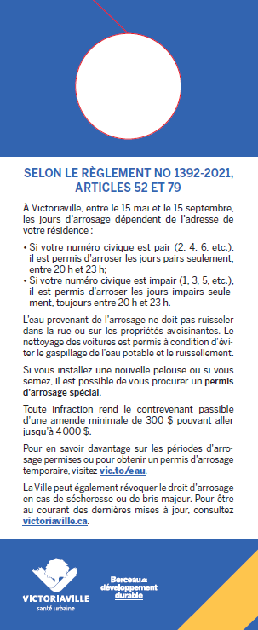
Figure 38: Front and Back Views of the Original Version of the Door Hanger
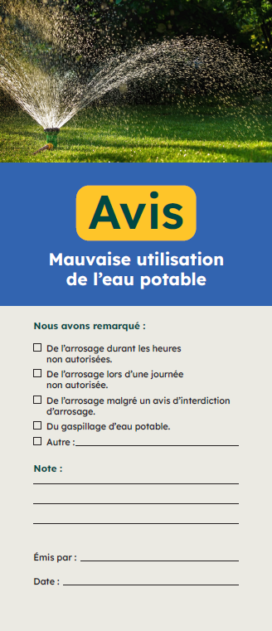 | 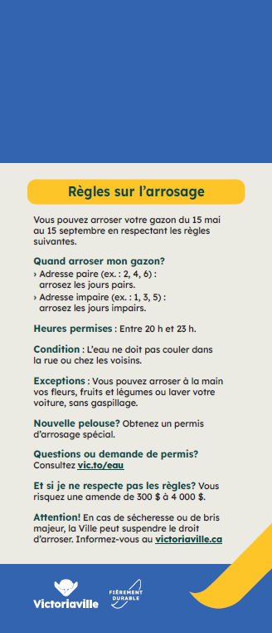
Figure 39: Front and Back Views of the Final Version of the Door
Key Improvements in the Final Version

  - Clear title: “Unauthorized Use of Drinking Water.”
  - By-law and article numbers were removed as they are non-essential for this type of notice. Instead, the back is titled “Watering Rules.” This heading and content is much more relevant to the residents receiving the notice.
  - Content is organized using subheadings to indicate the type of information presented. This allows recipients to scan the notice quickly and find the specific details they need.
  - Explicit subheadings are short, descriptive, and emphasized in bold.
  - Unjustified, left-aligned text is used.
In both versions, most of the message uses a direct “you” tone to engage the reader: First version: “If you install a new lawn...” Final version: “You may water by hand...

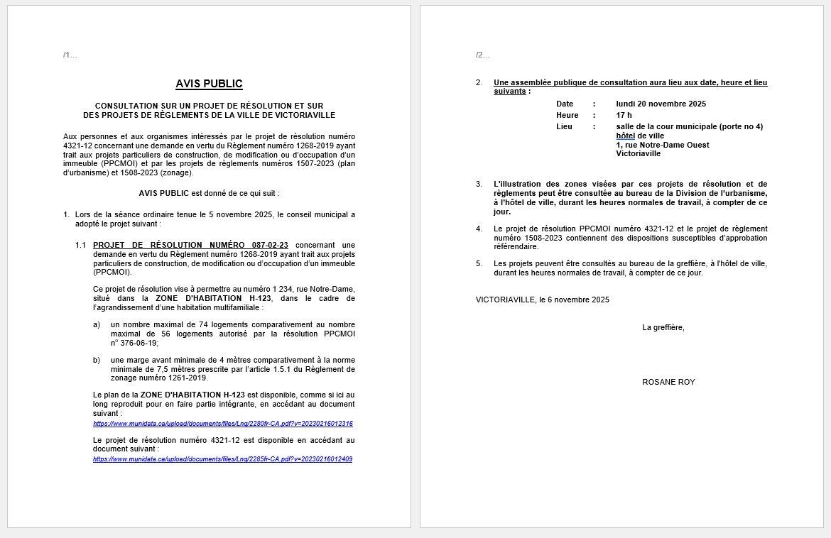
Exemple 4: Public Notice
Figure 40: Original Version of the Public Notice

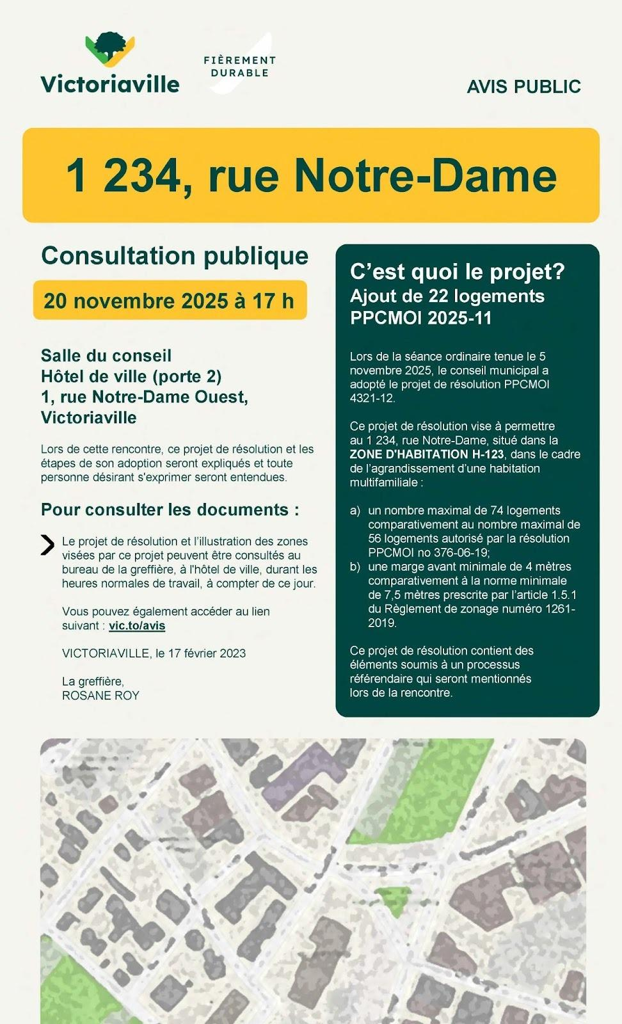
Figure 41: Final Version of the Public Notice
Key Improvements in the Final Version

  - The specific project under public consultation and its address are clearly highlighted at the very beginning (answering the question: “What is the project?”).
  - The project description uses clearer, more accessible language.
  - An illustration of the affected neighbourhood and the specific property.
  - The date, time, and location of the consultation are prominently displayed.
  - The notice provides only the information the public needs to understand the notice.
  - The redesigned notice is shorter, condensed from two pages down to one.
  - Adding columns and colour makes it more visually appealing.
  - Unjustified, left-aligned text is used.


Summary and Interpretation of Results
The summary and interpretation of this action research project highlight the essential conditions for ensuring that public information is truly accessible to people with disabilities and the population as a whole.
The following key takeaways were drawn from the Victoriaville pilot project:
  - Training insights are best acquired through practice.
The training sessions conducted at the start of the project sought to engage all City staff, which fostered strong project buy-in. Subsequently, meetings within the CoPs helped integrate this knowledge, leading to a profound shift in municipal communications toward becoming more accessible, understandable, and usable. Over time, employees developed new writing and proofreading reflexes to clarify their messaging. They moved away from communication designed interdepartmentally in favour of an approach centred on the public’s actual needs. Furthermore, simplifying communications involving legal aspects remains complex; it is best to validate these modifications with subject matter experts.

  - Access requires multiple formats.
The digital shift has led to an overabundance of text-based information. To foster more accessible communication, simplifying written text is not enough. It is necessary to leverage various formats, such as videos, posters, or providing a phone number for a contact person to answer questions.
Print versions should also remain available. They continue to be an essential resource for a significant portion of the population that has not adopted digital platforms.
For videos, short formats (30 seconds to 2 minutes) are highly valued, as they require less reading. However, care must be taken to ensure that subtitles do not obstruct sign language interpretation or other critical visual information.

  - Some substantial barriers appear to be recurring obstacles concrets semblent récurrents.
During the evaluation of these communications, several elements frequently resurfaced.
  - Visual presentation requires careful monitoring. Specific aspects such as colour contrast and font size are recurring issues.

  - Some communications are incompatible with speech synthesis tools. Information is often still too dense or features long lists, inaccessible PDFs, or text embedded within images.

  - The expected action must be clarified. For some individuals, exactly what needs to be done remains unclear.
  - Abstract vocabulary should be avoided. Certain words should be accompanied by a short definition or a concrete example.
  - Hyperlinks must be shown clearly and consistently so the public can quickly identify where to click and understand, at first glance, what will open.
  - QR codes are not accessible to everyone. While intuitive for some, they must always be accompanied by an explanation and an alternative (such as a short link or a phone number).
  - For changes to last, support from managers, elected officials, and community organizations is essential. New hires must also be trained.
To ensure that the adoption of these practices does not lose momentum, the support of elected officials and managers is crucial. Similarly, community organizations play an indispensable role as intermediaries: they identify information, simplify it, and redistribute it to people with disabilities. Finally, staff turnover makes it necessary to integrate accessibility into the onboarding of new team members and to also train external partners, such as subcontractors.

5) Mediators play a key role in access to public information.
The project results show that the accessibility of communications does not depend solely on the quality of the tools produced. Even when information is written simply and clearly, many people with disabilities still require support to understand, interpret, or use it in their daily lives. Thus, mediators play an essential role in relaying information. These mediators may be staff members, community sector workers, relatives, or other trusted individuals. They help bridge the gap between public information and the actual needs of the population. Their presence makes it possible to explain specific content, contextualize information, and support the uptake of messages. Recognizing and supporting this mediation role thus emerges as a significant lever for promoting more equitable access to public information.

Findings for Implementing Change in Other Settings

This report identifies five key findings to keep in mind when promoting organizational change.
  - Ongoing support fosters a shift in professional mindset and new writing habits.
The approach, which combines training with support through a CoP, gradually made teams more comfortable and capable of producing clearer, more accessible communications.
After two or three years, a new professional reflex has taken hold: before drafting, staff now pause to consider what the public truly needs to know, what information is essential, and whether the message will be understood as intended. This shift moved communications away from a protection-based logic toward a person-centred approach. Over time, clarity became a standard work criterion rather than an added task. However, one must remain vigilant regarding the pressure generated by a structured process like a CoP. Group discussions and the questioning of established practices can create tension or discomfort for participants. The goal is to improve communications, not to judge those who design them; a supportive environment is essential.

    - For change to occur, managers must allow dedicated time for learning and integrating best practices.
While designing inclusive information is becoming more embedded in professional habits, it generally requires more time (to rephrase, structure, simplify vocabulary, and ensure consistency). This can lead to fatigue and pressure if no time is allocated in the schedule. Ideally, different departments should have opportunities for discussion, to facilitate collaboration, understand each other’s challenges, and share best practices.
3) Practices become more consistent through the use of templates and tools.
The project supported the creation and use of templates, checklists, and readability tools (e.g., Scolarius) to standardize practices. Generative AI tools were also used to assist in drafting based on initial outlines. Using standardized tools reduces improvisation between and within departments.
4) Validation with the target audience is essential.

There is a clear consensus that the ease of finding, understanding, and using information must be validated with the people concerned to confirm actual comprehension and adjust as needed. However, this process requires fine-tuning to synchronize the municipal pace with that of people with disabilities. Reducing intermediaries by organizing face-to-face meetings between the staff drafting the communication and community members is a path worth exploring. For example, the City could create a registry of citizens with diverse profiles who are prepared to validate information accessibility.
  - The digital shift must maintain a multi-channel strategy, including community organizations.
A tension remains between the digital shift, with its “paperless” appeal, and accessibility. A multi-channel strategy (digital, but also print, posters, social and local media, with added audio or sign language options) is essential.
Specifically for people with disabilities, community organizations play a vital role in relaying information. However, this information must be accessible to them and transmitted in a timely manner. By fostering effective two-way communication between the City and community organizations, the latter can better fulfill their role as intermediaries for their members.

Conclusion
This action research project, which combined training with ongoing support through CoPs, demonstrates that making public information truly accessible is a long-term process.
Through these CoPs, teams developed new professional reflexes: clarifying the message, focusing on the essentials, and adopting the public’s perspective. The results also serve as a reminder that simplifying written text is not enough. Access to information requires a multichannel approach (print, web, signage, audio, video) and constant attention to recurring barriers, such as information layout, content selection, speech synthesis compatibility, the clarity of hyperlinks and expected actions, and the definition of technical vocabulary.
The next step is to sustain these gains so they become an organizational standard. This report identifies several key conditions: clear support from management and elected officials, accessibility training and support integrated into the onboarding process, and a recognized role for community organizations acting as intermediaries. To ensure continuity, it is also necessary to allocate dedicated time, utilize verification checklists, and more systematically validate materials with the target audience. Finally, a multichannel strategy that does not entirely phase out print remains essential to ensure the digital shift does not exclude segments of the population.

References

Académie de la transformation numérique (ATN). (2024). Portrait numérique des foyers québécois. https://transformation-numerique.ulaval.ca/enquetes-et-mesures/netendances/portrait-numerique-des-foyers-quebecois-2024/
Agency for Healthcare Research and Quality. (2023). AHRQ Health Literacy Universal Precautions Toolkit, (3 ^{rd} ed.). https://www.ahrq.gov/sites/default/files/wysiwyg/health-literacy/3rd-edition-toolkit/health-literacy-toolkit-third-edition.pdf
Gouvernement du Canada (2025). Guide de rédaction du contenu du site Canada.ca. https://conception.canada.ca/guide-redaction/
Grenon, M.M., Ruel, J., Fougeyrollas, P., Normand, C.L., Moreau, A.C., Romero-Torres, A. et Gravel, S. (2021). Conceptualizing access to and understanding of information. Universal Access in the Information Society, 22(1), 83-94. https://doi.org/10.1007/s10209-021-00836-w
Langlois, P. (2023). La littératie au Québec : un regard local sur les enjeux. Estimation d’un indice de littératie par MRC (2023) Estimation par MRC à partir des résultats du PEICA. https://fondationalphabetisation.org/wp-content/uploads/2023/01/FPAL36_Etude-litteratie-au-Quebec_20230118-2.pdf
Accessible Canada Act, S.C. 2019, C. 10. https://laws-lois.justice.gc.ca/fra/loisAnnuelles/2019_10/page-1.html
Accessibility Standards Canada. CAN-ASC-3.1:2025 Plain language. https://accessibilite.canada.ca/elaboration-normes-accessibilite/can-asc-312025-langage-clair
OCDE. (2024). Do adults have the skills they need to thrive in a changing world: Survey of adult skills 2023. OECD Skills Studies. https://doi.org/10.1787/e8d52c02-fr
OCDE. (2013). OECD Skills outlook 2013: First results from the survey of adult skills. OECD Skills Outlook. https://doi.org/10.1787/9789264204096-fr
United Nations. (2006). Convention on the rights of persons with disabilities and optional protocol. https://www.un.org/disabilities/documents/convention/convoptprot-f.pdf
Ruel, J., Allaire, C., Moreau, A.C., Kassi B., Brumagne, A., Delample, A., Grisard, C. et Pinto da Silva, F. (2018). Communiquer pour tous. Guide pour une information accessible. http://w3.uqo.ca/communiquerpourtous
Ruel, J., Moreau, A.C., Kassi, B., Prud’homme, M. (2016). Éléments clés, enjeux et retombées d’une démarche de rédaction inclusive réalisée avec des adultes ayant de très faibles compétences en littératie. Language and Litteratie, 18(2), 113-131.
Ruel, J., Romero-Torres, A., Grenon, M.M., Fougeyrollas, P., Moreau, A.C., Normand, C.L., Gravel, S., Couture, P., Dassy, S., Lanneville, C., Navert, S., Navert, S. et Prud’homme, M. (2019,14 mai). Conceptualisation de l’accès à l’information. Présentation dans le cadre du Séminaire « Accès à l’information sanitaire et littératie : perspectives francophones », Dipartimento di Lingue e letterature, Università Degli Studi di Udine, Italie.
Roy, M. et Prévost, P. (2013). La recherche-action : Origines, caractéristiques et implications de son utilisation dans les sciences de la gestion. Recherches qualitatives, 32(2), 129-151.
Science Presse. (2023). Le virage carboneutre des municipalités. https://www.sciencepresse.qc.ca/vote-pour-science/2023/03/08/virage-carboneutre-municipalites

Appendix 1: Writing Guidelines
I want you to act as a digital communications expert and user-centred content professional for the City of Victoriaville.

Help me update web content for our new website. The goal is to make the content shorter, clearer, simpler, and accessible to individuals with a primary school level of understanding.
veux que tu agisses en tant qu’expert des communications numériques et professionnel de la création de contenu centrée sur l’utilisateur pour la Ville de Victoriaville.

Here are the specific instructions:
- Summarize the content to make it shorter while keeping all essential information.
- Ensure the content follows the ISO Plain Language Standard.
- Use short sentences with only one idea (subject–verb–object).
- Use active and affirmative phrasing.
- Use simple verb tenses (present, past, imperfect, and future indicative).
- Thoroughly proofread the text to ensure there are no spelling, grammar, or syntax errors.
- Use simple, familiar words and expressions. If a complex term cannot be simplified, provide a brief explanation.
- Use gender-neutral language to ensure inclusivity and avoid gender stereotypes. Ensure the text is not gendered. Prioritize collective or neutral terms; do not use middots (e.g., “citoyen·ne”).
- Adopt a friendly, non-condescending tone. Use “we” and other inclusive terms.
- Address the reader in the first or second person (e.g., change “Staying Informed” to “Stay Informed”).
- Simplify content so it can be read and understood by 12-year-olds with a Grade 6 education level.

Appendix 2: Canopy FAQ
1. What is the canopy? The canopy is the set of all the trees over 3 metres tall, as seen from the air.
2. What is the new canopy contribution? The City of Victoriaville has created a fund to finance tree planting as part of its climate action plans.
Starting in 2025, every property owner will pay an amount on their tax bill to fund tree planting across the territory. This contribution applies to everyone.
Property Type | 2025 Fund Contribution
Residential | $15
Residential (6 units or more) | $140
Commercial (appraisal of $765,000 or less) | $140
Commercial (appraisal of over $765,000) | $280
Industrial ( appraisal of $1,270,000 or less) | $330
Industrial (appraisal of $1,270,000) | $370
In the coming years, the City intends to exempt owners who already have a sufficient number of trees on their land.
A fee will also be required to offset tree removal during new construction projects involving foundations.
3. What will the canopy fee be used for? The funds collected (minus administrative costs) will finance tree planting across the city, support tree-planting initiatives, and fund awareness campaigns on the importance of the canopy.
4. What is the current canopy coverage in Victoriaville? The canopy currently covers 22.4% of Victoriaville, ranging from 7.7% to 48.5% depending on the neighbourhood. The goal is to reach 30% coverage in urban areas.
5. Why is the City planting trees? Victoriaville plans to plant tens of thousands of trees using the 3-30-300 approach to address climate challenges and reduce urban heat islands.
6. What is the 3-30-300 approach? The 3-30-300 approach aims to ensure that every person can see 3 trees from their window, live in a neighbourhood with 30% canopy coverage, and have a green space within 300 metres of their home.
7. What is an urban heat island? An urban heat island is an area where the temperature is higher than in surrounding areas, often due to concrete, asphalt, and a lack of trees.
8. What are the benefits of having more trees? Trees purify the air, provide shade, offer wind protection, increase privacy, save energy, improve biodiversity by increasing the variety of living species, and enhance our overall quality of life.
9. Which projects are subject to the canopy reduction fee for new construction? In 2025, new construction projects with foundations must compensate for tree removal by paying a fee. For residential properties, this only applies to building permit applications for the main building. A fee is payable for these items when they are part of an applicable building permit application.
10. What is a fee? A fee is an amount you must pay to make up for an action, such as cutting down a tree. By cutting a tree, you decrease the city’s canopy. By paying the fee, you help fund the planting of new trees.
11. What is the fee for cutting down trees? The fee is $25 per square metre of canopy lost.
12. How can I help increase the canopy if I do not have the financial means? The City holds annual tree giveaways. To stay informed about upcoming distributions, you can sign up for the municipal newsletter (vic.to/bulletin) or visit vic.to/arbres.
13. Why are some trees not counted in the canopy? The City uses lidar data to measure the canopy. To be included, trees must reach a height of at least 3 metres.
14. How can I find out the canopy coverage on my property? You can consult the interactive online map to see the canopy percentage for your specific lot.
15. How can I increase the canopy on my property? Planting broad-growth trees is the best way to increase tree coverage. You can find advice on choosing a tree, finding the best location for it, and what care it will need, at vic.to/arbres.
16. Am I required to plant a tree on my property? Yes, all developed properties must have trees according to these rules:
- Residential: At least two trees, including one in the front yard. One tree must be medium or large.
- Non-residential: One medium or large tree for every 12 metres of frontage, with at least 60% of trees located in the front yard.
17. What are the minimum dimensions for a planted tree? A tree must be at least 1.5 metres tall and have a diameter of 2.5 cm.
18. Where can I plant my tree? You must respect these minimum distances:
sont les dimensions minimales d’un arbre planté ? Un arbre doit mesurer au minimum 1,5 mètre de hauteur et avoir un diamètre de 2,5 cm.
17. Où puis-je planter mon arbre ? Respectez ces distances minimales :
- 1.5 metres from sewer or water main easements
- 3 metres from a street or sidewalk (0.5 metres if the front setback is 3 metres or less)
- 4 metres from a main building (or 2 metres for a small tree)
- 3 metres from a fire hydrant
- 1,5 mètre d’une servitude d’égout ou d’aqueduc
- 3 mètres d’une rue ou d’un trottoir (0,5 m si la marge avant est de 3 mètres ou moins)
For planting under power lines, please consult the Hydro-Québec guide.

