Investigating the action of the microalgal pigment marennine on Vibrio splendidus by in vivo ²H and ³¹P solid-state NMR
Zeineb Bouhlel^{1,2}, Alexandre A. Arnold², Jean-Sébastien Deschênes³ Jean-Luc Mouget⁴, Dror E. Warschawski^{2,5}, Réjean Tremblay¹ and Isabelle Marcotte^{2*}

¹ Institut des Sciences de la Mer de Rimouski, Université du Québec à Rimouski, G5L 3A1, Rimouski, Canada

² Department of Chemistry, Université du Québec à Montréal, P.O. Box 8888, Downtown Station, H3C 3P8, Montreal, Canada

³ Mathematics, computer science and engineering department, Université du Québec à Rimouski, G5L 3A1, Rimouski, Canada.

⁴ Mer-Molécules-Santé, MMS, FR CNRS 3473, IUML, Le Mans Université, 72000 Le Mans, France

⁵ Laboratoire des Biomolécules, LBM, CNRS UMR 7203, Sorbonne Université, École normale supérieure, PSL University, 75005 Paris, France

*Corresponding author
Tel: 1-514-987-3000 #5015
Fax: 1-514-987-4054
E-mail: marcotte.isabelle@uqam.ca

HIGHLIGHTS
• The effect and mechanism of marennine on Vibrio splendidus are studied by in vivo 2H solid-state NMR
• The interaction of marennine with model membranes is studied by 31P solid-state NMR
• Marennine stiffens phospholipid acyl chains, even at low concentration
• Marennine has little effect on phospholipid headgroups dynamics
• Marennine is a potential treatment against vibriosis

ABSTRACT
This work investigates the potential probiotic effect of marennine - a natural pigment produced by the diatom Haslea ostrearia - on Vibrio splendidus. These marine bacteria are often considered a threat for aquaculture, therefore chemical antibiotics can be required to reduce bacterial outbreaks. In vivo ²H solid state NMR was used to probe the effects of marennine on the bacterial membrane in the exponential and stationary phases. Comparisons were made with polymyxin B (PxB) - an antibiotic used in aquaculture and known to interact with Gram(-) bacteria membranes. We also investigated the effect of marennine using ³¹P solid state NMR on model membranes. Our results show that marennine has little effect on phospholipid headgroups dynamics, but reduces the acyl-chain fluidity. Our results suggest that both antimicrobial agents perturb V. splendidus membranes via different mechanisms. While PxB would alter the bacterial outer and inner membranes, marennine would act through a direct or indirect membrane stiffening mechanism, without traversing the outer membrane. Our study proposes this microalgal pigment, which is harmless for humans, as a potential treatment against vibriosis.

GRAPHICAL ABSTRACT
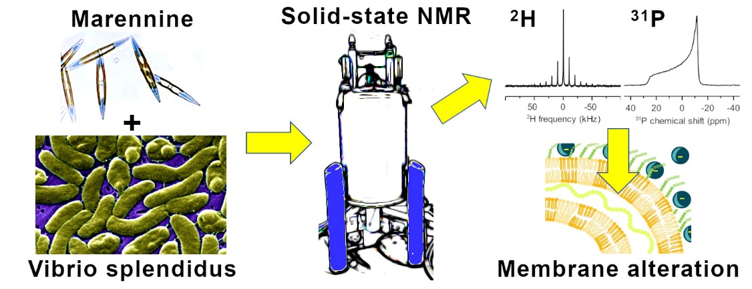

KEYWORDS
Antimicrobial pigment, polymyxin B, membrane fluidity, model membranes, ³¹P and ²H NMR, in cell NMR

ABBREVIATIONS
ASW, artificial sea water; BW, blue water; Chloroform-D, deuterated chloroform; CL, cardiolipin; CSA, chemical shift anisotropy; D₂O, deuterium oxide; PA-d₃₁, deuterated palmitic acid; DOPE, dioleoylphosphatidylethanolamine; LB, Lysogeny broth; LPS, lipopolysaccharides; M₂, second spectral moment; MAS, magic angle spinning; MIC, minimum inhibitory concentration; MLV, multilamellar vesicle; MTT, 3-(4,5-dimethylthiazol-2-yl)-2,5-diphenyltetrazolium bromide; OA, oleic acid; OD, optical density; PE, phosphatidylethanolamine; PG, phosphatidylglycerol; POPE, 1-palmitoyl-2-oleoyl-sn-glycero-3-phosphoethanolamine; POPG,1-palmitoyl-2-oleoyl-sn-glycero-3-phospho-(1'-rac- glycerol); PxB, polymyxin B; SSB, spinning side band; SS-NMR, solid-state nuclear magnetic resonance.

INTRODUCTION
According to the World Bank, aquaculture is a growing industry and a promising alternative to the fishery crisis [1]. However, like many commercial activities, aquaculture relies on intensive production and in the context of global warming, the stress that cultured animals may undergo can lead to diseases and losses [2, 3]. Vibriosis – an infection caused by Vibrio bacteria - are amongst the most problematic pathologies in the world for aquatic species [4]. Vibrio outbreaks are often associated with important mortality and Vibrio splendidus are almost exclusive to bivalve infection especially during the first stages of culture [6, 5.
For years, aquaculture has counted on antimicrobial agents for prophylactic or therapeutic purposes, and too extensively in some cases such as shrimp and salmon farming [8, 9]. Nowadays, regulations in aquaculture are stricter since bacterial resistance is a considerable issue [9, 10]. Consequently, there is a growing need to develop novel therapeutic approaches that are more environmentally friendly and less harmful for food human consumption than conventional synthetic antibiotics. New strategies include brood-stock conditioning [7], as well as the use of natural biologically active alternatives such as immuno-stimulants, bacteriophages and probiotics [11, 12].
Marennine is a natural blue pigment and a promising therapeutic alternative against vibriosis in aquaculture [13, 14]. It is secreted by Haslea ostrearia, a marine microalga responsible for the noticeable greening of oysters cultured in the French Marennes region and harmless for the consumers. Recent works showed that marennine is a water-soluble 10 kDa polyphenol with possibly a glycosidic skeleton [15]. The probiotic potential of marennine against aquatic Gram(-) bacteria including Vibrio species, has already been demonstrated [16-18]. Turcotte et al. also showed that in the presence of marennine extracts, the pathogenicity of Gram(-) V. splendidus was suppressed [14]. However, the action mechanism of marennine towards marine bacteria has not yet been elucidated. Considering the high molecular weight of marennine and its unlikely penetration in the bacterial membrane, the pigment would favor an interaction with the outer-membrane of Gram(-) bacteria, as suggested by a solid-state nuclear magnetic resonance (SS-NMR) study on Escherichia coli [19].
The objective of this work was to investigate the action mechanism of marennine towards the marine bacterium V. splendidus, more specifically the indigenous environmental strain (7SHRW) isolated from the St. Lawrence estuary, which causes significant mortality of blue mussel and scallops’ larvae. Marennine has previously been shown to inhibit the virulent action of this strain [14]. To do so, we studied the interaction of marennine with 7SHRW using in vivo ²H SS-NMR, and with model membranes using ³¹P SS-NMR. Deuterium SS-NMR provides valuable information on acyl chain dynamics and organization in membrane systems made of deuterated phosopholipids, while phosphorous NMR is a valuable tool to probe lipid headgroup perturbations. Traditionally used to study model membranes, the deuterium labelling of membrane lipids in intact bacteria enabled in vivo ²H SS-NMR experiments on E. coli, Bacillus subtilis, and more recently V. splendidus [19-22]. It is also a useful tool to examine membrane interactions with exogenous molecules such as detergents, drugs, and peptides, at a molecular-level [23].
In this work, the effect of marennine on V. splendidus membranes at two different growth stages (mid-log and stationary phase) is compared to a commercial antibiotic, polymyxin B (PxB), which has a well-documented action mechanism. Polymyxins are amongst the most commonly used antibiotics in aquaculture and are known to specifically act against Gram(-) bacteria by damaging their membranes [24-26]. However, recent regulations have prohibited the use of PxB in aquaculture [25]. By comparing the interaction of marennine and PxB with V. splendidus membranes, we propose a possible mechanism involved in the bactericidal action of marennine, and the use of this natural pigment as an alternative to synthetic antibiotics.

MATERIALS AND METHODS
Materials
Oleic acid (OA) and deuterated palmitic acid (PA-d₃₁), as well as deuterium depleted water, 3-(4,5-dimethylthiazol-2-yl)-2,5-diphenyltetrazolium bromide (MTT), and PxB sulfate salt, were all purchased from Sigma Aldrich (Oakville, ON, Canada). Synthetic lipids 1-palmitoyl-2-oleoyl-sn-glycero-3-phosphoethanolamine (POPE), 1-palmitoyl-2-oleoyl-sn-glycero-3-phospho-(1'-rac-glycerol) (POPG), and cardiolipin (CL) were purchased from Avanti Polar Lipids (Alabaster, AL, USA). Tween-20 (polyethylene glycol sorbitan monolaurate) and tris(hydroxymethyl)-aminomethane were acquired from BioShop (Burlington, ON, Canada), while LB Broth Miller was obtained from BioBasic (Markham ON, Canada), and ethylenediaminetetraacetic acid (EDTA) from Fisher Scientific (Fair Lawn, NJ, USA). Deuterium oxide (D₂O) and deuterated chloroform (chloroform-D) were respectively bought from CDN Isotopes (Pointe-Claire, Quebec, Canada) and Cambridge Isotope Laboratories (Endover, MA, USA). The solution of marennine tested was produced by H. ostrearia strain NCC-136-isolated from Bourgneuf Bay, France. Microalgae were cultured in filtered seawater with a salinity of 28, at 20°C and with a light level of 180 μmol photons m⁻²·s⁻¹, 14/10 hours light/dark cycle [14]. The supernatant was then extracted and purified according to previously published methods [13].
Bacterial growth and ²H labelling
V. splendidus 7SHRW [27] were grown in LB medium and deuterated using equal proportions of OA and PA-d₃₁ (0.3 mM each) micellized in 0.14 mM of Tween-20 detergent to insure fatty acid intake, as described in Bouhlel et al. [22]. The growth kinetics was monitored with a multiple plate reader (Infinite M200 TECAN, Männedorf, Switzerland) using 24-well plates, by measuring absorbance at 600 nm every 30 min. Typically, 3 to 4 wells were used for each treatment. Bacteria were harvested at two different moments, i.e., after the mid-log phase and at the early-stationary phase, centrifuged (2600 g, 10 min), then pellets were washed twice with a sterile NaCl solution (9 g/L) prepared with nanopure water. A standard curve relating optical density of the culture and the corresponding dry weight was determined after pellet lyophilization.
Antimicrobial activity measurement
The antimicrobial activity of marennine and PxB towards V. splendidus was assessed by measuring the minimum inhibitory concentration (MIC) using a serial dilution technique [17, 28]. An LB medium (10 g/L NaCl) was used for all dilutions, and final concentrations ranged from 1.25 to 400 µg/mL for marennine, and from 1 to 32 µg/mL for PxB. A total of 200 µL of initial cell suspension was transferred into a 100-well plate to monitor the growth kinetics with a multiple-plate reader at 25°C. The absorbance at 600 nm was recorded every 30 min over a 48h period.
Bacteria exposition for NMR experiments
Marennine and PxB assays were performed at selected concentrations in triplicate on ²H-labelled bacteria, adjusted to correspond to approximately 10 ± 2 mg (dry weight).
For PxB expositions, ²H-labelled bacteria pellets were resuspended in a 1 mL solution of NaCl (9 g/L) in ²H-depleted water, with the appropriate amount of antibiotics (final concentration of 1 µg/mL and the MIC), and vortexed before a 10 min incubation. For marennine experiments, ²H-labelled bacteria pellets were resuspended in a 50 mL solution of of ²H-depleted artificial seawater (ASW) containing NaCl (480 mM), MgSO₄ (28 mM), MgCl₂ (24 mM), CaCl₂ (16 mM) and NaHCO₃ (2.4 mM), with a pH adjusted to 8.0 ± 0.1, with the appropriate amount of marennine (final concentration of 2 µg/mL and at the MIC). Expositions were carried out in 250 mL Erlenmeyer flasks placed on a rotary shaker (100 rpm) at a temperature of 22 ± 1 °C for 2h. Note that nutrients were purposely discarded during marennine exposition to avoid continuing bacterial growth, and concomitant changes in membrane fluidity as previously reported [22]. The lack of nutrients and 2h shaking in ASW have a little effect on cell viability (90% ± 5), as estimated with an MTT 3-(4,5-dimethylthiazol-2-yl)-2,5-diphenyltetrazolium bromide) test [21]. Bacteria exposed to ASW only are considered as a control. Both types of sample pellets (control and exposed to marennine) came from the same culture replicates.
Bacteria were collected immediately after exposition to PxB or marennine, and centrifuged at 3200 g for 5 min. Pellets were then washed in a solution of 9‰ NaCl in ²H-depleted water, then centrifuged at 3200 g again for 5 min. The final pellet was used to fill a 4-mm zirconium oxide rotor, which corresponds to approximately 90 mg of hydrated bacteria.
Phospholipid analysis of V. splendidus
Bacteria harvested at the early stationary phase were washed with NaCl solution (9 g/L) and freeze-dried. Lipids were analyzed following the protocol of Mahabadi et al. (to be submitted). In short, lipids were extracted according to the protocol of Folch [29] using dichloromethane/methanol (2:1 CH₂Cl₂/MeOH v/v) and 0.88% KCl solution in a Potter glass homogenizer. Polar lipids were separated from neutral lipids by elution through a silica gel column (30×5 mm) hydrated to 6‰ with distilled water [30]. Final polar lipid extracts were dissolved in a mixture composed of 500 µL of deuterated chloroform, 200 µL methanol, 50 µL of an aqueous EDTA (200 mM) solution at pH 6, vortexed, transferred to a solution NMR glass tube for ³¹P NMR analysis, and stabilized until a biphasic solution was obtained.
Preparation of model bacterial membranes
Model membranes were prepared from lipid mixtures of POPE, POPG and CL in proportions similar to V. splendidus membrane composition, deduced from the ³¹P solution NMR experiments. For each sample, 30 mg of phospholipid powder mixture was dissolved in CH₂Cl₂/MeOH (3:1) and dried under a stream of N₂ gas for 30 min. Remaining organic residues were further evaporated overnight under vacuum. The dry lipid films were hydrated in 120 µL buffer solution (Tris (100 mM), NaCl (100 mM), EDTA (2 mM) and D₂O; pH=8), resulting in multilamellar vesicles (MLVs). For marennine-containing samples, the appropriate pigment amount was dissolved in the buffer solution before lipid hydration. All preparations were mechanically homogenized and processed through five cycles of liquid N₂ freezing and thawing in a 35°C water bath. MLV samples were subsequently filled in 4 mm rotors for ³¹P SS- NMR analysis.
²H solid-state NMR experiments
All ²H SS-NMR experiments were carried out using a Bruker Avance III HD Wide Bore 600 MHz NMR spectrometer (Milton, Ontario, Canada) and a double-resonance magic angle spinning (MAS) probe tuned to 92.1 MHz. Samples were spun at 10 kHz and at 25°C. Spectra were acquired using a Hahn Echo pulse sequence with 4 µs 90° pulses separated by an echo delay of 96 µs, a recycle time of 0.5 s, 4096 scans, 32k points and a spectral width of 500 kHz, for a total of 43 min of acquisition time. Spectra were zero-filled to 64k points, and treated with an exponential line broadening of 40 and 100 Hz for PxB and marennine sample spectra, respectively.
Spectral moment analysis was performed using MestRenova software V6.0 (Mestrelab Research, Santiago de Compostela, Spain) and a macro developed by Pierre Audet (Université Laval, Québec, Canada). The second moment (M₂) was calculated using the following equation [20]:
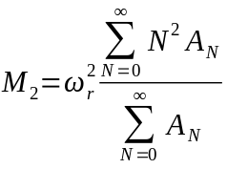
where ω_{r} is the angular spinning frequency, N the side band number, and A_{N} the area of each sideband obtained by spectral integration.
³¹P solid-state NMR experiments
All ³¹P SS-NMR experiments were carried out using a Bruker Avance III HD Wide Bore 400 MHz NMR spectrometer (Milton, Ontario, Canada) operating at frequencies of 161.9MHz and 400.02 MHz for ³¹P and ¹H, respectively. Samples were analyzed at 25°C, 50°C and 75°C, with a 25 min equilibration step before each temperature. Temperatures were controlled to within ± 0.5°C, and chemical shifts were referenced relative to external H₃PO₄ set to 0 ppm. Static spectra were recorded through a ¹H-decoupled Hahn echo pulse sequence with a ³¹P 90° pulse length of 3µs, a recycle delay of 3s, and 512 scans, in approximately 25 min.
Line shapes were fitted using the Bruker SOLA software. Vesicles shapes (spherical vs. ellipsoidal) were determined using dedicated MATLAB scripts based on the analytical model of Dubinnyi et al. [31], where the vesicle is described by the ratio ρ between the long and short axis of the ellipsoid (ρ=1 if vesicles are spherical).
³¹P solution-state NMR experiments
All ³¹P solution NMR experiments were performed at 25°C using a Bruker Avance III HD 600 MHz NMR spectrometer (Milton, Ontario, Canada) operating at frequencies of 242.84 MHz and 599.95 MHz for ³¹P and ¹H, respectively. For quantitative results, ³¹P spectra were recorded with a 10 s recycle delay, continuous ¹H decoupling during acquisition, without NOE enhancement, with 128 scans in approximately 22 min. Spectra were processed with an exponential line broadening of 2 Hz.

RESULTS AND DISCUSSION
Minimum inhibitory concentration
To quantify the antibacterial activity of marennine and PxB on V. splendidus, we have determined their minimum inhibitory concentration (MIC). The growth curves can be found in the Supplementary information section (Fig. S1 and S2). Values of 200 µg/mL and 8 µg/mL were determined for marennine and PxB, respectively. So far, marennine has been characterized as a potential polyphenol with a glycosidic structure [13, 15], and its MIC is in the same range as other plant polyphenol extracts acting on Gram(-) bacteria, i.e., from 70 to 500 µg/mL on Vibrio species [32, 33]. As for PxB, its MIC has been reported to range between 1 to 8 µg/mL depending on the bacterial species [34]. Here, we observe that the MIC of PxB for V. splendidus is 8 times higher than that reported for E. coli [19]. We also notice a different response of V. splendidus to marennine as compared to E. coli. Indeed, Tardy-Laporte et al. reported a change in membrane fluidity when E. coli was exposed to 2 µg/mL of marennine in NaCl (10 mg/L) solution for 15 min [19], while a longer exposition time (2h) was required to observe this effect for V. splendidus at the same marennine concentration. However, V. splendidus showed membrane collapse after 2 hours of exposition in NaCl (10 mg/L) solution. We have thus used artificial seawater (ASW) in this work since membrane integrity is preserved for up to 12 hours in ASW (data not shown), and to eliminate any possible effect of the salt and better focus on the antibacterial activity.
Effect of marennine and polymyxin B on V. splendidus membranes
To better understand the action of marennine and PxB on V. splendidus, their effect was studied by ²H SS-NMR at the MIC but also at a lower concentration, during the exponential and stationary phases. In practice, concentrations below the MIC are typically used in aquaculture [9]. As demonstrated in a previous work, membrane lipid chains in V. splendidus can be ²H-labelled by growing marine bacteria in a medium enriched with PA-d₃₁ [22]. The presence of OA ensures a lipid profile closer to unlabelled bacteria. A labelling percentage of 69% and 55% of total palmitic acid can be reached in the exponential and in the stationary phases, respectively. The second spectral moment (M₂) was used to quantify the membrane lipid acyl chain ordering. The greater the M₂, the higher the lipid chain ordering. As shown by Warnet et al., combination of MAS and ²H SS-NMR provides a fast method to ensure the in vivo characterization of bacteria [20]. In vivo conditions were confirmed for V. splendidus by estimating the bacterial viability using an MTT reduction assay [21] after 2 h of MAS experiments, which was 95 ± 5 %.
Figure 1 shows the effect of marennine on V. splendidus at low concentration (2 µg/mL) and at the MIC (200 µg/mL), with corresponding M₂ values presented in Table 1. The “low” marennine concentration employed here is 20 times that reported to be effective on V. splendidus (7SHRW) in aquaculture conditions [14]. Spectral analysis reveals that marennine has an ordering effect on V. splendidus membrane lipid chains at a concentration of 2 µg/mL, as shown by a ∼35% increase in M₂ value (Table 1). This effect is greater for bacteria sampled in the stationary phase, where M₂ is actually doubled. Figure 1 (b,e) indeed shows that spinning side bands (SSBs) span a larger frequency range and have increased intensities. The stiffening effect of marennine on the lipid chains is further observed at the MIC (Table 1). M₂ values increase by ∼60% compared to the control in the presence of marennine in the exponential phase and are doubled in the stationary phase.

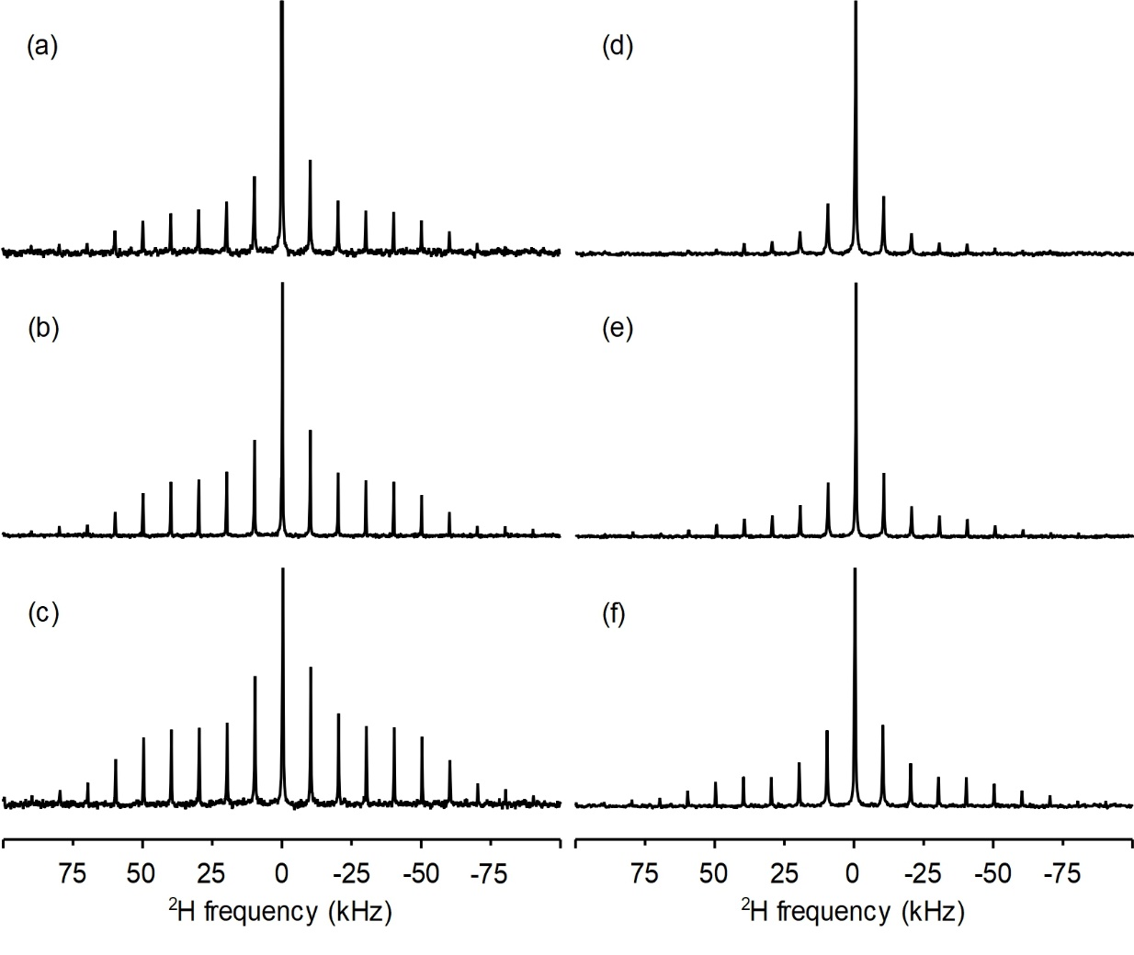
Figure 1: Representative ²H SS-NMR MAS spectra of V. splendidus exposed to marennine during the exponential (a-c) and stationary (d-f) stages. Spectra (a) and (d) are control experiments of V. splendidus in ASW; (b) and (e) correspond to bacteria exposed to low marennine (2 µg/mL) concentration; (c) and (f) to marennine at MIC (200 µg/mL). All spectra are normalized according to the central peak.

Table 1: Average second spectral moment, M₂ (10⁹ s⁻²) with standard deviation for V. splendidus exposed to marennine and polymyxin B at different concentrations. MIC for marennine and PxB are 200 µg/mL and 8 µg/mL, respectively. Control for marennine is done in artificial seawater.

 |  | Marennine |  |  |  | Polymyxin B
 | Control | 2 µg/mL | MIC |  | Control | 1 µg/mL | MIC
Exponential phase | 25 (5) | 34 (7) | 39 (4) |  | 20 (2) | 23 (3) | 12 (1)
Stationary phase | 10 (1) | 21 (3) | 20 (1) |  | 10 (1) | 18 (3) | 7 (2)

To explore the marine pigment marennine as a potential antimicrobial agent for aquaculture, its effect was compared to PxB since polymyxins have been widely used for this purpose. Figure 2 shows the effect of PxB on V. splendidus at low concentration (1 µg/mL) and at the MIC (8 µg/mL). Corresponding M₂ values are presented in Table 1. At low PxB concentration (Figures 2b,e), an increase in SSB intensities and spectral width can be seen, indicating an increased lipid chain ordering. Table 1 shows that the increase in lipid ordering at low concentration of PxB mostly occurs in the stationary phase, as revealed by an 80% augmentation in M₂. At the MIC (Figures 2c,f), however, the SSBs intensity is reduced, as well as the spectral width, with a concomitant decrease in M_{2,} revealing a disordering effect of PxB on V. splendidus inner membrane lipid chains at both growth phases.
With ²H NMR and M₂ determination, we were also able to evidence the effect of marennine and PxB on V. splendidus at different growth times. Control samples were compared to bacteria exposed to each antibacterial agent after a growth period of 15h (mid-log), 22h (early stationary) and 35h (late stationary). Figure 3 shows that M₂ values of V. splendidus membranes decrease as a function of the growth stage, in agreement with the increase in membrane fluidity reported in our previous work [22]. The addition of marennine results in an increase in the lipid acyl chain ordering at both concentrations, with a more important effect for bacteria sampled at mid-log phase, compared to the stationary phase (35h of growth). Interestingly, low PxB concentrations increased the membrane rigidity at all growth stages, while high concentration (MIC) showed the opposite pattern. These results are in agreement with an in vivo ²H SS-NMR study of the effect of PxB on
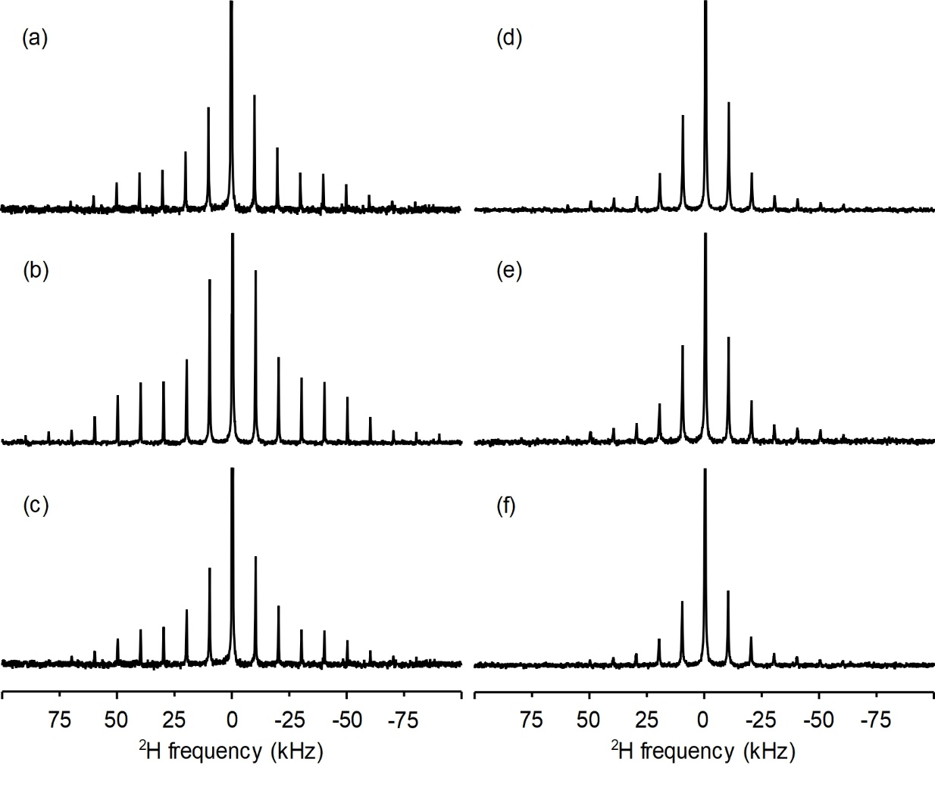
Figure 2: Representative ²H SS-NMR MAS spectra of V. splendidus exposed to polymyxin B during exponential (a-c) and stationary (d-f) stages. Spectra (a) and (d) are control experiments, spectra (b) and (e) correspond to bacteria exposed to low PxB (1 µg/mL) concentration; (c) and (f) to PxB at MIC (8 µg/mL). All spectra are normalized according to the central peak.

the Gram(-) bacterium E. coli [19]. They are also compatible with previous work suggesting a two-stage interaction mechanism for this antibiotic with respect to increased concentrations or exposition time [26]. Briefly, PxB first disturbs the bacteria outer membrane by electrostatically binding with the anionic phosphate groups of the lipopolysaccharides (LPS) via its positively charged residues, thus competing with divalent cations such as magnesium and calcium, which play a role in bridging adjacent LPS chains. Then the PxB lipid tail can insert itself in the inner membrane, thus disrupting the bilayer, and eventually leading to the loss of membrane integrity and cell leakage [26, 35]. The importance of LPS is highlighted by the fact that PxB does not significantly affect model membranes made without LPS [36, 37].
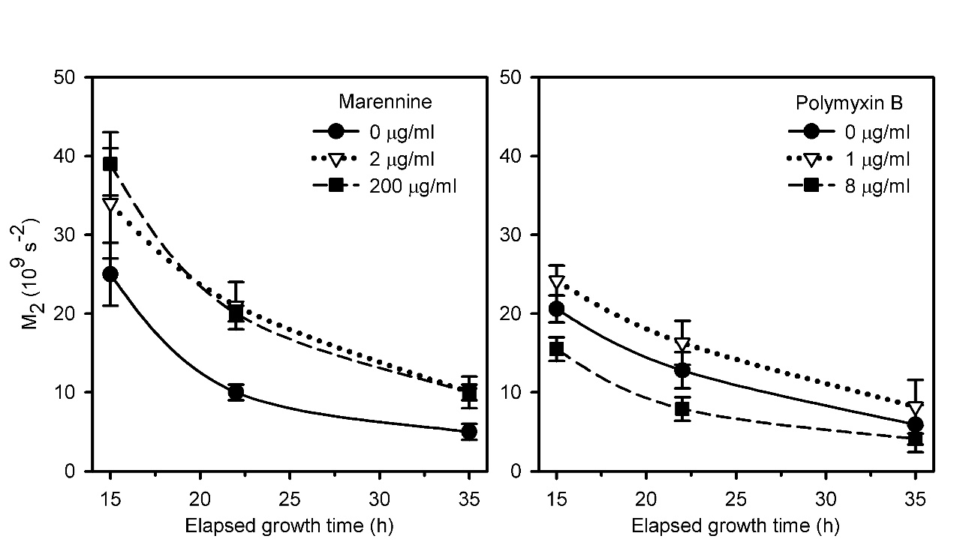
Figure 3: Effect of marennine and PxB on the second spectral moment M₂ of V. splendidus after exposition to marennine (left), and PxB (right). Control cells (solid lines) are compared to bacteria exposed to 2 µg/mL of marennine or 1 µg/mL of PxB (dotted lines), and at the respective MICs (dashed lines). Values correspond to average means of three replicates with 3-22% error for marennine samples and 8-40% error for PxB samples.

Altogether, these observations suggest that the action mechanism of marennine is similar to that of PxB at low concentration, but different at high concentration. As opposed to PxB, marennine, even at lethal concentrations, would not disrupt the inner bilayer and interact mostly with the outer layer of V. splendidus membrane. Nevertheless, while marennine probably does not disrupt the inner membrane, it can still affect it depending on how much it penetrates the outer membrane. To test this hypothesis, we have decided to study the interaction of marennine with model inner bacterial membranes.

Effect of marennine on model membranes
The ²H SS-NMR results obtained in vivo suggest a different action of marennine on V. splendidus, as compared to PxB, where this natural pigment is shown to reduce the membrane lipid chain dynamics at low concentration and at the MIC, and at both growth stages. Moreover, the action of marennine was observed following a longer incubation time as compared to PxB. To better understand the action mechanism of marennine, we have thus investigated its effect on the lipids using model V. splendidus inner membranes, i.e., without LPS. To do so, the phospholipid composition of the bacterium was first determined by ³¹P solution NMR using lipid extracts (a characteristic spectrum is shown in figure S3). Integration of the resonances allowed the quantification of three major phospholipids corresponding to 85% phosphatidylethanolamine (PE), 10% phosphatidylglycerol (PG) and 5% cardiolipin (CL) (in mole %) (phospholipid structures are shown in Figure S3 and the presence of two phosphate headgroups in CL was taken into account in the quantification). These proportions did not change whether samples were harvested at exponential or stationary growth stages. Model membranes (MLVs) of V. splendidus were thus prepared using POPE, POPG, and CL, respecting the same proportions as in natural membranes.

³¹P SS-NMR is a useful tool to probe changes in phospholipid headgroup dynamics, orientation and lipid phases [38]. The effect of marennine on the model membranes is presented in Figure 4 at low (2 μg/ml) concentration and at the MIC. Spectra were recorded between 25 and 75ºC to better evidence any possible changes in membrane morphology and phases. First, the model membranes at 25°C and 50°C are typical of bilayers in liquid-crystalline phase, with a chemical shift anisotropy (CSA, powder spectrum width) of approximately 37.5 and 33 ppm, respectively. The higher intensity of the right edge of the powder spectrum at 50ºC can be explained by a change in vesicles from a spherical to an ellipsoidal shape, as confirmed by spectral simulation (Figure S4). Indeed, the ratio ρ between the long and short axis of the vesicles changes from that of a sphere (ρ=1) to an ellipsoid (ρ=1.5) from 25 to 50ºC. This is explainable by the collective orientation of the phospholipids in a fluid membrane in the magnetic field, due to their negative magnetic susceptibility anisotropy [39, 40]. At 75ºC, the spectrum shows a narrow and symmetric high intensity line and a residual powder pattern. Bilayers are thus mostly transformed into smaller fast tumbling structures (67% of the spectrum area, Table 2). It should be noted that the isotropic signal may also result from lipid lateral diffusion in a highly curved bilayer and non-bilayer lipid structures [41]. DOPE, the most abundant lipid (85%) in our model membranes, is known to adopt a hexagonal phase. However, such phase could not be observed on the spectra at all temperatures. Warschawski et al. [42] reported that only 20% of PG in a PG/PE mixture can govern the phase behaviour of the membranes at 75°C. Under our conditions, with only 10% PG in the mixture, CL seems to contribute to maintaining a lamellar phase, as it is known to exert a major stabilizing effect on zwitterionic lipids [43, 44].

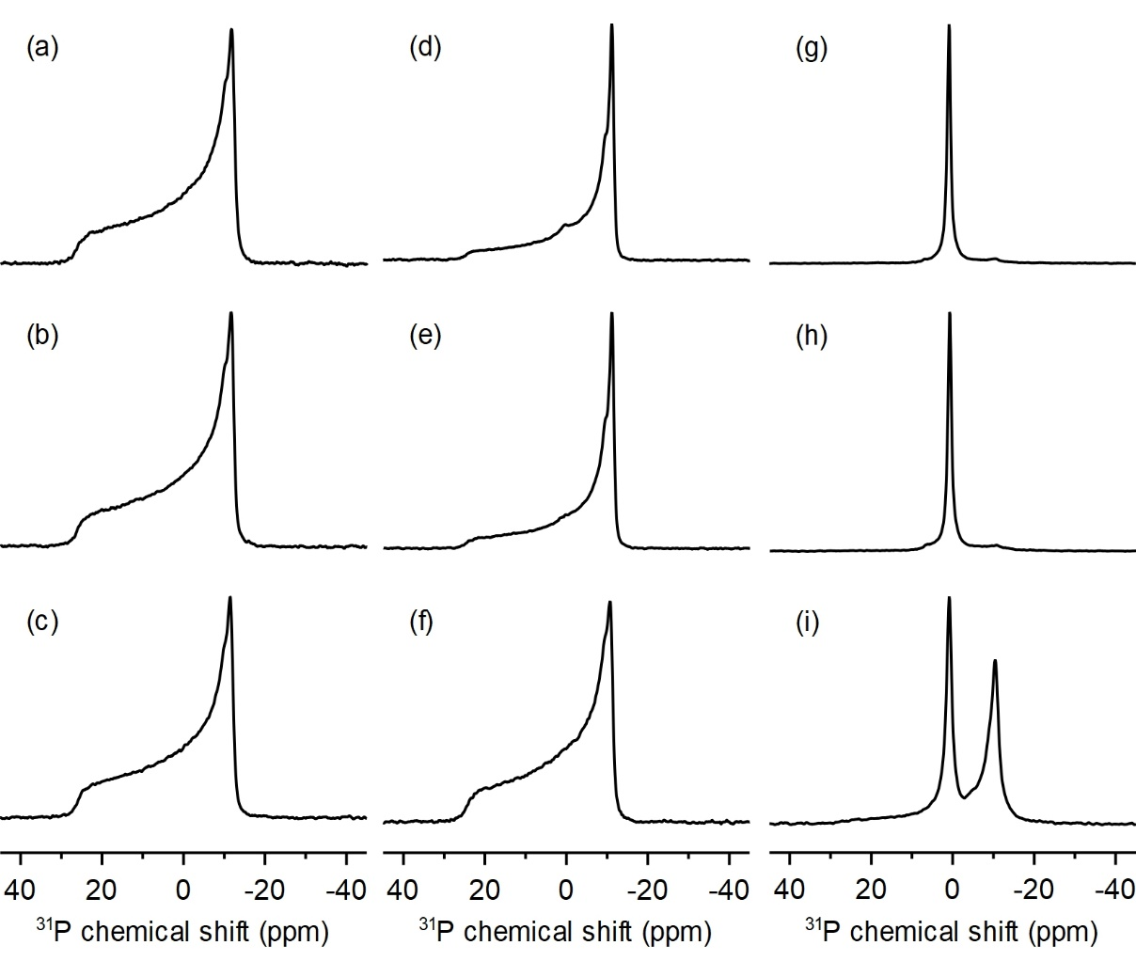
Figure 4: ³¹P-SS NMR spectra of model V. splendidus membranes as a function of temperature: (a-c) T=25°C, (d-f) T=50°C and (g-i) T=75°C. Top three spectra (a,d and g) are controls without marennine, middle spectra (b,e and h) are at a marennine concentration of 2 μg/mL, and bottom spectra (c,f and i) are at the MIC (200 μg/mL). Note the lineshape difference between spectra d and e which could be fitted with a ratio of long to short ellipsoid axis of ρ=1.5 compared to the more spherical cases (a-c, f) with ρ=1 as calculated by spectral simulations.

Table 2 : Estimated phase contributions expressed in % from area integration of V. splendidus model membranes at 75°C, in the absence and presence of marennine at two concentrations. Standard deviation is indicated between brackets.
 |  |  |  | Marennine
 |  | Control |  | 2 µg/mL |  | 200 µg/mL
Isotropic phase |  | 87% (8) |  | 79% (6) |  | 33% (8)
Lamellar phase |  | 13% (8) |  | 21% (6) |  | 67% (8)

The effect of marennine on the phospholipid headgroups of V. splendidus model membranes seems to depend on the concentration and temperature. At 25ºC, Figure 4 shows no effect at both pigment concentrations. However, at 50ºC, high concentrations of marennine re-establish the initial spherical shape of the MLVs, with ρ going from 1.5 to 1 in the presence of the pigment. These observations suggest that marennine affects the elastic properties of the lipid vesicles. Previous studies have reported that compounds such as antimicrobial peptides [45-47] or phenolic molecules [48] can have a similar action, i.e., altering the membranes without necessarily changing the CSA value. The interaction of marennine would thus impede the temperature-induced fast lateral diffusion and motion of the lipid polar headgroups, as was, for example, reported for proteins interacting with DMPC (1,2-dipalmitoylphosphatidylcholine) membranes [49]. At 75°C and in the presence of 200 µg/mL, lipids are mostly found in a lamellar phase (67%) as shown in Table 2, as compared to about 10% in the control sample. Altogether, our results suggest that marennine protects the lamellar phase.
The weak effects of marennine on the model bacterial membranes are comparable to those of negatively charged molecules observed on membrane systems [46, 50]. Reported effects of anionic molecules on zwitterionic membranes include alterations of lipid packing and gelation [51], vesicle shrinkage [50], or aggregation, as a result of hydration or condensation of the acyl chains [52]. The model V. splendidus membranes used in our work are composed of zwitterionic PE and anionic PG and CL (Figure S3). It is possible that the negative charges of marennine interact with PE’s positive amine group, while the hydroxyl groups of the pigment form H-bonds with PG and CL, similarly to polyhydroxylated fullerene (fullerenol) nanoparticles which were shown to selectively interact with PG in model membranes, and remain at the lipid/water interface [53].
Interaction mechanism of marennine with V. splendidus
The outer membrane of Vibrio species is extremely selective, blocking the permeation of molecules greater than 600-700 Da [54]. A 10-kDa molecule such as marennine is therefore unlikely to traverse the outer membrane. The great diversity in responses to marennine exposure observed with different species and strains of Vibrio, ranging from growth stimulation to complete inhibition, could thus originate from molecule specificity and diversity at the bacterial membrane level [17]. Our model membrane study reveals that, if marennine penetrated the outer membrane and reached the inner membrane, it would solely interact with the phospholipid headgroups and remain at the membrane surface, without perturbing the ³¹P atom vicinity, consistent with the absence of change in CSA. It would also slightly affect the membrane elastic properties, consistent with the stiffening effect observed by ²H SS-NMR. The results obtained by ³¹P SS-NMR using MLVs highlight the importance of marennine’s charged and hydroxylated groups upon molecular interactions, and help understanding the stiffening effect of marennine observed by ²H SS-NMR in vivo with V. splendidus.
Altogether, our results confirm our initial hypothesis that, as opposed to PxB, and even at concentrations at which marennine inhibit bacterial growth, marennine does not disrupt bacterial membranes. Marennine most likely interacts with the LPS on the bacterium outer membrane, as was suspected with E. coli. [19]. Similarly, Tardy-Laporte et al. (2013) studied the effect of fullerenol nanoparticles on E. coli, and hypothesized that the membrane stiffening effect of this polyhydroxylated molecule was due to an interaction with the polysaccharide core of the LPS, thus inducing a tighter packing of the phospholipids in the outer leaflet of the outer membrane [19]. A similar effect to fullerenol is thus suspected for marennine towards V. splendidus.
While a direct interaction of marennine can explain this membrane stiffening, the implication of other biochemical mechanisms cannot be ruled out. Under stress situations such as the presence of toxic organic compounds or nutrient deprivation, Vibrio species can react by rigidifying their outer membrane, for example via a cis-trans conversion process within the lipid unsaturated fatty acids [55, 56]. These isomerizations have been reported to increase with increasing phenol concentrations [57], aligning with the increased effect of marennine at the MIC, which may suggest increased phospholipid recruitment for isomerization. If marennine can hardly traverse V. splendidus outer membrane, it could still interfere with bacterial outer membrane proteins and induce such rearrangement at the membrane level. Indeed, it has been observed in vitro that marennine can interact and precipitate with proteins, like the tanning effect of polyphenols (Mouget, unpublished results). Stiffening could also be induced by cell shrinking due to lower water permeability under stress conditions [58].
Functional consequences of membrane fluidity alteration by marennine are enough to affect bacterial viability, as it may involve the perturbation of lipid-protein domains, and affect processes such as biofilm formation, cytokinesis or enzymatic pathways [59, 60]. More specifically, for virulent bacteria under stress, the release of chemical molecules during quorum sensing process could be directly affected by the alteration of membrane fluidity [61].

CONCLUSION
In this work, the action of marennine towards the marine bacterium V. splendidus was studied for the first time, at the molecular level, by in vivo ²H SS-NMR, at different growth phases. The antibiotic PxB was used as a reference antibiotic acting against Gram(-) bacteria. While PxB was proved efficient against infection threats in aquaculture, nowadays’ regulations as well as increased bacteria resistance prompt more natural alternatives. Our study demonstrates that marennine affects V. splendidus membranes at low concentrations, below the MIC. This microalgal pigment, which is not harmful for humans, could thus constitute a potential treatment against vibriosis. Our results also showed that marennine and PxB act against this bacterium via different mechanisms. As proposed in other studies [26, 35], PxB would disturb the bacteria outer membrane before accessing and disrupting the inner membrane. However, marennine would act in the vicinity of V. splendidus outer membrane through a stiffening mechanism. Marennine could interact with the LPS in the outer membrane, and/or trigger the isomerization of unsaturated fatty acids, as a stress-resistance reaction. More investigations would be required to test these hypotheses.
Finally, our results indicate that both marennine and PxB had a stronger effect in the stationary phase than in the exponential phase. Beney and Gervais [62] have reported that the membrane capacity to resist a source of stress by increasing the lipid ordering is highly related to the initial membrane fluidity state during cell growth. As shown in our previous study [22], cell membranes are more fluid in the stationary phase as compared to the mid-log phase, which would explain the more dramatic stiffening effect of the antimicrobial agents observed in the stationary phase. In all cases, results showed herein indicate that the membrane stiffening induced by marennine occurs even in balanced healthy stage cultures of V. splendidus (exponential phase), suggesting that this natural pigment is a potential candidate for antibacterial treatment in aquaculture.

Acknowledgments
We would like to thank Pierre Audet for sharing the MestRenova macro, François Turcotte for marennine production and purification, and Karine Lemarchand (ISMER) for providing the initial Vibrio strain. This work was supported by the Natural Sciences and Engineering Research Council (NSERC) of Canada (grant 326750-2013 to I.M. and grant 299100 to R.T.) and the Centre National de la Recherche Scientifique (UMR 7203 to D.E.W.). This publication also benefited from the Horizon 2020 Research and Innovation Programme GHaNA (The Genus Haslea, New marine resources for blue biotechnology and Aquaculture) under Grant Agreement No. 734708/GHANA/H2020-MSCA-RISE-2016 (JLM). Z.B. would like to acknowledge the Government of Tunisia and Ressources Aquatiques Québec (RAQ) research network from the Fonds de recherche Nature et technologie FRQNT (RS-171172) for the award of scholarships. I.M., J.-L.M., J-S.D. and R.T. are members of RAQ.
COMPETING INTERESTS
No competing interests declared.
AUTHOR CONTRIBUTIONS
Z.B. designed and conducted all sampling, data collection and analysis, and wrote the first draft of the manuscript. J-S.D. monitored microalgal culture, performed marennine production and purification, and participated in the revision of the manuscript. J-L.M. provided the initial Haslea strain culture and participated in the revision of the manuscript. A.A.A. and D.E.W assisted with NMR operation and analysis, and participated in the revision of the manuscript. R.T. and I.M. designed and supervised the research, contributed to the data analysis and writing of the manuscript.
REFERENCES
[1] Tacon, A. G. J., Gloabal trends in aquaculture and compound aquafeed production, World aquaculture (2018) 33-46.
[2] C. Paillard, F. Le Roux, J.J. Borrego, Bacterial disease in marine bivalves, a review of recent studies: trends and evolution, Aquatic Living Resources, 17 (2004) 477-498.
[3] R.A. Raja, K. Jithendran, Aquaculture Disease Diagnosis and Health Management, in: Advances in Marine and Brackishwater Aquaculture, Springer, 2015, pp. 247-255.
[4] F.L. Thompson, T. Iida, J. Swings, Biodiversity of vibrios, Microbiology and molecular biology reviews, 68 (2004) 403-431.
[5] L. DiSalvo, J. Blecka, R. Zebal, Vibrio anguillarum and larval mortality in a California coastal shellfish hatchery, Applied and Environmental Microbiology, 35 (1978) 219-221.
[6] M.-A. Travers, K.B. Miller, A. Roque, C.S. Friedman, Bacterial diseases in marine bivalves, Journal of invertebrate pathology, 131 (2015) 11-31.
[7] M. Holbach, R. Robert, P. Boudry, B. Petton, P. Archambault, R. Tremblay, Scallop larval survival from erythromycin treated broodstock after conditioning without sediment, Aquaculture, 437 (2015) 312-317.
[8] M. Weir, A. Rajić, L. Dutil, C. Uhland, N. Bruneau, Zoonotic bacteria and antimicrobial resistance in aquaculture: opportunities for surveillance in Canada, The Canadian Veterinary Journal, 53 (2012) 619.
[9] J.E. Watts, H.J. Schreier, L. Lanska, M.S. Hale, The rising tide of antimicrobial resistance in aquaculture: sources, sinks and solutions, Marine drugs, 15 (2017) 158.
[10] F.C. Cabello, Heavy use of prophylactic antibiotics in aquaculture: a growing problem for human and animal health and for the environment, Environmental Microbiology, 8 (2006) 1137-1144.
[11] A. Ravi, K. Musthafa, G. Jegathammbal, K. Kathiresan, S. Pandian, Screening and evaluation of probiotics as a biocontrol agent against pathogenic Vibrios in marine aquaculture, Letters in Applied Microbiology, 45 (2007) 219-223.
[12] T. Defoirdt, P. Sorgeloos, P. Bossier, Alternatives to antibiotics for the control of bacterial disease in aquaculture, Curr. Opin. Microbiol., 14 (2011) 251-258.
[13] R. Gastineau, F. Turcotte, J.-B. Pouvreau, M. Morançais, J. Fleurence, E. Windarto, F.S. Prasetiya, S. Arsad, P. Jaouen, M. Babin, L. Coiffard, C. Couteau, J.-F. Bardeau, B. Jacquette, V. Leignel, Y. Hardivillier, I. Marcotte, N. Bourgougnon, R. Tremblay, J.-S. Deschênes, H. Badawy, N.A. Pasetto Davidovich, G. Hansen, J. Dittmer, J.-L. Mouget, Marennine, Promising Blue Pigments from a Widespread Haslea Diatom Species Complex, Marine drugs, 12 (2014) 3161-3189.
[14] F. Turcotte, J.-L. Mouget, B. Genard, K. Lemarchand, J.-S. Deschênes, R. Tremblay, Prophylactic effect of Haslea ostrearia culture supernatant containing the pigment marennine to stabilize bivalve hatchery production, Aquatic Living Resources, 29 (2016) 401.
[15] J.-B. Pouvreau, M. Morançais, F. Fleury, P. Rosa, L. Thion, B. Cahingt, F. Zal, J. Fleurence, P. Pondaven, Preliminary characterisation of the blue-green pigment “marennine” from the marine tychopelagic diatom Haslea ostrearia (Gaillon/Bory) Simonsen, J. Appl. Phycol., 18 (2006) 757-767.
[16] R. Gastineau, J.-B. Pouvreau, C. Hellio, M. Morançais, J.l. Fleurence, P. Gaudin, N. Bourgougnon, J.-L. Mouget, Biological activities of purified marennine, the blue pigment responsible for the greening of oysters, Journal of agricultural and food chemistry, 60 (2012) 3599-3605.
[17] Falaise C., James A., Travers M.-A., Zanella M., Badawi M. Mouget J.-L., Complex relationships between the blue pigment marennine and marine bacteria of the genus Vibrio, Marine Drugs 17 (2019) 160.
[18] Falaise C., Cormier P., Tremblay R., Audet C., Deschênes J.-S., Turcotte F., François C., Seger A., Hallegraell G., Lindquist N., Sirjacobs D., Gobert S., Lejeune P., Demoulin V., Mouget J.-L., Harmful or harmless: biological effects of marennine on marine organisms, Aquatic Toxicology, 209 (2019) 13-25.
[19] C. Tardy-Laporte, A.A. Arnold, B. Genard, R. Gastineau, M. Morançais, J.-L. Mouget, R. Tremblay, I. Marcotte, A 2 H solid-state NMR study of the effect of antimicrobial agents on intact Escherichia coli without mutating, Biochimica et Biophysica Acta (BBA)-Biomembranes, 1828 (2013) 614-622.
[20] X.L. Warnet, M. Laadhari, A.A. Arnold, I. Marcotte, D.E. Warschawski, A 2 H magic-angle spinning solid-state NMR characterisation of lipid membranes in intact bacteria, Biochimica et Biophysica Acta (BBA)-Biomembranes, 1858 (2016) 146-152.
[21] M. Laadhari, A.A. Arnold, A.E. Gravel, F. Separovic, I. Marcotte, Interaction of the antimicrobial peptides caerin 1.1 and aurein 1.2 with intact bacteria by 2 H solid-state NMR, Biochimica et Biophysica Acta (BBA)-Biomembranes, 1858 (2016) 2959-2964.
[22] Z. Bouhlel, A.A. Arnold, D.E. Warschawski, K. Lemarchand, R. Tremblay, I. Marcotte, Labelling strategy and membrane characterization of marine bacteria Vibrio splendidus by in vivo ²H NMR, Biochim. Biophys. Acta-Biomembr., 1861 (2019) 871-878.
[23] V. Booth, D.E. Warschawski, N.P. Santisteban, M. Laadhari, I. Marcotte, Recent progress on the application of 2H solid-state NMR to probe the interaction of antimicrobial peptides with intact bacteria, Biochimica et Biophysica Acta (BBA)-Proteins and Proteomics, (2017).
[24] J.D. Oliver, K. Guthrie, J. Preyer, A. Wright, L. Simpson, R. Siebeling, J. Morris, Use of colistin-polymyxin B-cellobiose agar for isolation of Vibrio vulnificus from the environment, Applied and environmental microbiology, 58 (1992) 737-739.
[25] P.H. Serrano, Responsible use of antibiotics in aquaculture, Food & Agriculture Org., 2005.
[26] Z.Z. Deris, J.D. Swarbrick, K.D. Roberts, M.A. Azad, J. Akter, A.S. Horne, R.L. Nation, K.L. Rogers, P.E. Thompson, T. Velkov, Probing the penetration of antimicrobial polymyxin lipopeptides into Gram-negative bacteria, Bioconjugate chemistry, 25 (2014) 750-760.
[27] D.R. Mateo, A. Siah, M.T. Araya, F.C. Berthe, G.R. Johnson, S.J. Greenwood, Differential in vivo response of soft-shell clam hemocytes against two strains of Vibrio splendidus: changes in cell structure, numbers and adherence, Journal of invertebrate pathology, 102 (2009) 50-56.
[28] K. Yoshida, Y. Mukai, T. Niidome, C. Takashi, Y. Tokunaga, T. Hatakeyama, H. Aoyagi, Interaction of pleurocidin and its analogs with phospholipid membrane and their antibacterial activity, The Journal of Peptide Research, 57 (2001) 119-126.
[29] J. Folch, M. Lees, G.H. Sloane Stanley, A simple method for the isolation and purification of total lipides from animal tissues, J. Biol. Chem., 226 (1957) 497-509.
[30] Y. Marty, F. Delaunay, J. Moal, J.-F. Samain, Ecology, Changes in the fatty acid composition of Pecten maximus (L.) during larval development, Journal of Experimental Marine Biology, 163 (1992) 221-234.
[31] M.A. Dubinnyi, D.M. Lesovoy, P.V. Dubovskii, V.V. Chupin, A.S. Arseniev, Modeling of 31P-NMR spectra of magnetically oriented phospholipid liposomes: A new analytical solution, Solid State Nucl. Magn. Reson., 29 (2006) 305-311.
[32] T. Taguri, T. Tanaka, I. Kouno, Antibacterial spectrum of plant polyphenols and extracts depending upon hydroxyphenyl structure, Biological and Pharmaceutical Bulletin, 29 (2006) 2226-2235.
[33] V. Razafintsalama, S. Sarter, L. Mambu, R. Randrianarivo, T. Petit, J.F. Rajaonarison, C. Mertz, D. Rakoto, V. Jeannoda, Antimicrobial activities of Dilobeia thouarsii Roemer and Schulte, a traditional medicinal plant from Madagascar, South African Journal of Botany, 87 (2013) 1-3.
[34] M. Vaara, Polymyxins and their novel derivatives, Current opinion in microbiology, 13 (2010) 574-581.
[35] A.H. Delcour, Outer membrane permeability and antibiotic resistance, Biochimica et Biophysica Acta (BBA)-Proteins and Proteomics, 1794 (2009) 808-816.
[36] F. Sixl F, A. Watts, Deuterium and phosphorus nuclear magnetic resonance studies on the binding of polymyxin B to lipid bilayer-water interfaces, Biochemistry, 24 (1985) 7906-7910
[37] R. Zidovetzki, U. Banerjee, D.W. Harrington, S.I. Chan, NMR study of the interactions of polymyxin B, gramicidin S, and valinomycin with dimyristoyllecithin bilayers, Biochemistry, 27 (1988) 5686-5692
[38] J. Seelig, 31P nuclear magnetic resonance and the head group structure of phospholipids in membranes, Biochimica et Biophysica Acta (BBA)-Reviews on Biomembranes, 515 (1978) 105-140.
[39] F. Picard, M.-J. Paquet, J. Levesque, A. Bélanger, M. Auger, 31P NMR first spectral moment study of the partial magnetic orientation of phospholipid membranes, Biophysical journal, 77 (1999) 888-902.
[40] I. Marcotte, A. Bélanger, M. Auger, The Orientation Effect of Gramicidin A on Bicelles and Eu3+-Doped Bicelles as Studied by Solid-State NMR and FTIR Spectroscopy, Chem. Phys. Lipids, 139 (2006) 137-149.
[41] P.t. Cullis, B.d. Kruijff, Lipid polymorphism and the functional roles of lipids in biological membranes, Biochimica et Biophysica Acta (BBA)-Reviews on Biomembranes, 559 (1979) 399-420.
[42] D.E. Warschawski, A.A. Arnold, I. Marcotte, A New Method of Assessing Lipid Mixtures by 31 P Magic-Angle Spinning NMR, Biophysical journal, 114 (2018) 1368-1376.
[43] B. De Kruijff, P. Cullis, Cytochrome c specifically induces non-bilayer structures in cardiolipin-containing model membranes, Biochimica et Biophysica Acta (BBA)-Biomembranes, 602 (1980) 477-490.
[44] R.N. Lewis, R.N. McElhaney, The physicochemical properties of cardiolipin bilayers and cardiolipin-containing lipid membranes, Biochimica et Biophysica Acta (BBA)-Biomembranes, 1788 (2009) 2069-2079.
[45] J.-X. Lu, K. Damodaran, J. Blazyk, G.A.J.B. Lorigan, Solid-state nuclear magnetic resonance relaxation studies of the interaction mechanism of antimicrobial peptides with phospholipid bilayer membranes, 44 (2005) 10208-10217.
[46] S. Thennarasu, D.-K. Lee, A. Poon, K.E. Kawulka, J.C. Vederas, A.J.C. Ramamoorthy, p.o. lipids, Membrane permeabilization, orientation, and antimicrobial mechanism of subtilosin A, 137 (2005) 38-51.
[47] É. Robert, T. Lefèvre, M. Fillion, B. Martial, J. Dionne, M. Auger, Mimicking and Understanding the Agglutination Effect of the Antimicrobial Peptide Thanatin Using Model Phospholipid Vesicles, Biochemistry, 54 (2015) 3932-3941.
[48] S. Fujisawa, Y. Kadoma, Y. Komoda, ¹H and ¹³C NMR studies of the interaction of eugenol, phenol, and triethyleneglycol dimethacrylate with phospholipid liposomes as a model system for odontoblast membranes, J. Dent. Res., 67 (1988) 1438-1441.
[49] S. Rajan, S.-Y. Kang, H.S. Gutowsky, E. Oldfield, Phosphorus nuclear magnetic resonance study of membrane structure. Interactions of lipids with protein, polypeptide, and cholesterol, J. Biol. Chem., 256 (1981) 1160-1166.
[50] B. Wang, L. Zhang, S.C. Bae, S. Granick, Nanoparticle-induced surface reconstruction of phospholipid membranes, Proceedings of the National Academy of Sciences, 105 (2008) 18171-18175.
[51] D. Grillo, M.O. De La Cruz, I. Szleifer, Theoretical studies of the phase behavior of DPPC bilayers in the presence of macroions, Soft Matter, 7 (2011) 4672-4679.
[52] M.A. Morini, M.B. Sierra, V.I. Pedroni, L.M. Alarcon, G.A. Appignanesi, E.A. Disalvo, Influence of temperature, anions and size distribution on the zeta potential of DMPC, DPPC and DMPE lipid vesicles, Colloids Surfaces B: Biointerfaces, 131 (2015) 54-58.
[53] P.P. Brisebois, A.A. Arnold, Y.M. Chabre, R. Roy, I. Marcotte, Comparative study of the interaction of fullerenol nanoparticles with eukaryotic and bacterial model membranes using solid-state NMR and FTIR spectroscopy, European Biophysics Journal, 41 (2012) 535-544.
[54] F.C. Neidhardt, J.L. Ingraham, M. Schaechter, J.-P. Bohin, Physiologie de la cellule bactérienne: une approche moléculaire, Masson, 1994.
[55] N. Morita, A. Shibahara, K. Yamamoto, K. Shinkai, G. Kajimoto, H. Okuyama, Evidence for cis-trans isomerization of a double bond in the fatty acids of the psychrophilic bacterium Vibrio sp. strain ABE-1, Journal of bacteriology, 175 (1993) 916-918.
[56] H.J. Heipieper, F. Meinhardt, A. Segura, The cis–trans isomerase of unsaturated fatty acids in Pseudomonas and Vibrio: biochemistry, molecular biology and physiological function of a unique stress adaptive mechanism, FEMS microbiology letters, 229 (2003) 1-7.
[57] R. Diefenbach, H.-J. Heipieper, H. Keweloh, The conversion of cis into trans unsaturated fatty acids in Pseudomonas putita P8: evidence for a role in the regulation of membrane fluidity, Applied Microbiology and Biotechnology, 38 (1992) 382-387.
[58] E.E. Tymczyszyn, A. Gómez-Zavaglia, E.A. Disalvo, Influence of the growth at high osmolality on the lipid composition, water permeability and osmotic response of Lactobacillus bulgaricus, Archives of biochemistry and biophysics, 443 (2005) 66-73.
[59] M. Daglia, Polyphenols as antimicrobial agents, Current opinion in biotechnology, 23 (2012) 174-181.
[60] A.-N. Li, S. Li, Y.-J. Zhang, X.-R. Xu, Y.-M. Chen, H.-B. Li, Resources and biological activities of natural polyphenols, Nutrients, 6 (2014) 6020-6047.
[61] C. Baysse, M. Cullinane, V. Denervaud, E. Burrowes, J.M. Dow, J.P. Morrissey, L. Tam, J.T. Trevors, F. O'Gara, Modulation of quorum sensing in Pseudomonas aeruginosa through alteration of membrane properties, Microbiology, 151 (2005) 2529-2542.
[62] L. Beney, P. Gervais, Influence of the fluidity of the membrane on the response of microorganisms to environmental stresses, Appl. Microbiol. Biotechnol., 57 (2001) 34-42.

Supplementary Materials for

Investigating the action of the microalgal pigment marennine on Vibrio splendidus by in vivo ²H and ³¹P solid-state NMR
Zeineb Bouhlel^{1,2}, Alexandre A. Arnold², Jean-Sébastien Deschênes³ Jean-Luc Mouget⁴, Dror E. Warschawski^{2,5}, Réjean Tremblay¹ and Isabelle Marcotte^{2*}

¹ Institut des Sciences de la Mer de Rimouski, Université du Québec à Rimouski, G5L 3A1, Rimouski, Canada

² Department of Chemistry, Université du Québec à Montréal, P.O. Box 8888, Downtown Station, H3C 3P8, Montreal, Canada

³ Mathematics, computer science and engineering department, Université du Québec à Rimouski, G5L 3A1, Rimouski, Canada.

⁴ Mer-Molécules-Santé, MMS, FR CNRS 3473, IUML, Le Mans Université, 72000 Le Mans, France

⁵ Laboratoire des Biomolécules, LBM, CNRS UMR 7203, Sorbonne Université, École normale supérieure, PSL University, 75005 Paris, France

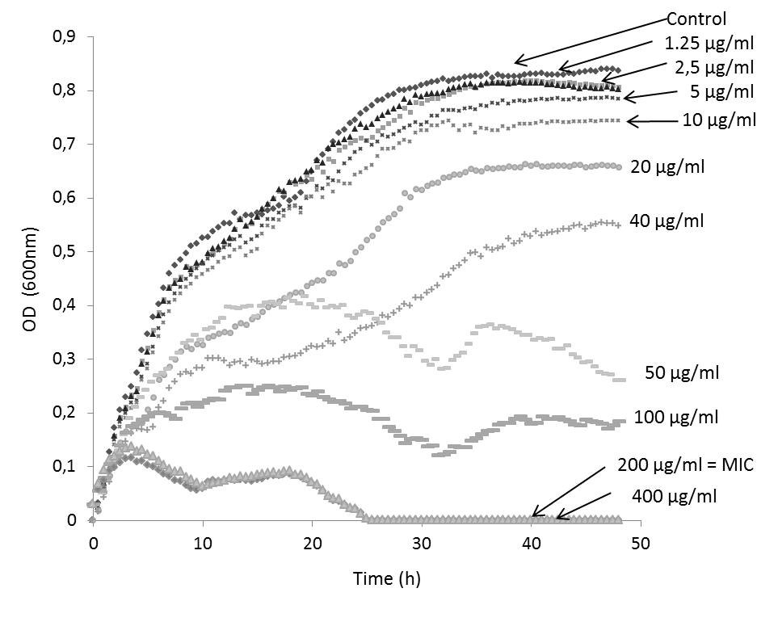
Figure S1: Determination of minimal inhibitory concentration (MIC) for marennine with bacterial growth (OD = 600nm) as a function of time (hours). MIC is indicated.
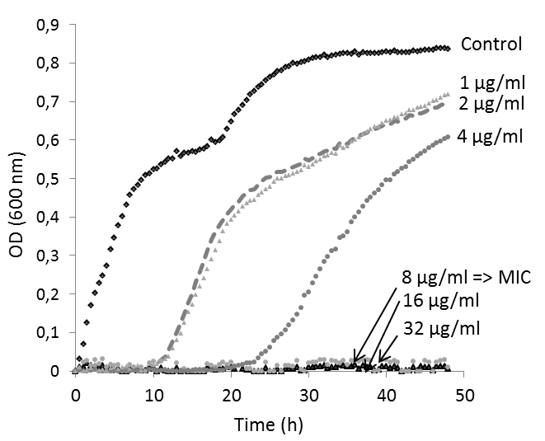
Figure S2: Determination of minimal inhibitory concentration (MIC) for polymyxin B with bacterial growth (OD = 600nm) as a function of time (hours). MIC is indicated.

A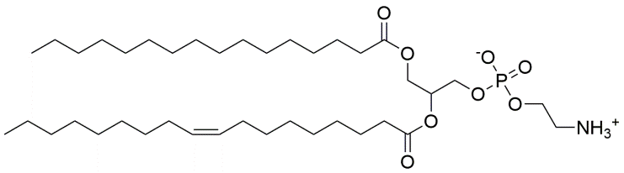 | 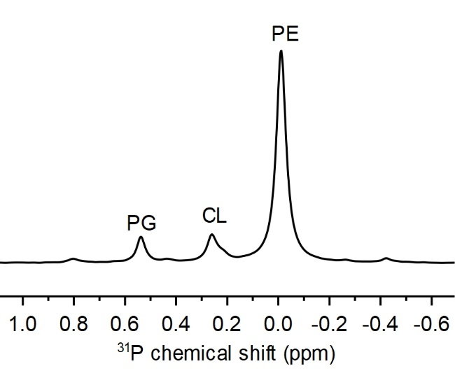  D
B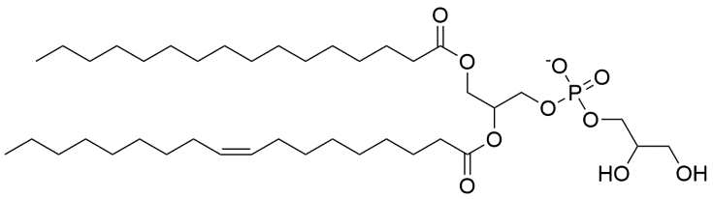
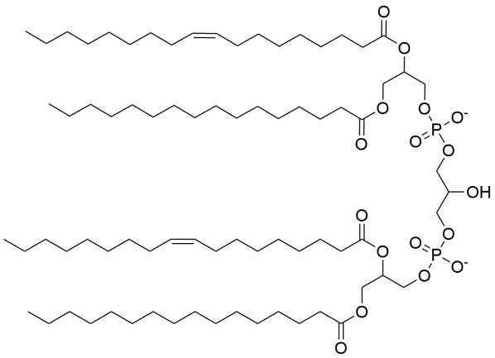
C

Figure S3: Chemical structures of phospholipids used in model membranes of V. splendidus. A: phosphatidylethanolamine (PE), B: phosphatidylglycerol (PG) and C: cardiolipin (CL). D: Characteristic ³¹P solution NMR spectrum of lipid extracts of V. splendidus (7SHRW) grown in LB medium at 25°C. Lipids were solubilized in 500 μL of CDCl₃, 200 μL methanol, and 50 μL aqueous EDTA solution (200 mM at pH 6).

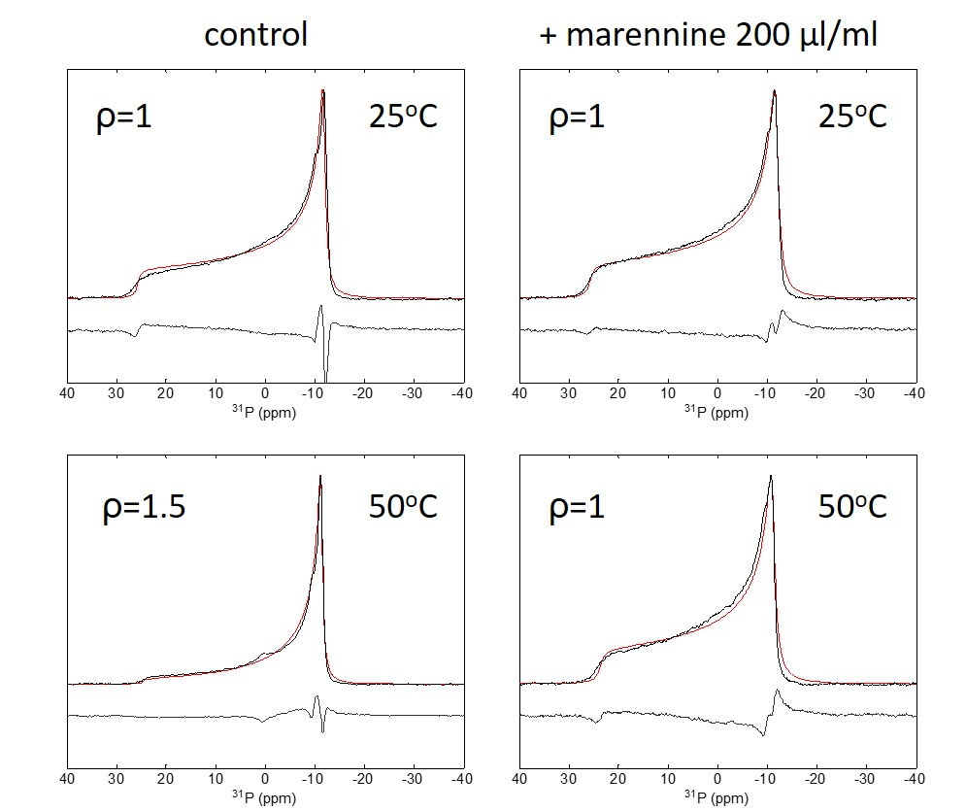
Figure S4: Experimental (black) and simulated spectra (red) of vibrio splendidus model membranes without marennine and in the presence of 200 µg/mL marennine at 25 and 50 °C. The ellipsoid long to short axis ratio ρ is indicated.

